Darwin Harbour Water Quality Pressures

Murray Logan

17 May, 2023

Table of Contents

**List of tables**

**List of figures**

# Background

The pressure monitoring sub-program within the Integrated Marine Monitoring and Research Program (IMMRP) collates data on various pressures of perceived relevance to Darwin Harbour. An objective of the IMMRP pressure monitoring sub-program is to, where possible, explore relationships between pressures (and drivers) and stressor and response variables to understand key influences on marine condition, and to incorporate ‘multiple lines of evidence’ into condition assessments.

# Project Scope

This project comprises an exploratory statistical investigation of pressure - stressor relationships utilising the water quality data underpinning the Darwin Harbour (Water Quality) Report Card as a first step toward attribution. The driving question behind the study is what if any of the myriad of pressures show relationships.

# Import data

All of the data were provided via email from Lynda Radke (Wed 30/09/2022 13:24, Tue 10/01/2023 08:39 and Tue 10/01/2023 08:58) or Julia Fortune (Tue 26/09/2022 12:32)

The following sub-sections each correspond to particular sets of provided data. In each of these sub-sections, I provide the code for importing the data into R along with a glimpse of the raw data.

## Water quality data

Summaries of the data supplied water quality data are supplied in tables , and within the following sections.

### 2012 - 2015

**Table** **:** Overview of the supplied 2012-2015 water quality data.

| Variable | Type | Min | Max | Missing | Values |
| --- | --- | --- | --- | --- | --- |
| Location ID | character |  |  | 0 | G8150409,G8150358,G8155139,... |
| Observed Property ID | character |  |  | 0 | Orthophosphate as P,pH Fiel... |
| Depth Unit | character |  |  | 4,615 | m,NA |
| Data Classification | character |  |  | 0 | LAB,FIELD |
| Result Unit | character |  |  | 0 | mg/l,pH Units,degC,NTU,m,%,... |
| Medium | character |  |  | 0 | Water |
| Collection Method | character |  |  | 5 | WQ-GRAB,WQ-PUMP,WQ-IN SITU,NA |
| Lab: Analysis Method | character |  |  | 0 | 4500-P F;Orthophosphate by ... |
| Lab: Detection Condition | character |  |  | 17,884 | NA,NOT_DETECTED |
| Lab: Quality Flag | character |  |  | 17,884 | NA,< |
| Lab: Sample Fraction | character |  |  | 11,121 | DISSOLVED,NA,TOTAL |
| Country | character |  |  | 0 | Australia |
| State | character |  |  | 0 | NT |
| Location Type | character |  |  | 0 | Estuarine,Spring |
| Field Visit Start Date | character |  |  | 0 | 11/07/2012,11/09/2012,7/11/... |
| Result Status | character |  |  | 13,321 | NA,Reviewed |
| Result Grade | character |  |  | 13,321 | NA,Ok |
| Lab: From Laboratory | character |  |  | 12,742 | NA,NTEL,ECMU |
| Lab: Limit Type | logical |  |  | 19,313 | : |
| Lab: MRL | logical |  |  | 19,313 | : |
| Lab: Received DateTime | logical |  |  | 19,313 | : |
| Lab: Prepared DateTime | logical |  |  | 19,313 | : |
| County | logical |  |  | 19,313 | : |
| Depth | numeric | 0.200 | 0.500 | 4,615 | ▁▁▁▁▁▁▁▇ |
| Result Value | numeric | 0.001 | 59400.000 | 1,429 | ▇▁▁▁▁▁▁▁ |
| Lab: MDL | numeric | 0.001 | 1.000 | 17,884 | ▇▁▁▁▁▁▁▁ |
| Latitude | numeric | -12.748 | -12.197 | 0 | ▁▅▇▇▂▁▁▁ |
| Longitude | numeric | 130.694 | 131.037 | 0 | ▁▂▅▃▆▇▇▂ |
| Observed DateTime | POSIXct | 2012-02-06 | 2015-12-03 | 0 | ▆▇▂▃▂▃▆▆ |

### 2016 - 2022

**Table** **:** Overview of the supplied 2016-2022 water quality data.

| Variable | Type | Min | Max | Missing | Values |
| --- | --- | --- | --- | --- | --- |
| Location ID | character |  |  | 534,052 | G8155580,G8150338,G8150343,... |
| Observed Property ID | character |  |  | 534,052 | Dissolved oxygen,Water Temp... |
| Depth Unit | character |  |  | 535,912 | NA,m |
| Data Classification | character |  |  | 534,052 | FIELD,LAB,NA |
| Result Unit | character |  |  | 534,052 | mg/l,degC,uS/cm,ppt,%,pH Un... |
| Result Status | character |  |  | 534,052 | Reviewed,NA |
| Result Grade | character |  |  | 534,052 | Ok,NA |
| Medium | character |  |  | 534,052 | Water,NA |
| Activity ID | character |  |  | 534,877 | NA,7cda2835-cf97-42ff-bdf3-... |
| Activity Name | character |  |  | 534,877 | NA,EA16-FN-190116,MH23-F-01... |
| Collection Method | character |  |  | 534,052 | WQ-GRAB,WQ-IN SITU,WQ-PUMP,NA |
| Lab: Analysis Method | character |  |  | 534,052 | 4500-O G;Dissolved Oxygen b... |
| Lab: Detection Condition | character |  |  | 535,726 | NA,NOT_DETECTED |
| Lab: Quality Flag | character |  |  | 535,726 | NA,< |
| Lab: Sample Fraction | character |  |  | 535,062 | NA,DISSOLVED |
| Lab: From Laboratory | character |  |  | 534,882 | NA,NTEL,ECMU |
| Country | character |  |  | 534,052 | Australia,NA |
| State | character |  |  | 534,052 | NT,NA |
| Location Type | character |  |  | 534,052 | Estuarine,NA |
| Field Visit Start Date | character |  |  | 534,052 | 18/01/2016,19/01/2016,15/04... |
| Source | character |  |  | 1,881 | NA,CFM,Discrete |
| Date | character |  |  | 1,881 | NA,2/06/2016,1/06/2016,31/0... |
| SAMPTYPE | character |  |  | 1,881 | NA,CFM,Discrete |
| Lab: Limit Type | logical |  |  | 535,933 | : |
| Lab: MRL | logical |  |  | 535,933 | : |
| Lab: Received DateTime | logical |  |  | 535,933 | : |
| Lab: Prepared DateTime | logical |  |  | 535,933 | : |
| County | logical |  |  | 535,933 | : |
| Depth | numeric | 0.500 | 0.500 | 535,912 | ▁▁▁▇▁▁▁▁ |
| Result Value | numeric | 0.001 | 51900.000 | 534,259 | ▇▁▁▁▁▁▁▁ |
| Lab: MDL | numeric | 0.001 | 0.005 | 535,726 | ▇▁▁▁▁▁▁▂ |
| Latitude | numeric | -12.716 | 130.956 | 7 | ▇▁▁▁▁▁▁▁ |
| Longitude | numeric | -12.522 | 131.040 | 7 | ▁▁▁▁▁▁▁▇ |
| Zone | numeric | 1.000 | 9.000 | 1,881 | ▇▅▅▃▃▅▁▁ |
| Region | numeric | 1.000 | 3.000 | 1,881 | ▇▁▁▂▁▁▁▃ |
| Chla_mug_PER_L | numeric | -1.090 | 1690.000 | 79,539 | ▇▁▁▁▁▁▁▁ |
| Turbidity_NTU | numeric | -0.060 | 335.000 | 27,233 | ▇▁▁▁▁▁▁▁ |
| DO_PERCENT_saturation | numeric | 0.000 | 270.600 | 6,753 | ▁▁▇▁▁▁▁▁ |
| NH3_mug_PER_L | numeric | 0.001 | 6.870 | 531,144 | ▇▁▁▁▁▁▁▁ |
| PO4_mug_PER_L | numeric | 0.001 | 5.410 | 531,108 | ▇▁▁▁▁▁▁▁ |
| Nox_mug_PER_L | numeric | 0.001 | 1.420 | 527,723 | ▇▁▁▁▁▁▁▁ |
| Observed DateTime | POSIXct | 2016-01-18 | 2016-10-11 | 534,052 | ▇▂▃▁▂▁▁▂ |

### 2018 alterations

The original water quality data for the year 2018 contained a very large number of samples collected via an via a continuous flow system with insufficient encoding to permit separation from more routine and discrete samples. Hence, a modified version of the water quality data were provided for the year 2018 to replace those within the 2016-2022 data.

To assist with distinguishing *routine* and *discrete* samples, a lookup of routine sites was provided - a summary of which is contained in table .

**Table** **:** Overview of the supplied modified 2018 water quality data.

| Variable | Type | Min | Max | Missing | Values |
| --- | --- | --- | --- | --- | --- |
| Source | character |  |  | 0 | CFM,Discrete |
| Date | character |  |  | 0 | 18/05/2018,18/09/2018,2/10/... |
| SAMPTYPE | character |  |  | 0 | CFM,Discrete |
| Zone | numeric | 1.000 | 9.000 | 0 | ▇▅▇▂▅▇▁▁ |
| Region | numeric | 1.000 | 3.000 | 0 | ▇▁▁▂▁▁▁▂ |
| Latitude | numeric | -12.715 | -12.226 | 0 | ▂▃▇▆▂▂▃▁ |
| Longitude | numeric | 130.694 | 131.040 | 0 | ▁▅▇▅▅▇▇▃ |
| Chla_mug_PER_L | numeric | 0.210 | 50.110 | 136,735 | ▇▁▁▁▁▁▁▁ |
| Turbidity_NTU | numeric | 0.000 | 147.650 | 4,206 | ▇▁▁▁▁▁▁▁ |
| DO_PERCENT_saturation | numeric | 0.000 | 144.700 | 3,495 | ▁▁▁▁▂▇▁▁ |
| NH3_mug_PER_L | numeric | 0.001 | 3.200 | 134,281 | ▇▁▁▁▁▁▁▁ |
| PO4_mug_PER_L | numeric | 0.001 | 1.800 | 134,311 | ▇▁▁▁▁▁▁▁ |
| Nox_mug_PER_L | numeric | 0.001 | 0.125 | 134,350 | ▇▁▁▁▁▁▁▁ |

**Table** **:** Overview of the lookup of list of routine sites from the water quality data.

| Variable | Type | Min | Max | Missing | Values |
| --- | --- | --- | --- | --- | --- |
| Site | character |  |  | 0 | Buff C O/Fall Bck6,OH8,OH5,... |
| Gcode | character |  |  | 0 | G8150090,G8150133,G8150134,... |
| Zone | character |  |  | 0 | BC,OH,ER,EA,MA,MH,WA,SB,Myr |
| Temp | character |  |  | 0 | X |
| Salinity | character |  |  | 0 | X |
| EC | character |  |  | 0 | X |
| DO | character |  |  | 0 | X |
| Turbidity | character |  |  | 0 | X |
| NOX | character |  |  | 0 | X |
| NH3 | character |  |  | 0 | X |
| FRP | character |  |  | 0 | X |
| Chla | character |  |  | 0 | X |
| TN/TP | character |  |  | 79 | NA,EA1,EA16,EA18,MA17,MA29,... |
| ID | numeric | 1.000 | 93.000 | 0 | ▇▇▇▇▇▇▇▇ |
| Latitude | numeric | -12.714 | -12.197 | 0 | ▃▃▇▅▂▃▂▁ |
| Longitude | numeric | 130.694 | 131.037 | 0 | ▁▃▅▅▆▇▆▂ |

## Primary point data

Julia Fortune provided a word file containing point-source TN, TP, TSS and VSS loads to the Harbour at various scales from 2011-12 to 2020-21. An excel sheet was also provided of the underlying data - a summary of which is contained in table .

**Table** **:** Overview of the supplied point source (total nitrogen, total phosphorus, total suspended solids and volitile suspended solids) data.

| Variable | Type | Min | Max | Missing | Values |
| --- | --- | --- | --- | --- | --- |
| Site | character |  |  | 0 | Bleesers Creek (Berrimah Ww... |
| Discharge location | character |  |  | 0 | Bleesers Creek,Buffalo Cree... |
| Organisation | character |  |  | 0 | Power and Water Corporation... |
| Fin. Year | character |  |  | 0 | 2011-12,2012-13,2013-14,201... |
| Parameter | character |  |  | 0 | Total N (t),Total P (t),Tot... |
| Source of discharge | character |  |  | 0 | Berrimah waste stabilisatio... |
| Catchment | character |  |  | 10 | Bleesers Creek,Buffalo Cree... |
| Receiving water body | character |  |  | 0 | Darwin Harbour |
| Revieving zone | character |  |  | 0 | Inner,Outer |
| Financial year end | numeric | 41090.000 | 44377.000 | 0 | ▅▂▂▂▃▅▅▇ |
| Load | numeric | 0.004 | 8178654.400 | 5 | ▇▁▁▁▁▁▁▁ |
| Year ref. | numeric | 2012.000 | 2021.000 | 0 | ▅▂▂▂▃▅▅▇ |
| Latitude | numeric | -12.568 | -12.359 | 12 | ▃▁▇▁▆▁▇▇ |
| Longitude | numeric | 130.822 | 130.949 | 12 | ▃▁▁▁▁▇▁▃ |

## Estimated resident population (ERP) and gross regional product (GRP)

Table provides a summary of the estimated resident population (ERP) and gross regional product (grp) data provided for the years spanning 2000-01 to 2021-21.

**Table** **:** Overview of the supplied estimated resident population (ERP) and gross regional product (GRP) data.

| Variable | Type | Min | Max | Missing | Values |
| --- | --- | --- | --- | --- | --- |
| Date (FY) | character |  |  | 0 | 2000-01,2001-02,2002-03,200... |
| ...8 | character |  |  | 19 | ERP = Estimated resident po... |
| ...7 | logical |  |  | 21 | : |
| Year ending June | numeric | 2001.000 | 2021.000 | 0 | ▇▇▅▇▅▇▅▇ |
| ERP | numeric | 108375.000 | 150506.000 | 0 | ▆▂▁▂▂▁▁▇ |
| ERP growth | numeric | -0.689 | 4.124 | 1 | ▇▂▆▆▃▃▆▃ |
| GRP ($M) | numeric | 7146.000 | 18664.000 | 0 | ▇▇▃▃▁▆▃▇ |
| Change GRP from previous year (%) | numeric | -1.666 | 15.526 | 1 | ▁▅▇▇▃▁▁▁ |

## Catchment ERP

Table provides a summary of the population density data for 2016 to 2020 (year ending June 30), including for sub-catchment areas.

**Table** **:** Overview of the supplied catchment estimated resident population (ERP) data population density.

| Variable | Type | Min | Max | Missing | Values |
| --- | --- | --- | --- | --- | --- |
| Catchment Name | character |  |  | 0 | Blackmore River (Middle Arm... |
| Region | character |  |  | 1 | MWA,EA,OHR,NA |
| 2020 ERP | character |  |  | 0 | 3119,355,17925,474,-,15514,... |
| ...9 | logical |  |  | 23 | : |
| Area | numeric | 6.200 | 2422.300 | 0 | ▇▁▁▁▁▁▁▁ |
| 2016 ERP | numeric | 0.000 | 142852.000 | 0 | ▇▁▁▁▁▁▁▁ |
| 2017 ERP | numeric | 0.000 | 144610.000 | 0 | ▇▁▁▁▁▁▁▁ |
| 2018 ERP | numeric | 0.000 | 144140.000 | 0 | ▇▁▁▁▁▁▁▁ |
| 2019 ERP | numeric | 0.000 | 143206.000 | 0 | ▇▁▁▁▁▁▁▁ |
| 2016 Population/km2 | numeric | 0.000 | 1882.143 | 0 | ▇▁▂▂▁▁▁▁ |
| 2017 Population/km2 | numeric | 0.000 | 1931.071 | 0 | ▇▁▁▂▁▁▁▁ |
| 2018 Population/km2 | numeric | 0.000 | 1899.167 | 0 | ▇▁▁▂▁▁▁▁ |
| 2019 Population/km2 | numeric | 0.000 | 1862.381 | 0 | ▇▁▂▂▁▁▁▁ |
| 2020 Population/km2 | numeric | 0.000 | 1846.905 | 0 | ▇▁▂▂▁▁▁▁ |

## Fire frequency

Table provides a summary of the fire frequencies for five year windows from 2000-04 until 2017-21 and then 2018-22. The data are based on weighted averages (WA) for the individual sub-catchments and the overall catchment area. Standard deviations (SDs) are also provided.

**Table** **:** Overview of the supplied fire frequency data.

| Variable | Type | Min | Max | Missing | Values |
| --- | --- | --- | --- | --- | --- |
| Catchment | character |  |  | 0 | Blackmore River,Bleesers Cr... |
| 00_04 (WA) | numeric | 0.000 | 0.668 | 0 | ▇▃▁▂▂▂▁▁ |
| 00_04 (STD) | numeric | 0.000 | 1.001 | 0 | ▆▇▇▂▆▃▆▆ |
| 01_05 (WA) | numeric | 0.000 | 0.838 | 0 | ▇▅▂▃▁▁▁▁ |
| 01_05 (STD) | numeric | 0.000 | 1.137 | 0 | ▅▂▇▆▅▅▃▃ |
| 02_06 (WA) | numeric | 0.000 | 0.953 | 0 | ▇▃▃▂▂▁▁▂ |
| 02_06 (STD) | numeric | 0.000 | 1.258 | 0 | ▆▂▆▅▇▅▂▃ |
| 03_07 (WA) | numeric | 0.000 | 1.022 | 0 | ▇▂▅▂▁▁▁▁ |
| 03_07 (STD) | numeric | 0.000 | 4.609 | 0 | ▇▆▁▂▁▁▁▂ |
| 04_08 (WA) | numeric | 0.000 | 0.872 | 0 | ▇▂▃▃▁▁▁▂ |
| 04_08 (STD) | numeric | 0.000 | 5.629 | 0 | ▇▅▂▁▁▁▁▁ |
| 05_09 (WA) | numeric | 0.000 | 0.856 | 0 | ▇▂▂▃▂▁▁▁ |
| 05_09 (STD) | numeric | 0.000 | 1.182 | 0 | ▅▅▇▃▆▅▃▂ |
| 06_10 (WA) | numeric | 0.000 | 0.835 | 0 | ▇▂▂▂▂▁▁▁ |
| 06_10 (STD) | numeric | 0.000 | 1.222 | 0 | ▇▃▁▅▅▃▁▁ |
| 07_11 (WA) | numeric | 0.000 | 0.614 | 0 | ▇▃▂▂▁▁▁▁ |
| 07_11 (STD) | numeric | 0.000 | 1.047 | 0 | ▇▂▂▅▂▅▁▁ |
| 08_12 (WA) | numeric | 0.000 | 0.527 | 0 | ▇▂▁▃▂▁▁▂ |
| 08_12 (STD) | numeric | 0.000 | 0.906 | 0 | ▇▅▃▃▅▆▃▃ |
| 09_13 (WA) | numeric | 0.000 | 0.612 | 0 | ▇▂▁▂▂▂▁▁ |
| 09_13 (STD) | numeric | 0.000 | 1.002 | 0 | ▇▁▁▁▁▅▃▂ |
| 10_14 (WA) | numeric | 0.000 | 0.855 | 0 | ▇▁▂▃▂▁▁▂ |
| 10_14 (STD) | numeric | 0.000 | 1.130 | 0 | ▇▁▁▁▃▂▃▂ |
| 11_15 (WA)...24 | numeric | 0.000 | 0.870 | 0 | ▇▂▁▃▂▁▂▃ |
| 11_15 (WA)...25 | numeric | 0.000 | 1.150 | 0 | ▇▁▁▂▁▃▃▃ |
| 12_16 (WA) | numeric | 0.000 | 0.940 | 0 | ▇▁▃▃▁▃▁▁ |
| 12_16 (STD) | numeric | 0.000 | 1.230 | 0 | ▇▁▁▁▃▇▂▂ |
| 13_17 (WA) | numeric | 0.000 | 0.910 | 0 | ▇▁▅▁▅▂▁▁ |
| 13_17 (STD) | numeric | 0.000 | 1.240 | 0 | ▇▁▁▁▅▇▁▂ |
| 14_18 (WA) | numeric | 0.000 | 0.876 | 0 | ▇▃▂▂▅▂▁▁ |
| 14_18 (STD) | numeric | 0.000 | 1.122 | 0 | ▇▁▁▂▃▆▅▁ |
| 15_19 (WA) | numeric | 0.000 | 0.620 | 0 | ▇▁▃▁▂▁▂▂ |
| 15_19 (STD) | numeric | 0.000 | 0.951 | 0 | ▇▁▃▁▅▃▃▃ |
| 16_20 (WA) | numeric | 0.000 | 0.551 | 0 | ▇▂▂▂▂▁▁▂ |
| 16_20 (STD) | numeric | 0.000 | 0.883 | 0 | ▇▁▁▂▃▂▆▂ |
| 17_21 WA | numeric | 0.000 | 0.570 | 0 | ▇▂▃▁▂▁▁▂ |
| 17_21 STD | numeric | 0.000 | 1.018 | 0 | ▇▁▃▃▂▂▂▃ |
| 18_22 WA | numeric | 0.000 | 0.529 | 0 | ▇▂▃▂▂▂▁▂ |
| 18_22 STD | numeric | 0.000 | 0.879 | 0 | ▇▁▁▂▃▃▂▃ |

## Fire areas

Table and Table provide summaries of the fire scar areas as km² and percentages respectively of the total catchment areas from 2000 to 2021. The data are also broken down according to whether or not they formed in early dry-season and late dry-season. Totals comprise early+late fire scars.

### Areas

**Table** **:** Overview of the supplied fire frequency data in area.

| Variable | Type | Min | Max | Missing | Values |
| --- | --- | --- | --- | --- | --- |
| Catchment | character |  |  | 0 | Blackmore River (Middle Arm... |
| 2000 | numeric | 0.000 | 912.562 | 0 | ▇▁▁▁▁▁▁▁ |
| 2001 | numeric | 0.000 | 1091.188 | 0 | ▇▁▁▁▁▁▁▁ |
| 2002 | numeric | 0.000 | 1060.250 | 0 | ▇▁▁▁▁▁▁▁ |
| 2003 | numeric | 0.000 | 949.062 | 0 | ▇▁▁▁▁▁▁▁ |
| 2004 | numeric | 0.000 | 977.750 | 0 | ▇▁▁▁▁▁▁▁ |
| 2005 | numeric | 0.000 | 1348.312 | 0 | ▇▁▁▁▁▁▁▁ |
| 2006 | numeric | 0.000 | 1000.062 | 0 | ▇▁▁▁▁▁▁▁ |
| 2007 | numeric | 0.000 | 1009.500 | 0 | ▇▁▁▁▁▁▁▁ |
| 2008 | numeric | 0.000 | 1016.500 | 0 | ▇▁▁▁▁▁▁▁ |
| 2009 | numeric | 0.000 | 806.625 | 0 | ▇▁▁▁▁▁▁▁ |
| 2010 | numeric | 0.000 | 910.375 | 0 | ▇▁▁▁▁▁▁▁ |
| 2011 | numeric | 0.000 | 1018.688 | 0 | ▇▁▁▁▁▁▁▁ |
| 2012 | numeric | 0.000 | 1018.312 | 0 | ▇▁▁▁▁▁▁▁ |
| 2013 | numeric | 0.000 | 997.062 | 0 | ▇▁▁▁▁▁▁▁ |
| 2014 | numeric | 0.000 | 1176.688 | 0 | ▇▁▁▁▁▁▁▁ |
| 2015 | numeric | 0.000 | 1095.875 | 0 | ▇▁▁▁▁▁▁▁ |
| 2016 | numeric | 0.000 | 968.438 | 0 | ▇▁▁▁▁▁▁▁ |
| 2017 | numeric | 0.000 | 1147.438 | 0 | ▇▁▁▁▁▁▁▁ |
| 2018 | numeric | 0.000 | 1135.625 | 0 | ▇▁▁▁▁▁▁▁ |
| 2019 | numeric | 0.000 | 1012.688 | 0 | ▇▁▁▁▁▁▁▁ |
| 2020 | numeric | 0.000 | 982.188 | 0 | ▇▁▁▁▁▁▁▁ |
| 2021 | numeric | 0.000 | 888.500 | 0 | ▇▁▁▁▁▁▁▁ |
| 2022 | numeric | 0.000 | 1008.000 | 0 | ▇▁▁▁▁▁▁▁ |

### Percentages

**Table** **:** Overview of the supplied fire frequency percentage data in percentages.

| Variable | Type | Min | Max | Missing | Values |
| --- | --- | --- | --- | --- | --- |
| Catchment | character |  |  | 0 | Blackmore River,Bleesers Cr... |
| 2000 | numeric | 0.000 | 54.537 | 0 | ▇▅▅▂▁▂▂▃ |
| 2001 | numeric | 0.000 | 69.452 | 0 | ▇▁▂▃▂▃▂▁ |
| 2002 | numeric | 0.000 | 70.435 | 0 | ▇▃▂▁▃▃▂▁ |
| 2003 | numeric | 0.000 | 62.997 | 0 | ▇▅▁▂▁▂▁▂ |
| 2004 | numeric | 0.000 | 65.723 | 0 | ▇▂▁▃▂▁▂▁ |
| 2005 | numeric | 0.000 | 82.368 | 0 | ▇▁▃▁▇▇▁▂ |
| 2006 | numeric | 0.000 | 58.195 | 0 | ▇▃▁▂▁▅▅▁ |
| 2007 | numeric | 0.000 | 67.800 | 0 | ▇▃▁▃▃▂▁▂ |
| 2008 | numeric | 0.000 | 67.034 | 0 | ▇▂▁▅▁▃▁▂ |
| 2009 | numeric | 0.000 | 55.643 | 0 | ▇▂▅▁▂▁▂▁ |
| 2010 | numeric | 0.000 | 75.104 | 0 | ▇▂▂▃▂▁▁▂ |
| 2011 | numeric | 0.000 | 77.566 | 0 | ▇▃▃▅▁▂▁▁ |
| 2012 | numeric | 0.000 | 77.851 | 0 | ▇▁▂▂▅▁▁▁ |
| 2013 | numeric | 0.000 | 69.898 | 0 | ▇▁▂▃▂▁▁▂ |
| 2014 | numeric | 0.000 | 74.378 | 0 | ▇▃▂▁▁▂▂▂ |
| 2015 | numeric | 0.000 | 77.237 | 0 | ▇▁▂▁▃▂▁▁ |
| 2016 | numeric | 0.000 | 70.066 | 0 | ▇▆▃▃▁▁▂▁ |
| 2017 | numeric | 0.000 | 75.844 | 0 | ▇▂▁▁▅▁▂▁ |
| 2018 | numeric | 0.000 | 83.176 | 0 | ▇▃▂▃▃▁▁▂ |
| 2019 | numeric | 0.000 | 73.918 | 0 | ▇▁▁▂▂▁▁▁ |
| 2020 | numeric | 0.000 | 67.280 | 0 | ▇▃▁▁▃▁▁▁ |
| 2021 | numeric | 0.000 | 66.624 | 0 | ▇▂▃▁▂▂▁▂ |
| 2022 | numeric | 0.000 | 73.508 | 0 | ▇▅▁▂▃▁▃▁ |

## Sea level rise

Table and Table provide summaries of BOM monthly sea levels and annual averages of the mean monthly sea levels for calendar and financial years respectively.

### Calendar year

**Table** **:** Overview of the supplied annual sea levels from BOM (calendar years).

| Variable | Type | Min | Max | Missing | Values |
| --- | --- | --- | --- | --- | --- |
| Year | numeric | 1989.000 | 2021.000 | 0 | ▇▆▆▆▆▆▆▆ |
| Avg SL (m) (cal. Year) | numeric | 4.072 | 4.342 | 0 | ▆▁▇▇▁▆▇▂ |

### Financial year

**Table** **:** Overview of the supplied annual sea levels from BOM (financial years).

| Variable | Type | Min | Max | Missing | Values |
| --- | --- | --- | --- | --- | --- |
| Financial year | character |  |  | 0 | 1989-90,1990-91,1991-92,199... |
| Year (ending) | numeric | 1990.000 | 2022.000 | 0 | ▇▆▆▆▆▆▆▆ |
| Avg SL (m) (fy) | numeric | 4.064 | 4.364 | 0 | ▅▃▃▇▂▇▃▂ |

## Temperature/Rainfall/Anomaly

The tables in this section provide summaries of a range of climatic data sets, including:

* Annual total rainfall at Darwin airport (calendar) – 1902-2021 (Table )
* Monthly rainfall at Darwin airport– 1989 -2022 (Table )
* Annual rainfall (financial year) – 1989-90 – 2021-22 (Table )
* Rainfall anomaly – 1902-2021 (Table )
* Mean air temperature – 1910-2020 (Table )
* Maximum air temperature – 1910 – 2020 (Table )
* Mean temperature anomaly – 1910 – 2020 (Table )
* Maximum temperature anomaly – 1910-2020 (Table )
* Annual averages of monthly SOI for financial years and calendar (Tables and ) years
* Sea surface temperature (SST) anomaly – 1900 – 2021 (Tables )

Most of the data are from Darwin airport or gauging station.

You should definitely include annual rainfall and SOI data in your analyses. Rainfall anomalies and SSTs may also be interesting.

### Annual rainfall (calendar year)

**Table** **:** Overview of the supplied annual total rainfall data (per calendar year).

| Variable | Type | Min | Max | Missing | Values |
| --- | --- | --- | --- | --- | --- |
| Year | numeric | 1989.000 | 2021.000 | 0 | ▇▆▆▆▆▆▆▆ |
| Avg SL (m) (cal. Year) | numeric | 4.072 | 4.342 | 0 | ▆▁▇▇▁▆▇▂ |

### Annual rainfall (financial year)

**Table** **:** Overview of the supplied annual total rainfall data (per financial year).

| Variable | Type | Min | Max | Missing | Values |
| --- | --- | --- | --- | --- | --- |
| Financial year | character |  |  | 0 | 1989-90,1990-91,1991-92,199... |
| Year (ending) | numeric | 1990.000 | 2022.000 | 0 | ▇▆▆▆▆▆▆▆ |
| Avg SL (m) (fy) | numeric | 4.064 | 4.364 | 0 | ▅▃▃▇▂▇▃▂ |

### Rainfall anomaly

**Table** **:** Overview of the supplied annual total rainfall anomaly data.

| Variable | Type | Min | Max | Missing | Values |
| --- | --- | --- | --- | --- | --- |
| Source | character |  |  | 118 | www.bom.gov.au/cgi-bin/clim... |
| For years | character |  |  | 119 | 1902-2020,NA |
| ...3 | logical |  |  | 120 | : |
| Year | numeric | 1902.000 | 2021.000 | 0 | ▇▇▇▇▇▇▇▇ |
| Precipitaton anomaly (mm) | numeric | -680.400 | 1071.500 | 0 | ▅▃▇▇▂▂▁▁ |
| Accessed | POSIXct | 2021-12-10 | 2021-12-10 | 119 | ▁▁▁▇▁▁▁▁ |

### Mean air temperature

**Table** **:** Overview of the supplied mean annual air temperature data.

| Variable | Type | Min | Max | Missing | Values |
| --- | --- | --- | --- | --- | --- |
| Source | character |  |  | 109 | www.bom.gov.au/cgi-bin/clim... |
| For years | character |  |  | 110 | 1910-2020,NA |
| Date | numeric | 1910.000 | 2020.000 | 0 | ▇▇▇▇▇▇▇▇ |
| Mean air temperature (oC) (Darwin Airport) | numeric | 26.300 | 28.700 | 3 | ▆▅▇▆▅▅▁▁ |
| Accessed | POSIXct | 2021-12-13 | 2021-12-13 | 110 | ▁▁▁▇▁▁▁▁ |

### Max air temperature anomaly

**Table** **:** Overview of the supplied max annual air temperature anomaly data.

| Variable | Type | Min | Max | Missing | Values |
| --- | --- | --- | --- | --- | --- |
| Sources | character |  |  | 109 | www.bom.gov.au/cgi-bin/clim... |
| For years | character |  |  | 110 | 1910-2020,NA |
| ...3 | logical |  |  | 111 | : |
| Year | numeric | 1910.000 | 2020.000 | 0 | ▇▇▇▇▇▇▇▇ |
| Max Air_Temperature anomaly (oC) (Darwin Airport) | numeric | -1.700 | 1.500 | 3 | ▁▅▇▅▅▇▅▁ |
| Accessed | POSIXct | 2021-12-10 | 2021-12-10 | 110 | ▁▁▁▇▁▁▁▁ |

### SOI (cal year)

**Table** **:** Overview of the supplied annual southern oscillation index (SOI) data (calendar year).

| Variable | Type | Min | Max | Missing | Values |
| --- | --- | --- | --- | --- | --- |
| Year | numeric | 1990.120 | 2021.120 | 0 | ▇▇▇▇▇▇▇▇ |
| Avg SOI (Cal) | numeric | -11.933 | 13.300 | 0 | ▇▂▆▇▅▂▆▁ |

### SOI (fin year)

**Table** **:** Overview of the supplied annual southern oscillation index (SOI) data (financial year).

| Variable | Type | Min | Max | Missing | Values |
| --- | --- | --- | --- | --- | --- |
| Year ending | numeric | 1990.060 | 2022.060 | 0 | ▇▆▆▆▆▆▆▆ |
| Avg SOI (FY) | numeric | -14.283 | 18.083 | 0 | ▃▇▇▅▇▇▂▁ |

### SST anomaly

**Table** **:** Overview of the supplied annual sea surface temperature (SST) anomaly data.

| Variable | Type | Min | Max | Missing | Values |
| --- | --- | --- | --- | --- | --- |
| Source | character |  |  | 119 | www.bom.gov.au/climate/chan... |
| Data range | character |  |  | 121 | 1900-2020,NA |
| Year | numeric | 1900.000 | 2021.000 | 0 | ▇▇▇▇▇▇▇▇ |
| SST Anomaly (Northern tropics) (oC) | numeric | -0.720 | 0.960 | 0 | ▃▆▇▆▅▅▁▁ |
| Accessed | POSIXct | 2021-12-10 | 2021-12-10 | 121 | ▁▁▁▇▁▁▁▁ |

## Building activity

Table provide summaries of the supplied data on annual costs of total, engineering, residential and non-residential building activity from 1987-88 to 2021-22.

**Table** **:** Overview of the supplied building activity data.

| Variable | Type | Min | Max | Missing | Values |
| --- | --- | --- | --- | --- | --- |
| Financial year | character |  |  | 0 | 1987-88,1988-89,1989-90,199... |
| ...8 | logical |  |  | 35 | : |
| Year (ending June) | numeric | 1988.000 | 2022.000 | 0 | ▇▆▆▇▆▆▆▇ |
| Total ($'000) | numeric | 952429.000 | 10703246.000 | 0 | ▇▅▃▁▁▁▂▁ |
| Engineering ($'000) | numeric | 311460.000 | 9386283.000 | 0 | ▇▃▂▁▁▂▁▁ |
| Non-residential building ($'000) | numeric | 258907.000 | 1110180.000 | 0 | ▇▅▆▁▂▁▁▁ |
| Residential ($'000) | numeric | 280482.000 | 839211.000 | 0 | ▇▇▇▆▂▃▂▃ |
| Total ($B) | numeric | 0.952 | 10.703 | 0 | ▇▅▃▁▁▁▂▁ |
| Engineering ($B) | numeric | 0.311 | 9.386 | 0 | ▇▃▂▁▁▂▁▁ |
| Non-residential building ($B) | numeric | 0.259 | 1.110 | 0 | ▇▅▆▁▂▁▁▁ |
| Residential ($B) | numeric | 0.280 | 0.839 | 0 | ▇▇▇▆▂▃▂▃ |
| Moving annual total date | POSIXct | 1988-06-01 | 2022-06-01 | 0 | ▇▆▆▇▆▆▆▇ |

## Ship counts

Table provide summaries of the supplied data on various trade ship counts from Darwin Port from 2011-11 to 2021-22.

### Get data

### Glimpse data

**Table** **:** Overview of the supplied ship counts data.

| Variable | Type | Min | Max | Missing | Values |
| --- | --- | --- | --- | --- | --- |
| Year | character |  |  | 0 | 2010-11,2011-12,2012-13,201... |
| ...4 | logical |  |  | 12 | : |
| Year ending | numeric | 2011.000 | 2022.000 | 0 | ▇▃▇▃▃▇▃▇ |
| Trade ships | numeric | 1150.000 | 3178.000 | 0 | ▂▇▂▁▁▁▁▁ |
| Container/General cargo/Ro-Ro | numeric | 71.000 | 195.000 | 1 | ▅▅▅▁▁▁▅▇ |
| Liquid bulk | numeric | 40.000 | 116.000 | 1 | ▇▃▆▁▁▁▂▂ |
| Car carriers | numeric | 13.000 | 36.000 | 1 | ▇▁▂▂▂▁▂▆ |
| Rig tender | numeric | 172.000 | 499.000 | 1 | ▅▁▅▅▅▁▁▇ |
| Livestock | numeric | 69.000 | 170.000 | 1 | ▂▂▅▂▇▅▁▂ |
| Cruise ships | numeric | 9.000 | 75.000 | 1 | ▂▁▁▂▁▂▇▅ |
| Dry bulk | numeric | 17.000 | 60.000 | 1 | ▂▇▅▁▂▁▅▅ |
| Barge | numeric | 562.000 | 604.000 | 10 | ▇▁▁▁▁▁▁▇ |
| Charter | numeric | 18.000 | 20.000 | 10 | ▇▁▁▁▁▁▁▇ |
| LNG | numeric | 165.000 | 166.000 | 10 | ▇▁▁▁▁▁▁▇ |
| LPG | numeric | 39.000 | 39.000 | 10 | ▁▁▁▇▁▁▁▁ |
| Bunkers | numeric | 20.000 | 36.000 | 10 | ▇▁▁▁▁▁▁▇ |
| SUM | numeric | 553.000 | 1510.000 | 1 | ▃▂▇▃▁▁▁▃ |

# Lookup tables

Although each of the data collections provide a (spatio) temporal series, they are not all on the same spatial and temporal scales. Furthermore, whilst the stressor indicators (water quality samples) are collected within the Darwin Harbour water bodies, most (if not all) of the pressures are measured from the adjoining sub-catchments or else were recorded at the scale of the entire harbour.

To be able to relate stressors to pressures, it is necessary to combine the multiple data sources together which in turn necessitates finding common scales (both temporal and spatial) in which all datasets can be projected.

Since many of the provided pressures are on a annual financial year scale, this scale is used as the common temporal scale across all data sets. For the spatial scale, Darwin Harbour Zones are used as these are the major spatial unit for the Darwin Harbour Water Quality Report Card.

The following sub-sections provide a series of lookup tables that are used to map variables from each data set to the common spatial scales, provide reporting units and provide some analysis settings.

## Measures lookup

Table provides a mapping between the original pressure/stressor names (Var) and more convenient (shorter) working versions (Measure) from each Dataset. There are also some additional data managment settings associated with each data type.

**Table** **:** Spatial lookup for stressors across all data sets.

| Dataset | Var | Type | Measure |
| --- | --- | --- | --- |
| WQ 2016-2022 | Chla_mug_PER_L | Response | Chla |
| WQ 2016-2022 | Turbidity_NTU | Response | Turbidity |
| WQ 2016-2022 | DO_PERCENT_saturation | Response | DO |
| WQ 2016-2022 | NH3_mug_PER_L | Response | NH3 |
| WQ 2016-2022 | PO4_mug_PER_L | Response | PO4 |
| WQ 2016-2022 | Nox_mug_PER_L | Response | NOx |
| WQ 2012-2015 | Chlorophyll a Lab | Response | Chla |
| WQ 2012-2015 | Turbidity Field | Response | Turbidity |
| WQ 2012-2015 | Dissolved oxygen % | Response | DO |
| WQ 2012-2015 | Ammonia as N | Response | NH3 |
| WQ 2012-2015 | Phosphorus Total Filterable | Response | PO4 |
| Primary point | Total N (t) | Pressure | TotalN |
| Primary point | Total P (t) | Pressure | TotalP |
| Primary point | Discharge volume (annual kL) | Pressure | Discharge |
| Primary point | Total suspended solids (t) | Pressure | TSS |
| Primary point | Volatile suspended solids (t) | Pressure | VSS |
| ERPGDP | ERP | Pressure | ERP |
| ERPGDP | ERP growth | Pressure | ERP_growth |
| ERPGDP | GRP (\$M) | Pressure | GRP |
| ERPGDP | Change GRP from previous year (%) | Pressure | GRP_change |
| CatchmentERP | ERP | Pressure | Catch_ERP |
| CatchmentERP | POP | Pressure | POP |
| SeaLevels | Year (ending) | Time | Year |
| SeaLevels | Avg SL (m) (fy) | Pressure | SL |
| TempRainfallAnom | Precipitaton anomaly (mm) | Pressure | Rainfall_anom |
| TempRainfallAnom | Mean air temperature (oC) (Darwin Airport) | Pressure | AirTemp |
| TempRainfallAnom | Max Air_Temperature anomaly (oC) (Darwin Airport) | Pressure | AirTemp_anom |
| TempRainfallAnom | Year ending | Time | Year |
| TempRainfallAnom | Avg SOI (FY) | Pressure | SOI |
| TempRainfallAnom | SST Anomaly (Northern tropics) (oC) | Pressure | SST_anom |
| Building | Year (ending June) | Time | Year |
| Building | Total (\$B) | Pressure | Building_total |
| Building | Engineering (\$B) | Pressure | Building_eng |
| Building | Non-residential building (\$B) | Pressure | Building_non |
| Building | Residential (\$B) | Pressure | Building_res |
| Shipping | Trade ships | Pressure | Ship_trade |
| Shipping | Container/General cargo/Ro-Ro | Pressure | Ship_cont |
| Shipping | Liquid bulk | Pressure | Ship_liq |
| Shipping | Car carriers | Pressure | Ship_car |
| Shipping | Rig tender | Pressure | Ship_rig |
| Shipping | Livestock | Pressure | Ship_live |
| Shipping | Cruise ships | Pressure | Ship_cruise |
| Shipping | Dry bulk | Pressure | Ship_dry |
| Fire Freq | Fire_TotalKm_WA | Pressure | Fire_TotalKm_WA |
| Fire Freq | Fire_TotalKm_STD | Pressure | Fire_TotalKm_STD |
| Fire Areas | Fire_Areas | Pressure | Fire_Areas |
| Fire Areas | Fire_Areas_p | Pressure | Fire_Areas_p |

## Units lookup

Table defines the units (and thus figure/table labels) for each of the pressure/stressors.

**Table** **:** Units lookup for stressors across all data sets.

| Measure | Units | TableLabel |
| --- | --- | --- |
| Chla | mu.g/L | Chlorophyll-a (µg/L) |
| Turbidity | NTU | Turbidity (NTU) |
| DO | % saturation | Dissolved Oxygen (% Saturation) |
| NH3 | mu.g/L | Ammonia (µg/L) |
| PO4 | mu.g/L | Filterable Reactive Phosphate (µg/L) |
| NOx | mu.g/L | NOx as N (µg/L) |
| TotalN | t | Total N (t) |
| TotalP | t | Total P (t) |
| Discharge | kL | Discharge volume (annual kL) |
| TSS | t | Total suspended solids (t) |
| VSS | t | Volatile suspended solids (t) |
| ERP |  | Estimated resident population |
| ERP_growth |  | Estimated resident population growth |
| GRP | (\$M) | Gross regional product (\$M) |
| GRP_change | (%) | Gross regional product change (%) |
| Catch_ERP |  | Estimated resident population |
| Fire_TotalKm_WA | km | Five year moving average fire frequency (Km) |
| Fire_TotalKm_STD | km | Five year standard deviation of fire frequency (Km) |
| Fire_Areas | (Km²) | Total fire area (Km²) |
| Fire_Areas_p | (%) | Percentage fire area (%) |
| POP | (#/km2) | Population density (pop/km2) |
| SL | (m) | Mean sea level (m) |
| Rainfall | (mm) | Annual Rainfall (mm) |
| Rainfall_anom | (mm) | Rainfall anomaly (mm) |
| AirTemp | (oC) | Mean air temperature (oC) |
| AirTemp_anom | (oC) | Mean air temperature anomaly (oC) |
| SOI |  | Southern Oscillation Index |
| SST_anom |  | Sea Surface Temperature anomaly |
| Building_total | (\$B) | Total building activity (\$B) |
| Building_eng | (\$B) | Engineering building activity (\$B) |
| Building_non | (\$B) | Non-residential building activity (\$B) |
| Building_res | (\$B) | Residential building activity (\$B) |
| Ship_trade |  | Number of trade ships |
| Ship_cont |  | Number of container ships |
| Ship_liq |  | Number of liquid bulk ships |
| Ship_car |  | Number of car carrier ships |
| Ship_live |  | Number of livestock ships |
| Ship_rig |  | Number of rig tenders |
| Ship_cruise |  | Number of cruise ships |
| Ship_dry |  | Number of dry bulk ships |

## Spatial lookup

Table defines the Darwin Harbour Water Zone hierarchy.

**Table** **:** Darwin Harbour water zone hierachy.

| Region | RegionName | Zone | ZoneName | Area |
| --- | --- | --- | --- | --- |
| 1 | Upper | 4 | Middle Arm | Inner |
| 1 | Upper | 5 | East Arm | Inner |
| 1 | Upper | 6 | Elizabeth River | Inner |
| 1 | Upper | 7 | West Arm | Inner |
| 1 | Upper | 8 | Buffalo Creek | Outer |
| 1 | Upper | 9 | Myrmidon Creek | Inner |
| 2 | Middle | 3 | Central Harbour | Inner |
| 3 | Outer | 1 | Outer Harbour | Outer |
| 3 | Outer | 2 | Shoal Bay | Outer |

## Spatial sub-catchments lookup

Table defines the Darwin Harbour sub-catchments and maps these to Darwin Harbour Water Zones. There are also additional settings that can be used in the preparation of maps. Note, the spelling of Michett Creek and Leichhardt Creek. This is the spelling provided in the Darwin Harbour shapefiles, however the spellings are different in the various excel spreadsheets. I have opted to honour the spellings in the shapefiles.

**Table** **:** Darwin Harbour water sub-catchments hierachy.

| Catchment | CatchmentNumber | ZoneName | nudge_x | Lab_lat | Lab_long | Curvature |
| --- | --- | --- | --- | --- | --- | --- |
| Charles Point | 1 | Outer Harbour | 0.00 | -12.40 | 130.95 | 0.1 |
| Woods Inlet | 2 | West Arm | 0.00 | -12.40 | 130.95 | 0.1 |
| West Arm | 3 | West Arm | 0.00 | -12.40 | 130.95 | 0.1 |
| Creek A | 4 | West Arm | 0.00 | -12.53 | 131.02 | -0.1 |
| Pioneer Creek | 5 | Middle Arm | 0.00 | -12.53 | 131.02 | -0.1 |
| Blackmore River | 6 | Middle Arm | 0.00 | -12.53 | 131.02 | -0.1 |
| Elizabeth River | 7 | Elizabeth River | 0.00 | -12.44 | 131.00 | 0.1 |
| Mitchell Creek | 8 | Elizabeth River | 0.00 | -12.44 | 131.00 | 0.1 |
| Palmerston South | 9 | Elizabeth River | 0.00 | -12.47 | 131.00 | 0.1 |
| Myrmidon Creek | 10 | Myrmidon Creek | 0.00 | -12.47 | 131.00 | 0.1 |
| Hudson Creek | 11 | East Arm | 0.00 | -12.44 | 131.00 | 0.1 |
| Bleesers Creek | 12 | East Arm | 0.00 | -12.44 | 131.00 | 0.1 |
| Reichhardt Creek | 13 | East Arm | 0.00 | -12.47 | 131.00 | 0.1 |
| Sadgroves Creek | 14 | East Arm | 0.01 | -12.47 | 131.00 | 0.1 |
| Darwin CBD | 15 | Central Harbour | -0.01 | -12.44 | 131.00 | 0.1 |
| Ludmilla Creek | 16 | Outer Harbour | 0.00 | -12.40 | 130.95 | 0.1 |
| Rapid Creek | 17 | Outer Harbour | 0.00 | -12.40 | 130.95 | 0.1 |
| Sandy Creek | 18 | Outer Harbour | 0.00 | -12.47 | 131.00 | 0.1 |
| Buffalo Creek | 19 | Buffalo Creek | 0.00 | -12.40 | 130.95 | 0.1 |
| Mickett Creek | 20 | Shoal Bay | 0.00 | -12.40 | 130.95 | 0.1 |
| Kings Creek | 21 | Shoal Bay | 0.00 | -12.40 | 130.95 | 0.1 |
| Howard River | 22 | Shoal Bay | 0.00 | -12.40 | 130.95 | 0.1 |

## Primary point spatial lookup

Table provides settings that can be used in the preparation of maps for the primary point data.

**Table** **:** Spatial metadata for the primary point source data.

| Site | Lab_lat | Lab_long | Curvature |
| --- | --- | --- | --- |
| Beluyen (Woods Inlet WwTP) | -12.45 | 130.70 | 0.1 |
| Bleesers Creek (Berrimah WwTP) | -12.30 | 131.05 | 0.1 |
| Buffalo Creek (Leanyer-Sanderson WwTP) | -12.20 | 131.00 | 0.1 |
| ConocoPhillips Pipeline Australia Pty Ltd (combined discharges) | -12.60 | 130.71 | 0.1 |
| East Point (Ludmilla WwTP) | -12.30 | 130.78 | 0.1 |
| INPEX Operations Australia Pty Ltd (combined discharges) | -12.56 | 131.10 | -0.1 |
| Myrmidon Creek (Palmerston WwTP) | -12.41 | 131.10 | 0.1 |
| Paspaley Pearling Company | -12.70 | 131.10 | -0.1 |
| Tasmanian Seafoods | -12.80 | 131.05 | -0.1 |
| Territory Generation ADP1 | -12.71 | 130.83 | -0.1 |

## Catchment ERP spatial lookup

Table provides a mapping between the catchment names supplied in the Catchment ERP data and the standardised names used across all datasets. Note, the spelling of Michett Creek and Leichhardt Creek.

**Table** **:** Naming lookup for catchment ERP data.

| Catchment Name | Catchment |
| --- | --- |
| Blackmore River (Middle Arm) | Blackmore River |
| Bleesers Creek | Bleesers Creek |
| Buffalo Creek | Buffalo Creek |
| Charles Point | Charles Point |
| Creek A (Middle Arm) | Creek A |
| Darwin CBD | Darwin CBD |
| Elizabeth River (East Arm) | Elizabeth River |
| Howard River | Howard River |
| Hudson Creek | Hudson Creek |
| Kings Creek | Kings Creek |
| Ludmilla Creek | Ludmilla Creek |
| Micket Creek | Mickett Creek |
| Mitchell Creek | Mitchell Creek |
| Myrmidon Creek | Myrmidon Creek |
| Palmerston South | Palmerston South |
| Pioneer Creek | Pioneer Creek |
| Rapid Creek | Rapid Creek |
| Reichardt Creek | Reichhardt Creek |
| Sadgroves Creek | Sadgroves Creek |
| Sandy Creek | Sandy Creek |
| West Arm | West Arm |
| Woods Inlet | Woods Inlet |

## Fire frequency spatial lookup

Table provides a mapping between the catchment names supplied in the FireFreq data and the standardised names used across all datasets. Note, the spelling of Michett Creek and Leichhardt Creek.

**Table** **:** Naming lookup for fire frequency data.

| Catchment Name | Catchment |
| --- | --- |
| Blackmore River | Blackmore River |
| Bleesers Creek | Bleesers Creek |
| Buffalo Creek | Buffalo Creek |
| Charles Point | Charles Point |
| Creek A (Middle Arm) | Creek A |
| Darwin CBD | Darwin CBD |
| Elizabeth River | Elizabeth River |
| Howard River | Howard River |
| Hudson Creek | Hudson Creek |
| Kings Creek | Kings Creek |
| Ludmilla Creek | Ludmilla Creek |
| Micket Creek | Mickett Creek |
| Mitchell Creek | Mitchell Creek |
| Myrmidon Creek | Myrmidon Creek |
| Palmerston South | Palmerston South |
| Pioneer Creek | Pioneer Creek |
| Rapid Creek | Rapid Creek |
| Reichardt Creek | Reichhardt Creek |
| Sadgroves Creek | Sadgroves Creek |
| Sandy Creek | Sandy Creek |
| West Arm | West Arm |
| Woods Inlet | Woods Inlet |

## Fire areas spatial lookup

Table provides a mapping between the catchment names supplied in the FireAreas data and the standardised names used across all datasets. Note, the spelling of Michett Creek and Leichhardt Creek.

**Table** **:** Naming lookup for fire frequency areas data.

| Catchment Name | Catchment |
| --- | --- |
| Blackmore River (Middle Arm) | Blackmore River |
| Bleesers Creek | Bleesers Creek |
| Buffalo Creek | Buffalo Creek |
| Charles Point | Charles Point |
| Creek A (Middle Arm) | Creek A |
| Darwin CBD | Darwin CBD |
| Elizabeth River (East Arm) | Elizabeth River |
| Howard River | Howard River |
| Hudson Creek | Hudson Creek |
| Kings Creek | Kings Creek |
| Ludmilla Creek | Ludmilla Creek |
| Micket Creek | Mickett Creek |
| Mitchell Creek | Mitchell Creek |
| Myrmidon Creek | Myrmidon Creek |
| Palmerston South | Palmerston South |
| Pioneer Creek (Middle Arm) | Pioneer Creek |
| Rapid Creek | Rapid Creek |
| Reichardt Creek | Reichhardt Creek |
| Sadgroves Creek | Sadgroves Creek |
| Sandy Creek | Sandy Creek |
| West Arm | West Arm |
| Woods Inlet | Woods Inlet |

# Process data

## Spatial data

### Darwin Harbour

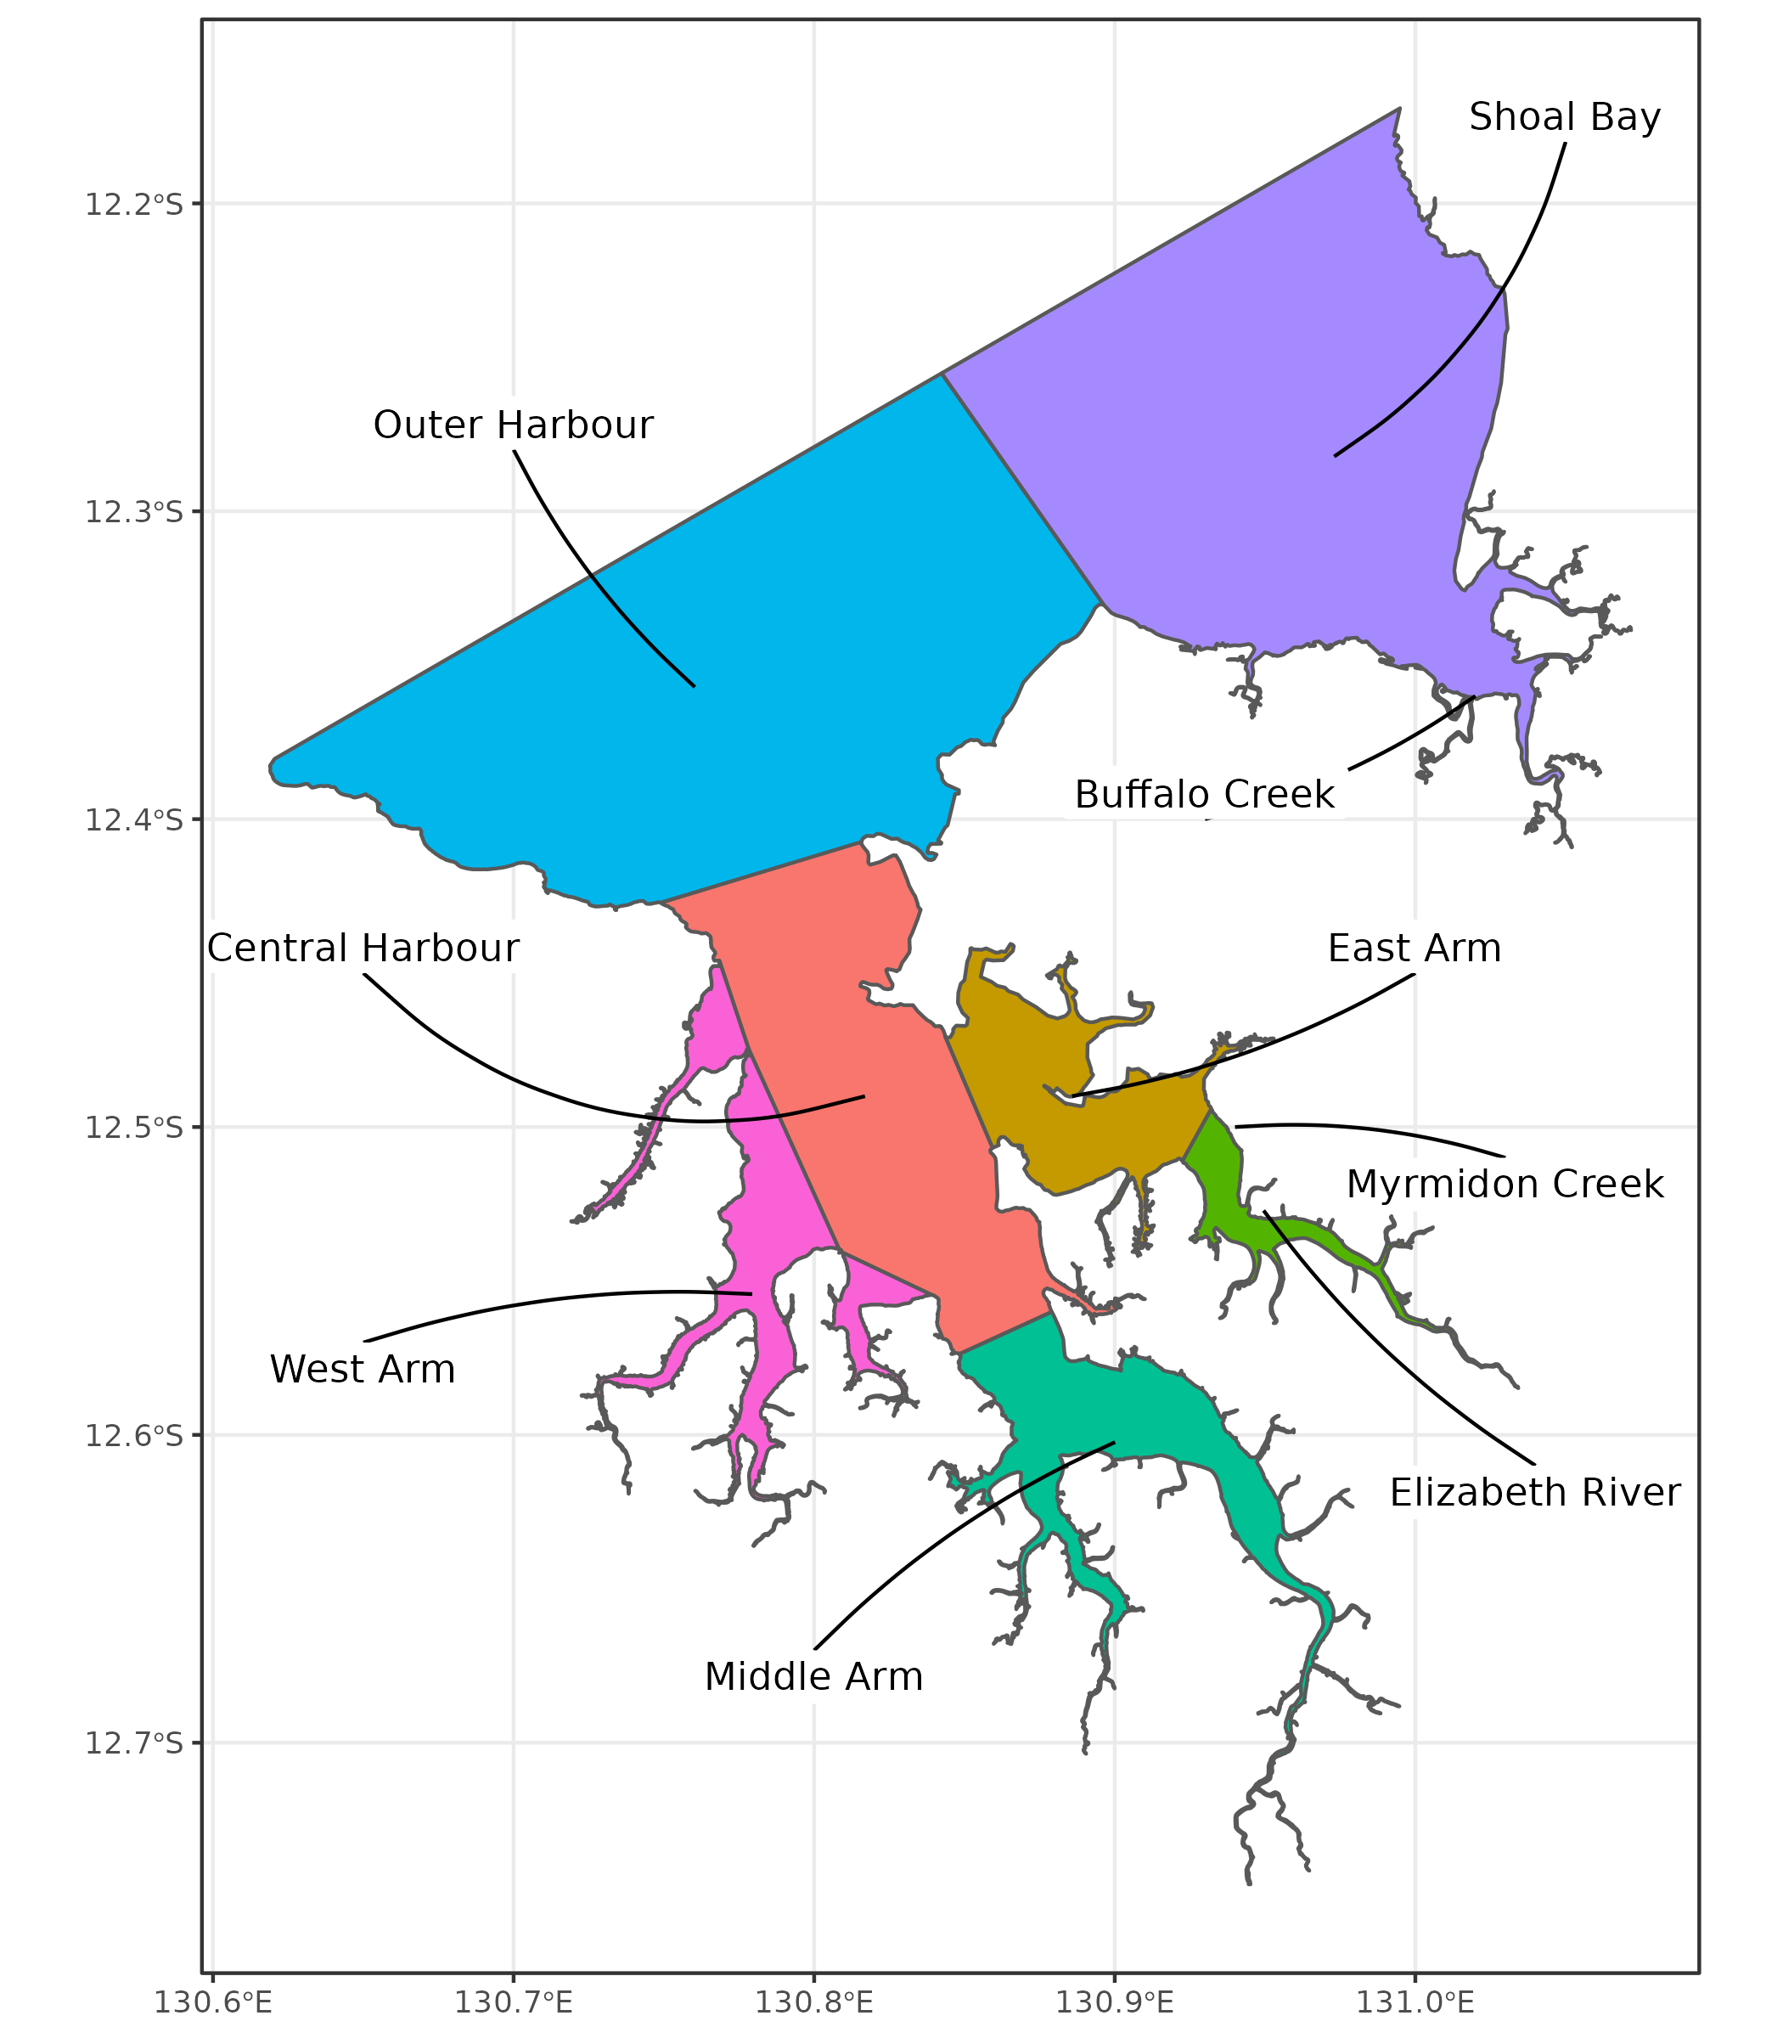

**Figure** **:** Map of Darwin Harbour illustrating the zones.

### Darwin Harbour sub-catchments

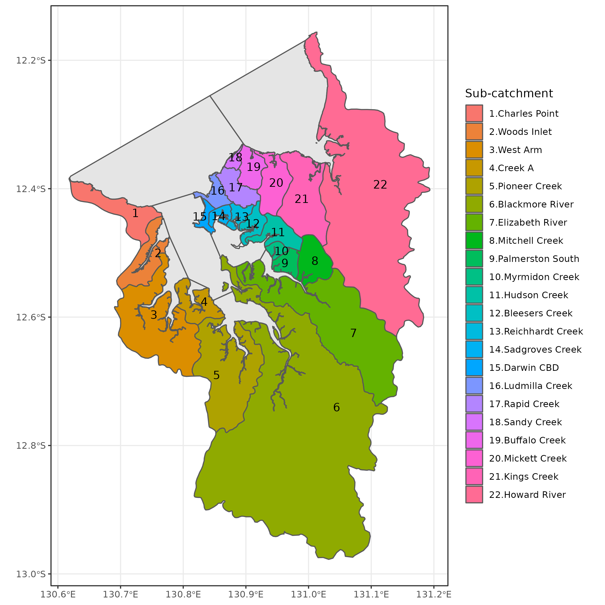

**Figure** **:** Map of Darwin Harbour illustrating the sub-catchments.

## Water Quality

### 2012-2015

After ingesting the supplied data, the following processing steps were applied in order to facilitate further analyses:

* standardise field names to be consistent with 2016-2022 data set
* only retain response variables that are common to both 2012-2015 and 2015-2022 data sets
* provide short names for response variables
* format date
* add spatial context

Figure provides a graphical overview of the spatio-temporal design of the 2012-2015 water quality data and figure illustrates the spatial sampling configuration during this sampling period.

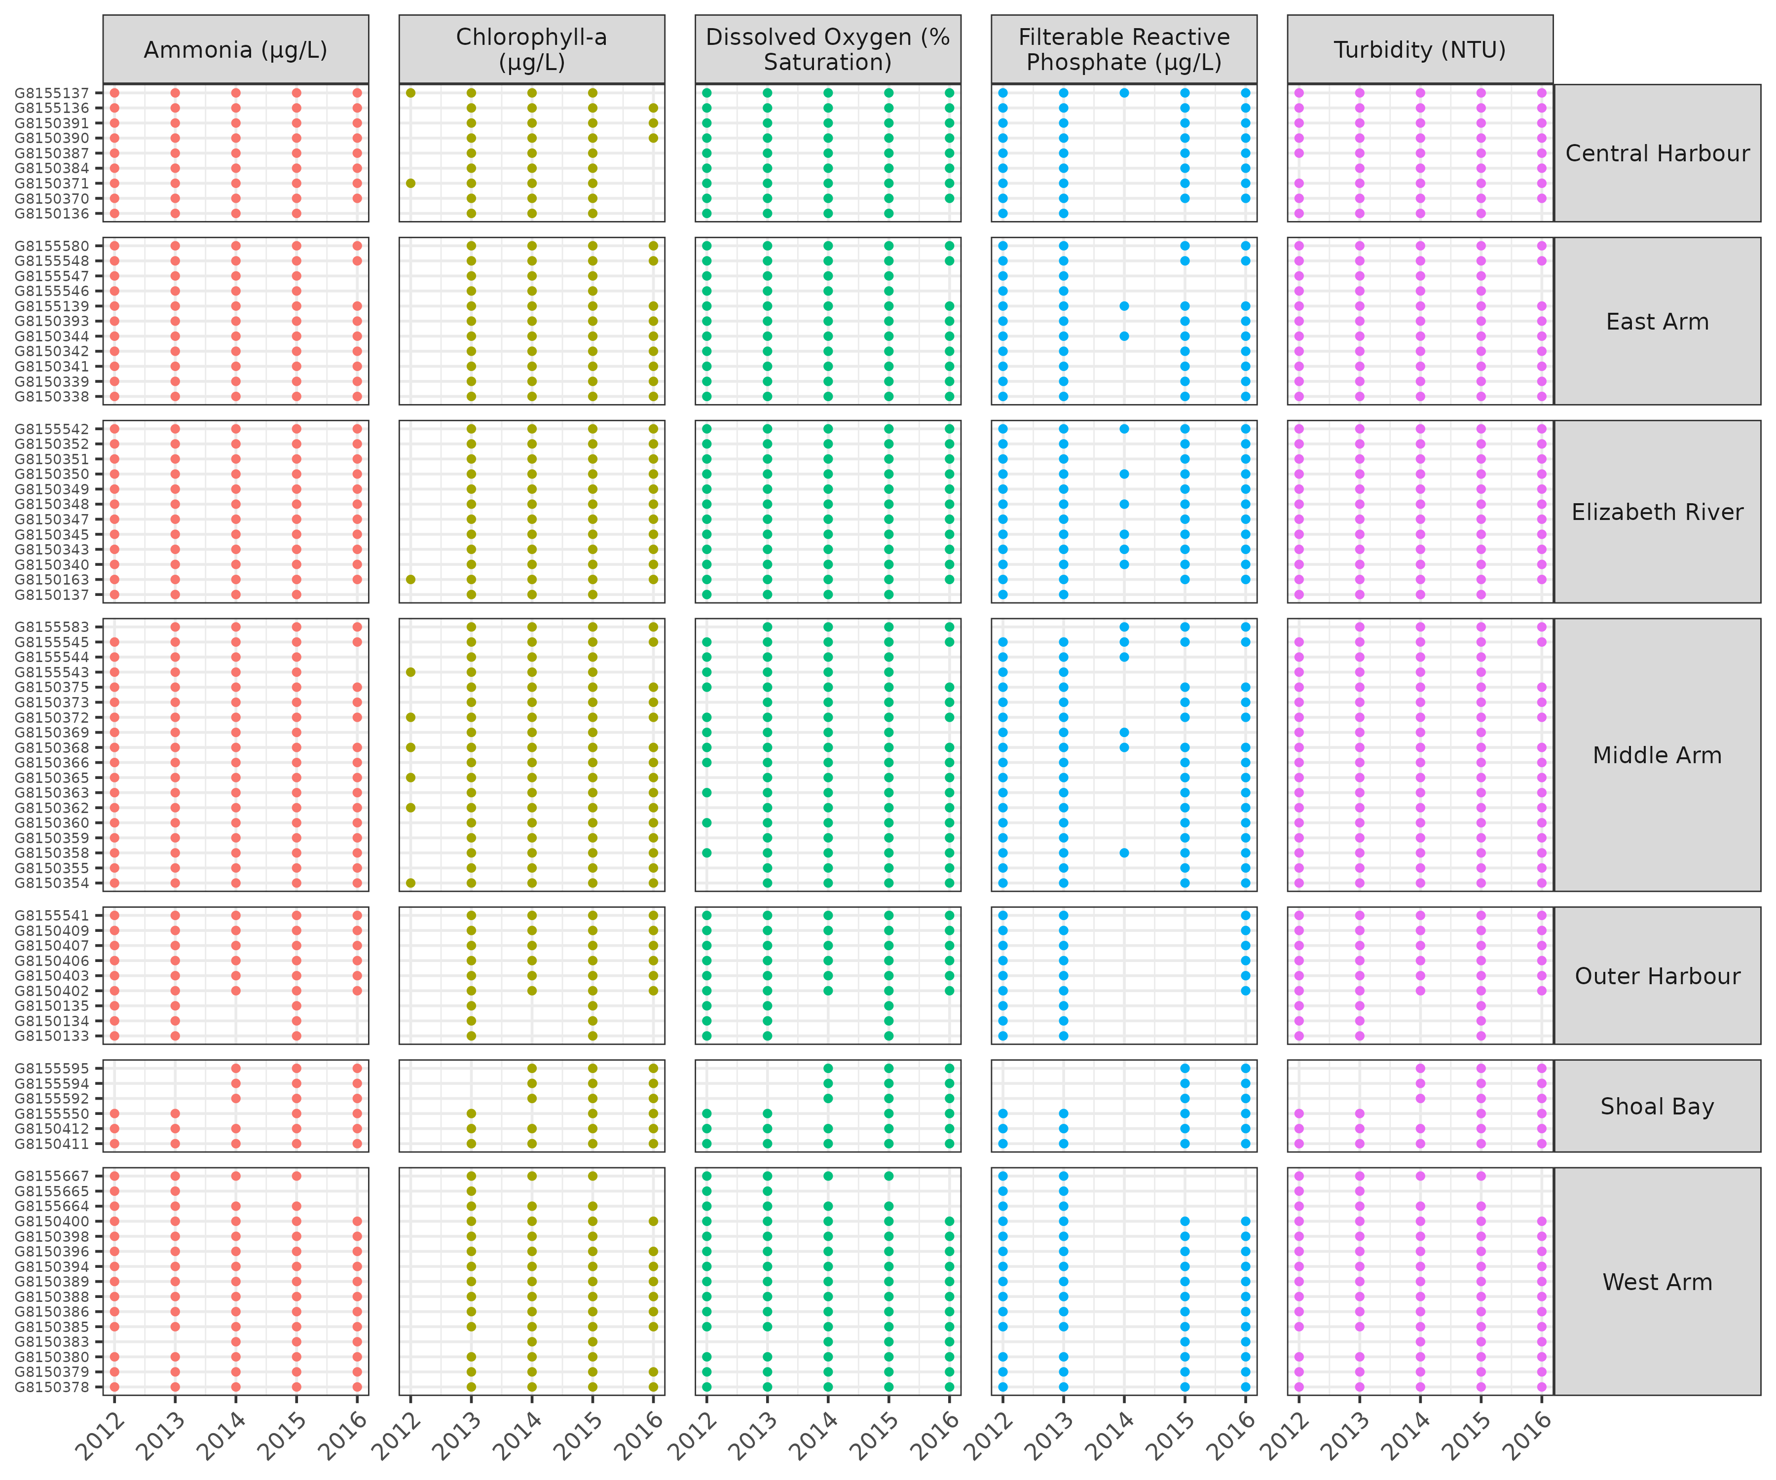

**Figure** **:** Broad spatio-temporal design of the observed water quality data. Solid dots indicate the presence of data.

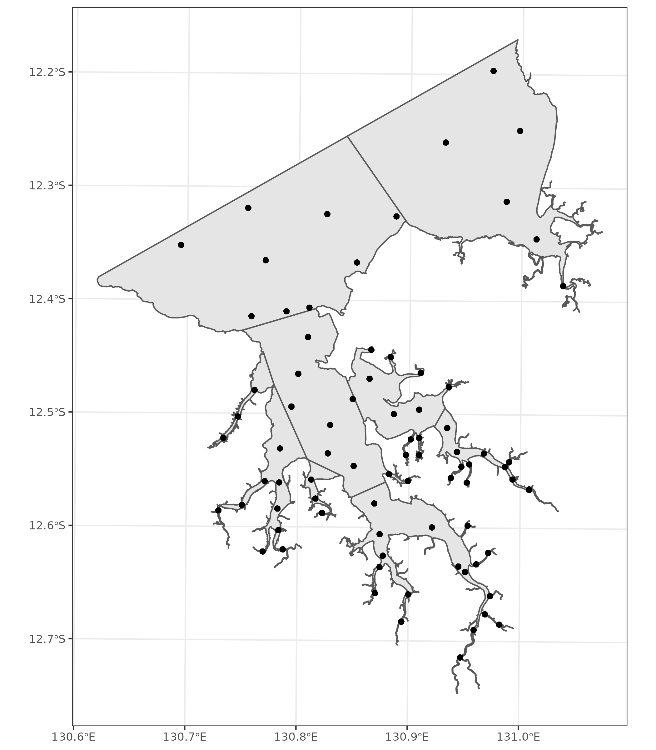

**Figure** **:** Spatial distribution of water quality sampling locations between 2012-2015.

### 2016-2022

The 2016-2022 data contain both Discrete and CFM (Continuous Flow Management) data. I am not sure that I understand the distinction. Initially I thought that Discrete data were collected via individual, manual grab samples at specific locations repeatedly on an annual schedule. However, given the very large number of Discrete samples in 2018, it is unlikely that this description is completely accurate.

Whilst the relatively small number of discrete sampling locations does mean that the estimates are biased towards the sampling locations (that is, they are not necessarily fully representative of the entire Zone from which they are collected), this design does make it easier to detect temporal trends (since the bias remains relatively constant over time) for a given sampling effort.

By contrast, CFM data are collected via a system that draws water samples at regular intervals, analyses them and couples the with a GPS for geocoding. These data are not necessarily replicated over time and thus, whilst potentially more spatially representative, if not replicated annually, the biases in estimates will fluctuate and potentially mask temporal trends.

Since the purpose of this study is to relate temporal trends in the pressures and stressors, it is more appropriate to work primarily with the discrete data.

To ready these data for analyses, the following processing steps were performed:

* attempt to correct the Latitude values that are stored as longitudes and vice verse.
* attempt to recode and “Discrete” Source values that have “CFM” SAMPTYPE as “Discrete”
* format date
* pivot longer according to the focal response variables
* provide short names for response variables
* to prevent issues of joining based on the spatial hierarchy inconsistencies (with Region), I will remove the Region field prior to join.
* provide spatial context

Figure is supposed to illustrate purely “Discrete” samples, however, it is clear that there are a large number of samples that are potentially continuous flow management (CFM) present in 2018.

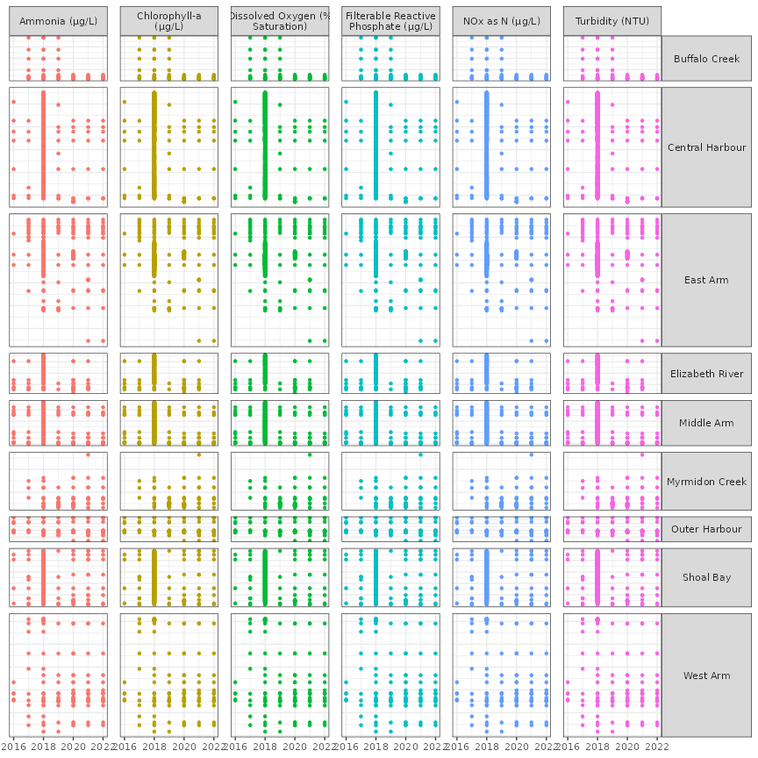

**Figure** **:** Broad spatio-temporal design of the 2016-2022 observed water quality data. Solid dots indicate the presence of data.

Similarly, figure shows the spatial configuration of sampling locations per year.

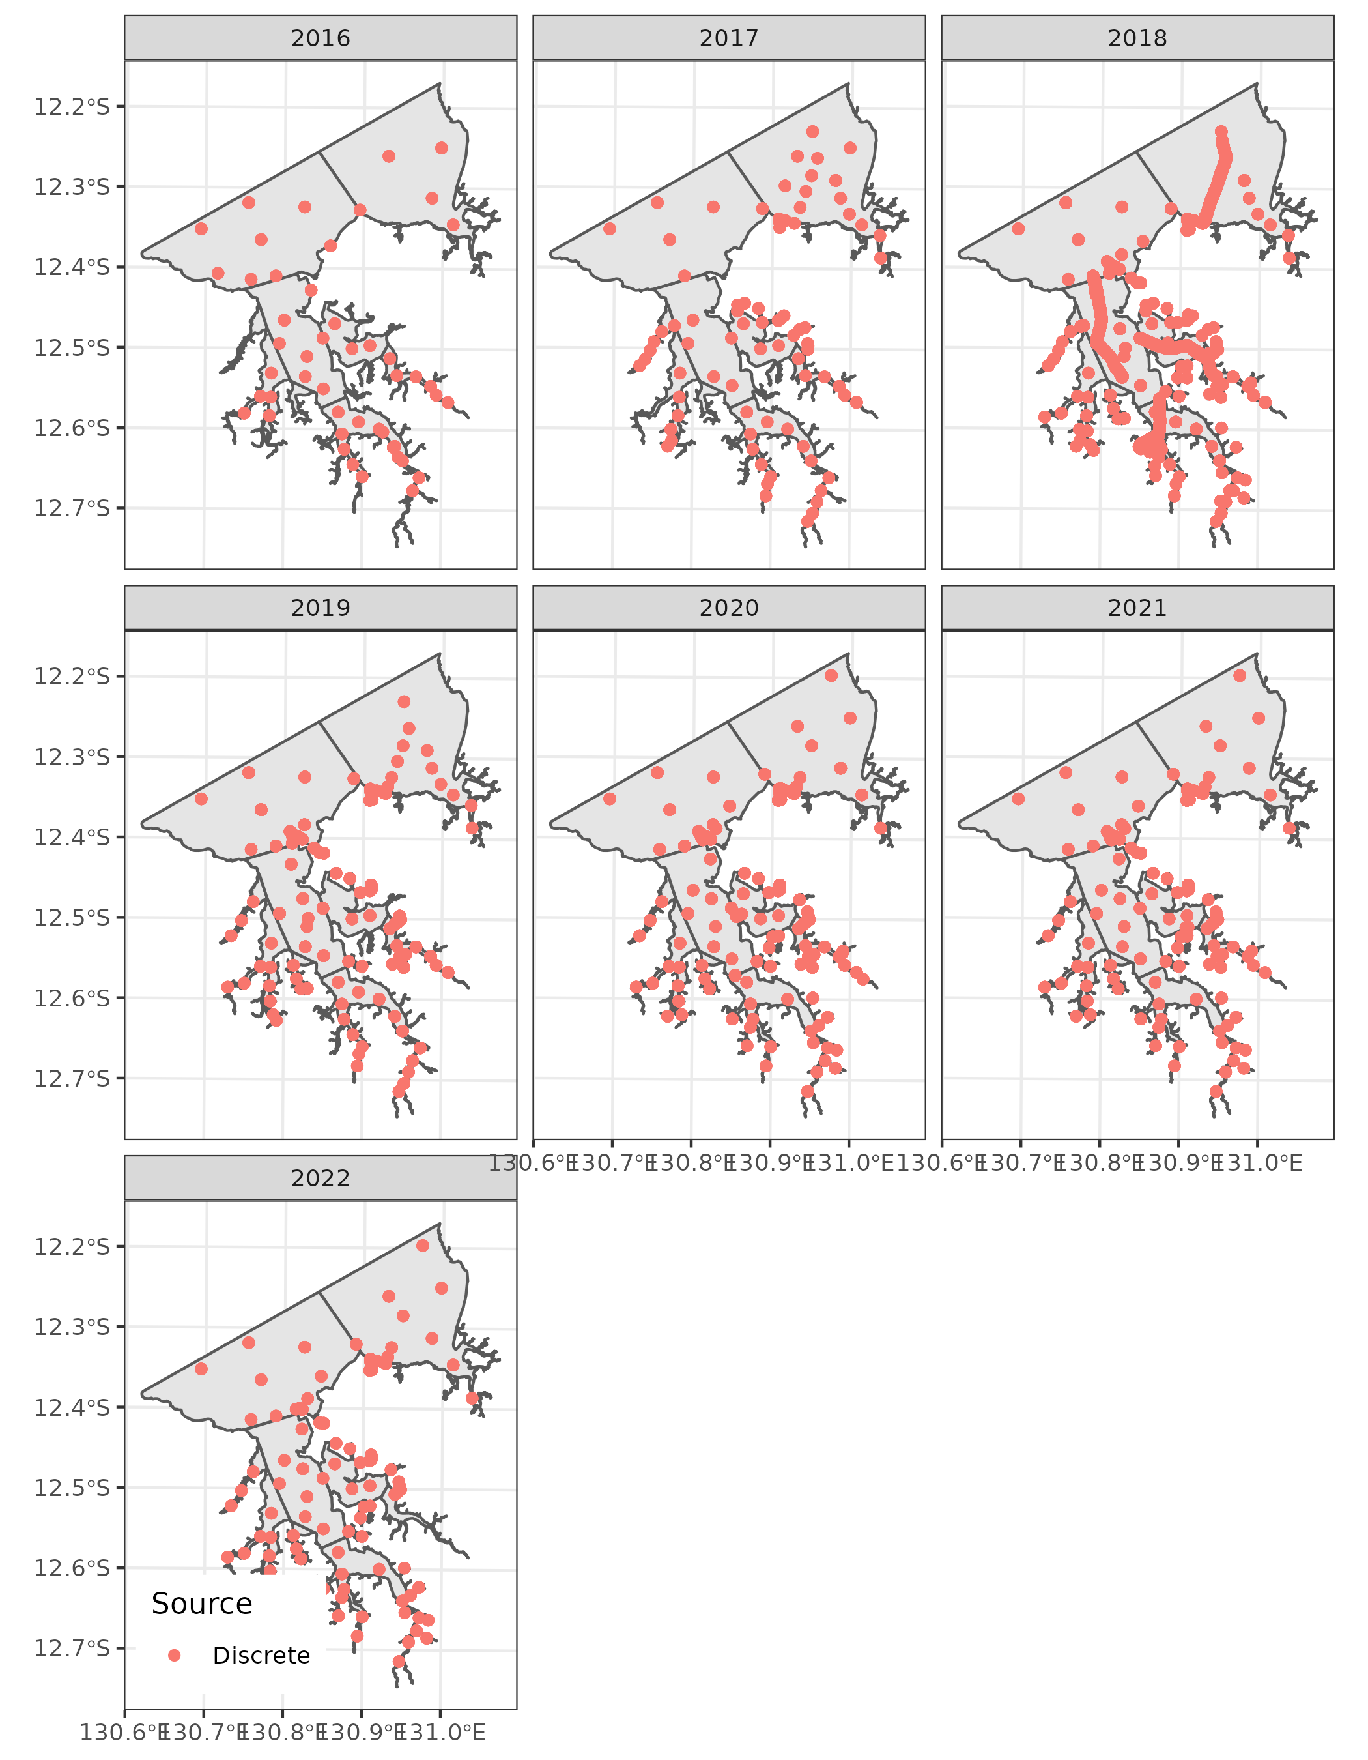

**Figure** **:** Spatio-temporal distribution of discrete sampling locations between 2016 and 2022.

Figure summarises the location of all samples, including the continuous flow management system (CFM) samples.

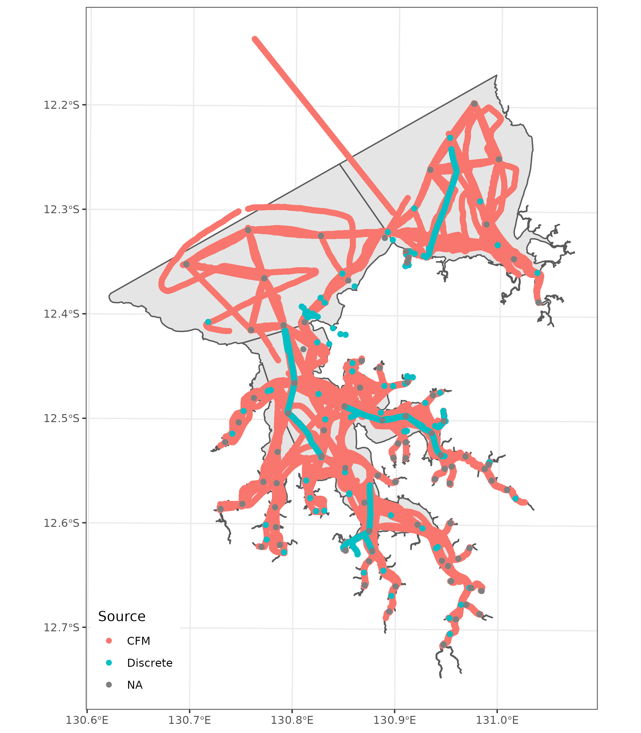

**Figure** **:** Spatio-temporal distribution of all sampling locations between 2016 and 2022.

### 2018 alterations

Figure illustrates the further curated data for 2018 that attempts to further distinguish the genuine discrete samples from other samples that may have been collected for differently purposes. These data are processed (prepared) identically to the 2016-2022 data. It is clear that these ‘discrete’ samples still do not always represent samples collected at discrete (and repeatedly sampled) stations.

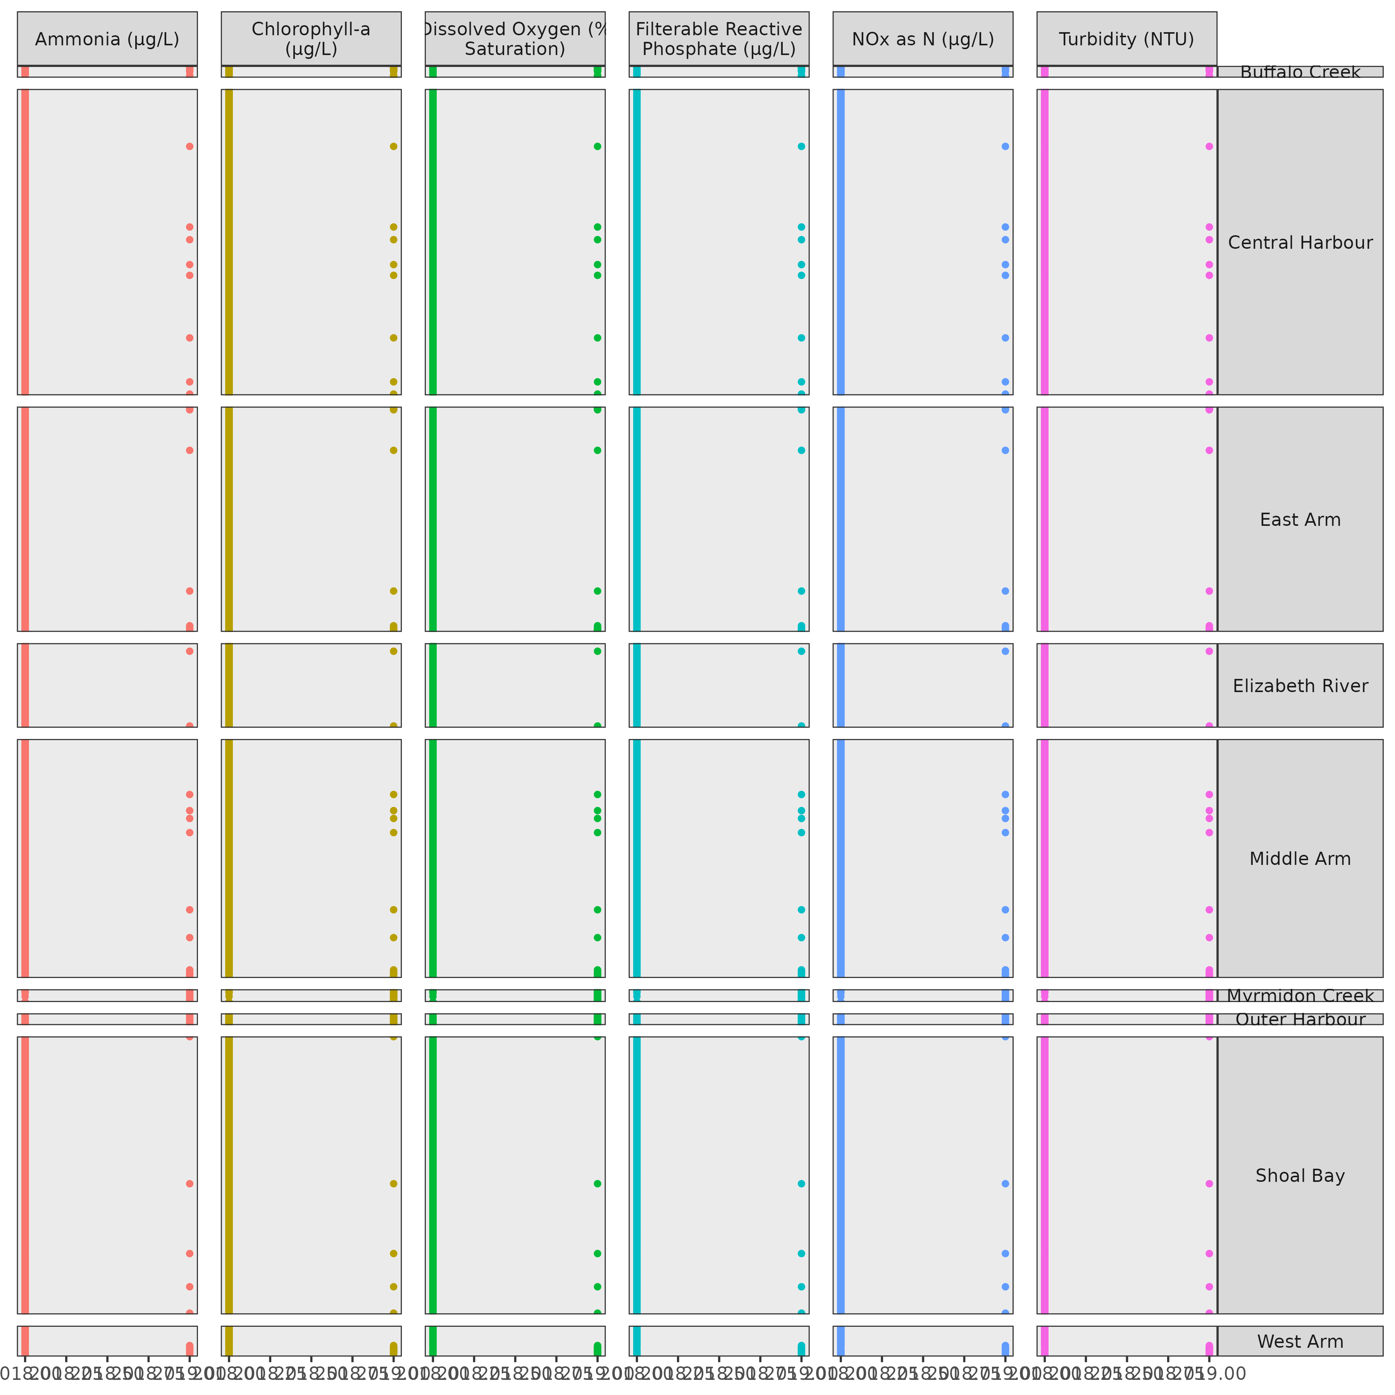

**Figure** **:** Broad spatio-temporal design of the observed 2018 water quality data. Solid dots indicate the presence of data.

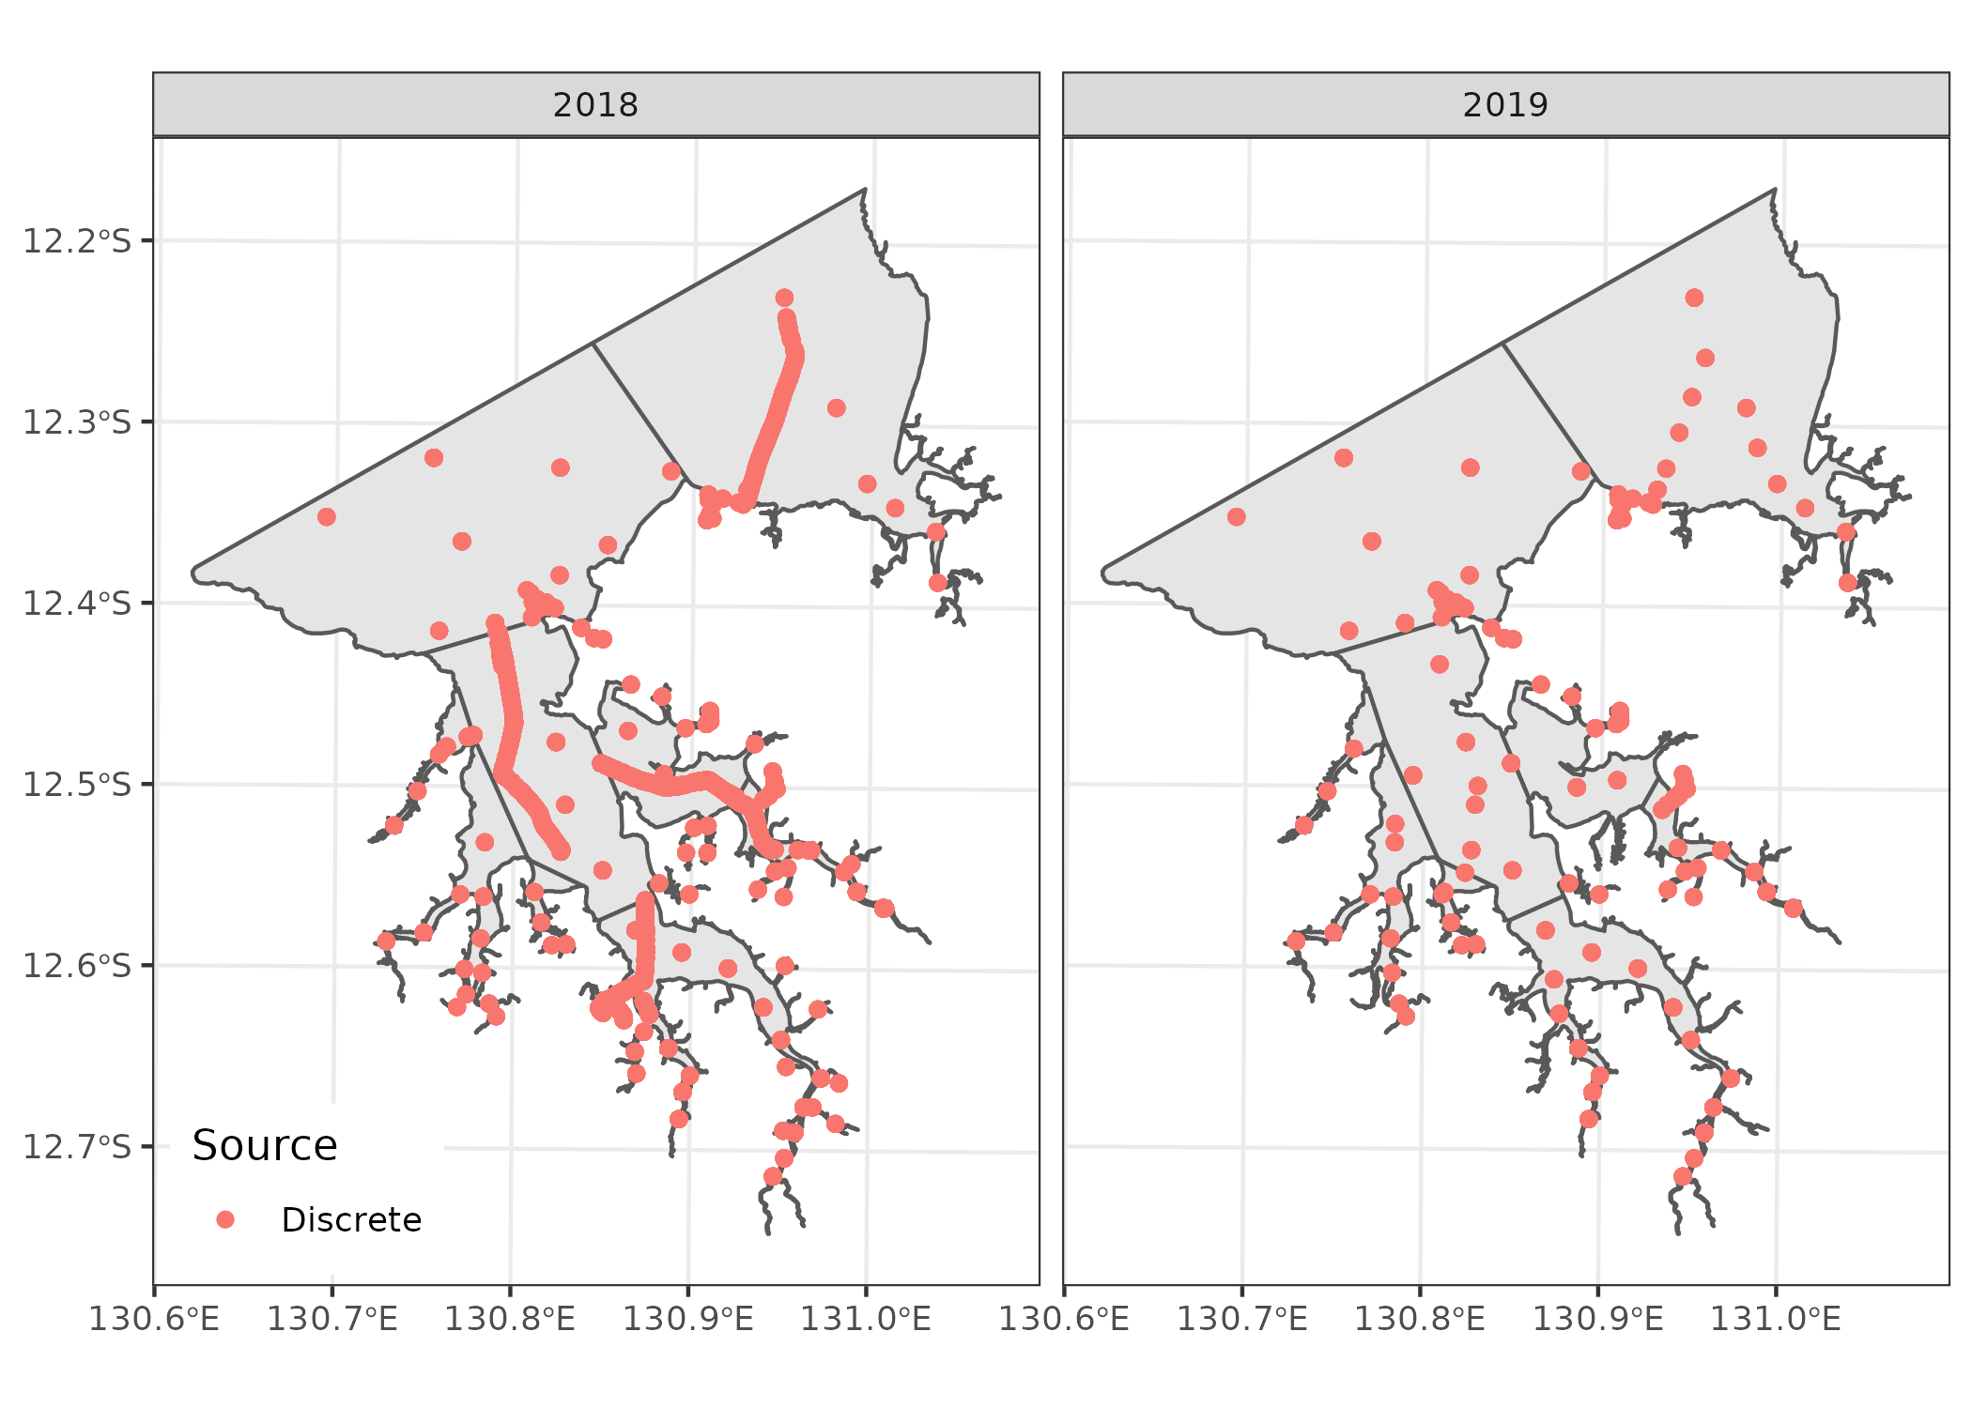

**Figure** **:** Spatio-temporal distribution of discrete sampling locations in 2018.

Figure summarises the location of all samples, including the continuous flow management system (CFM) samples.

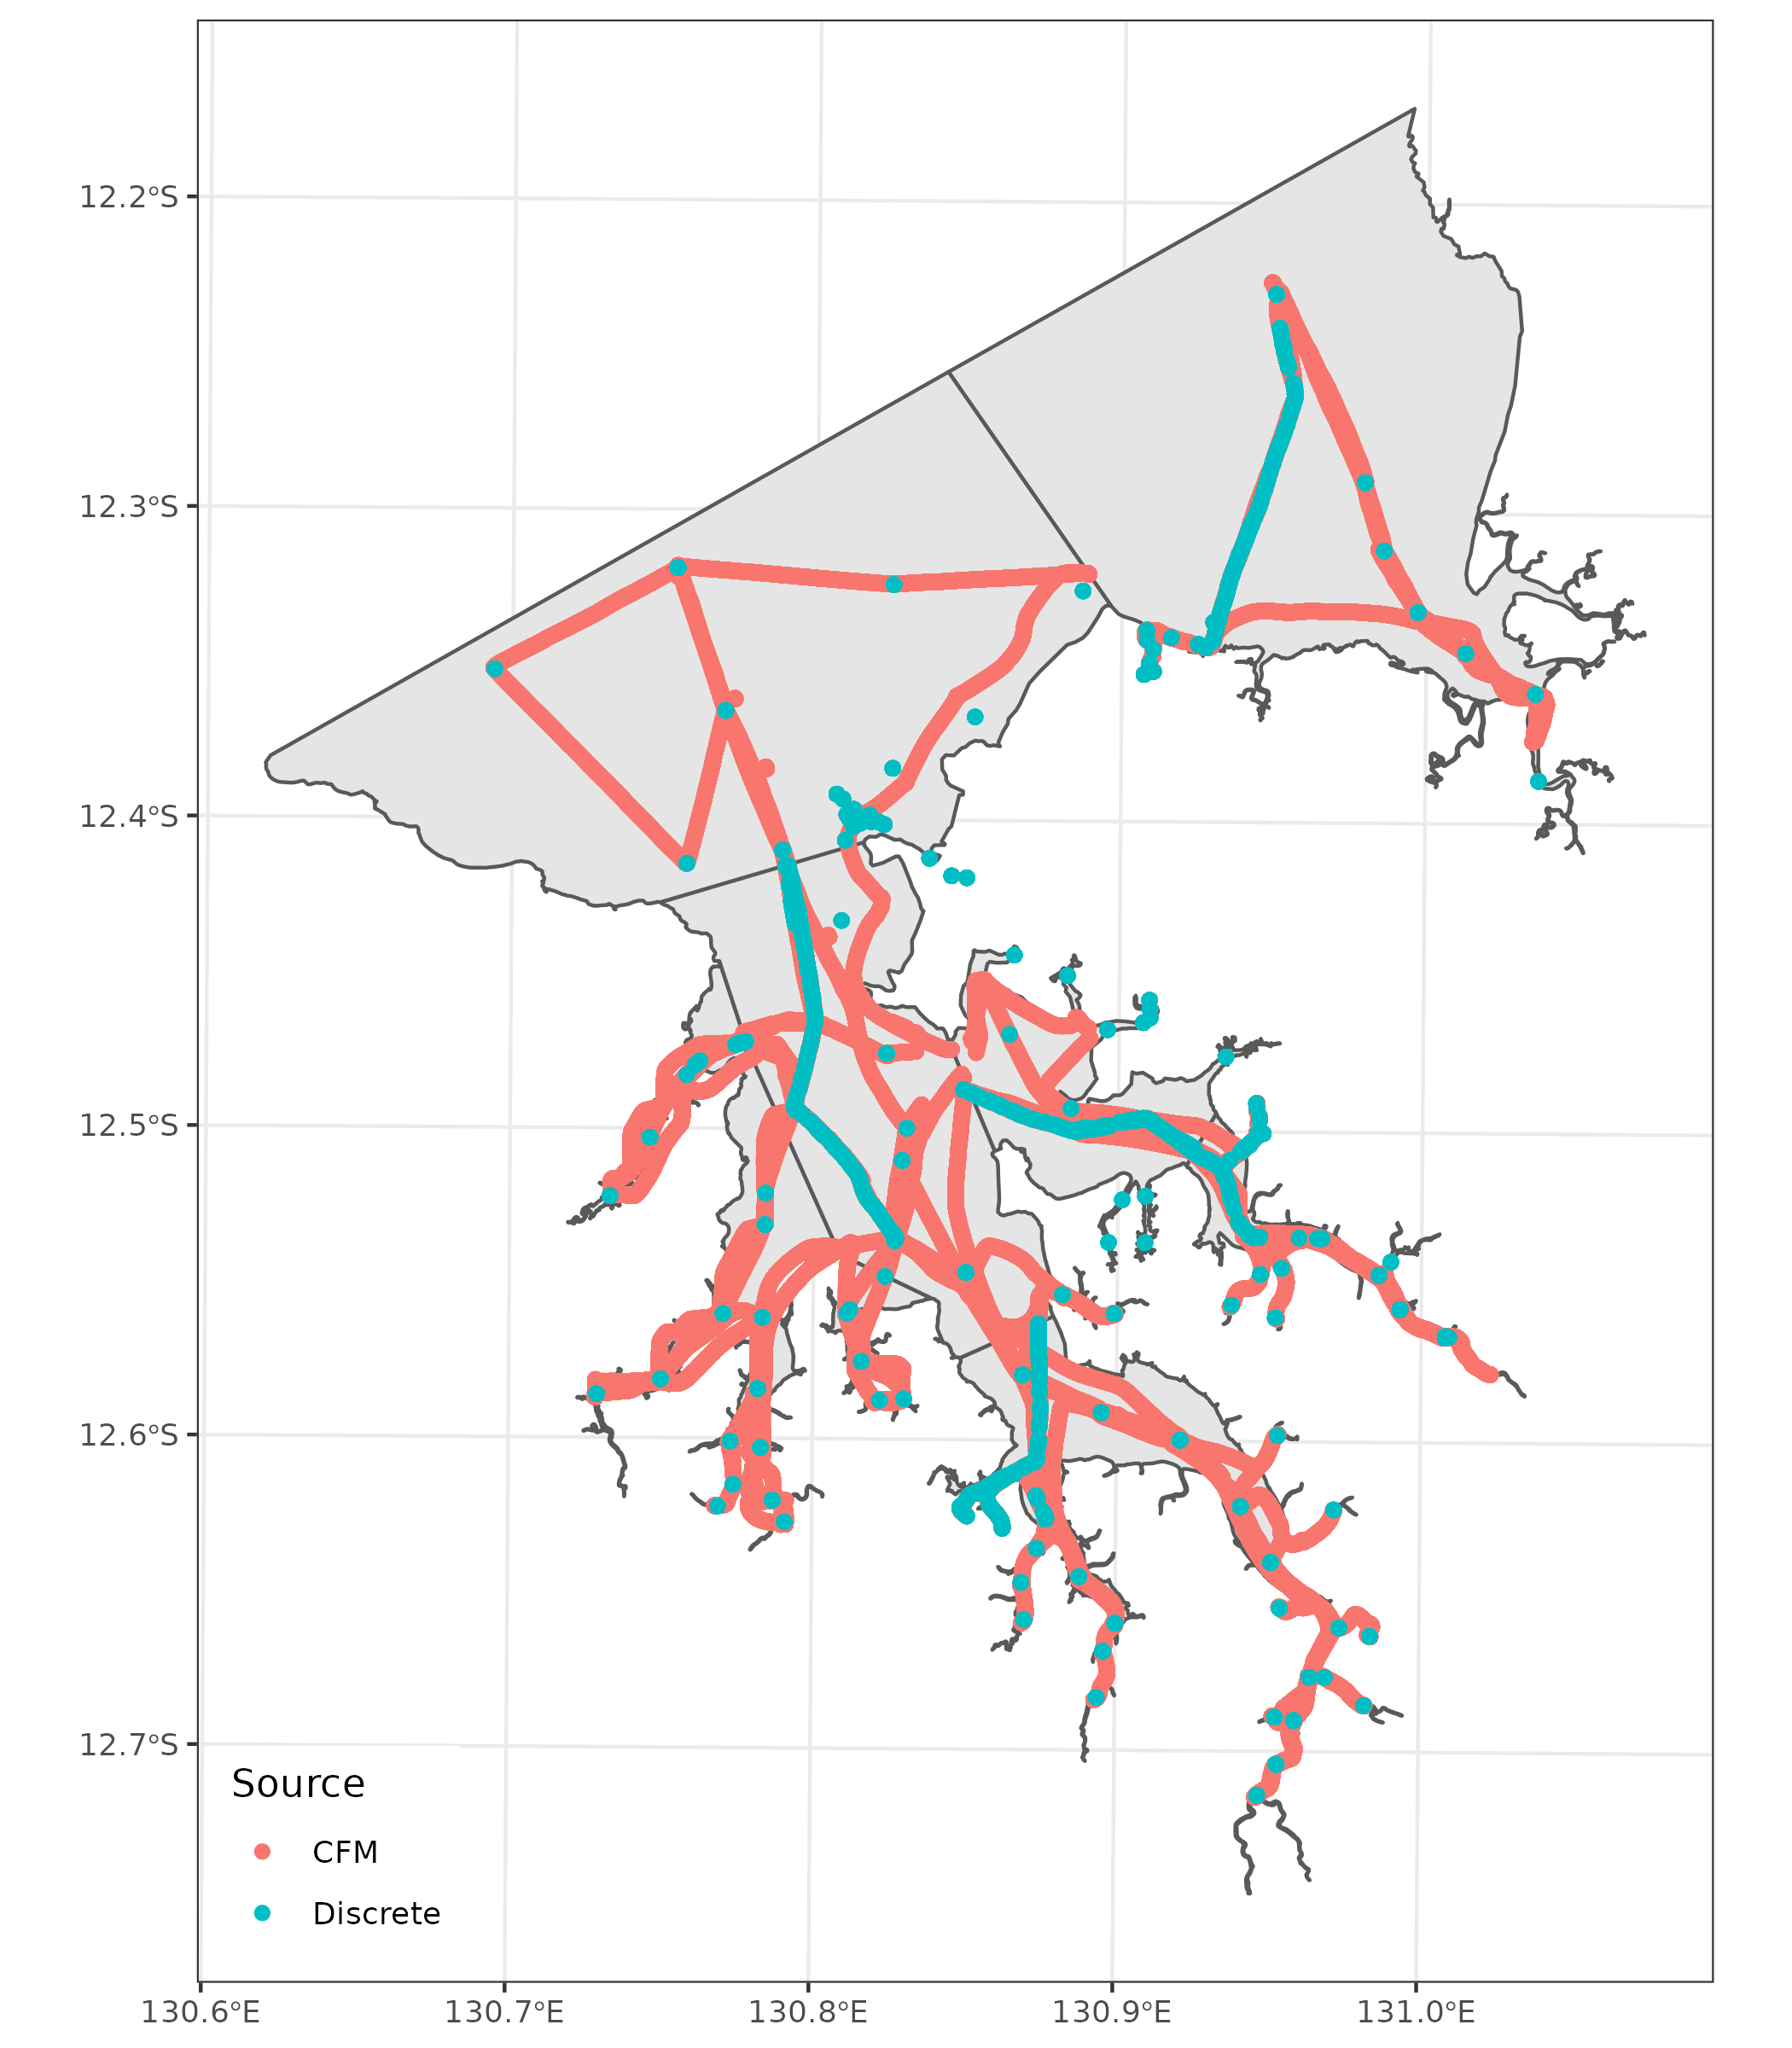

**Figure** **:** Spatio-temporal distribution of all sampling locations in 2018.

### Routine sites

To help identify samples that would be considered routine from those that are temporally unique (such as those collected via some sort of underway system, Julia Fortune has provided a list of the routine sites (along with there Lat/Longs). These routine sampling locations are featured in figure .

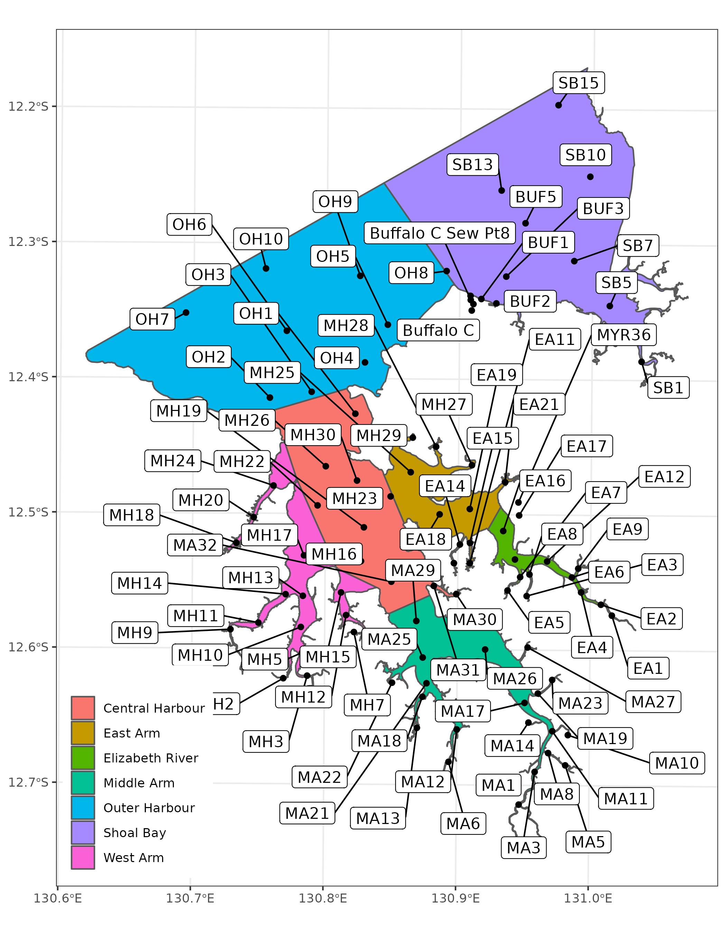

**Figure** **:** Spatio-temporal distribution of routine sampling locations.

### Combine data

Finally, each of the water quality data sets were combined to form a single data set spanning 2015 - 2022 and subsitituting in the alterative 2018 data. Furthermore, additional spatial information (such as Area, Region and Zone Names) were also applied.

Note, when pivoting, it was necessary to aggregate duplicates (means). There were instances in which there were multiple Values for the same response at the same time and location. For example, there are two Chlorophyll-a values (11.570 and 9.780) sampled on 07/07/2014 at location (131.0372, -12.38608). These records are on rows 80 and 2454 of the original 2014.csv input file.

#### Routine sites

Figures and illustrate the spatio-temporal design configuration of the routine water quality sampling sampling sites.

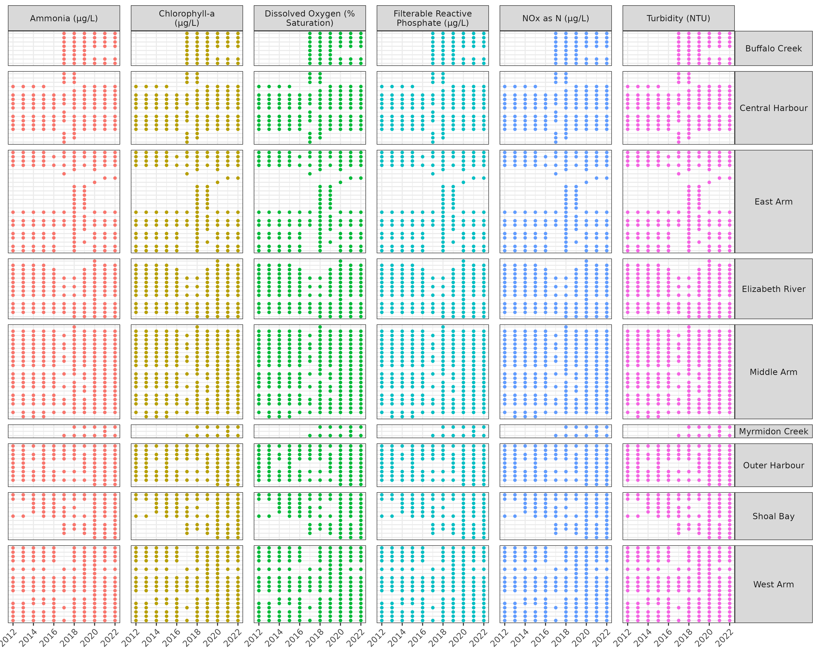

**Figure** **:** Broad spatio-temporal design of the routine observed water quality data. Solid dots indicate the presence of data.

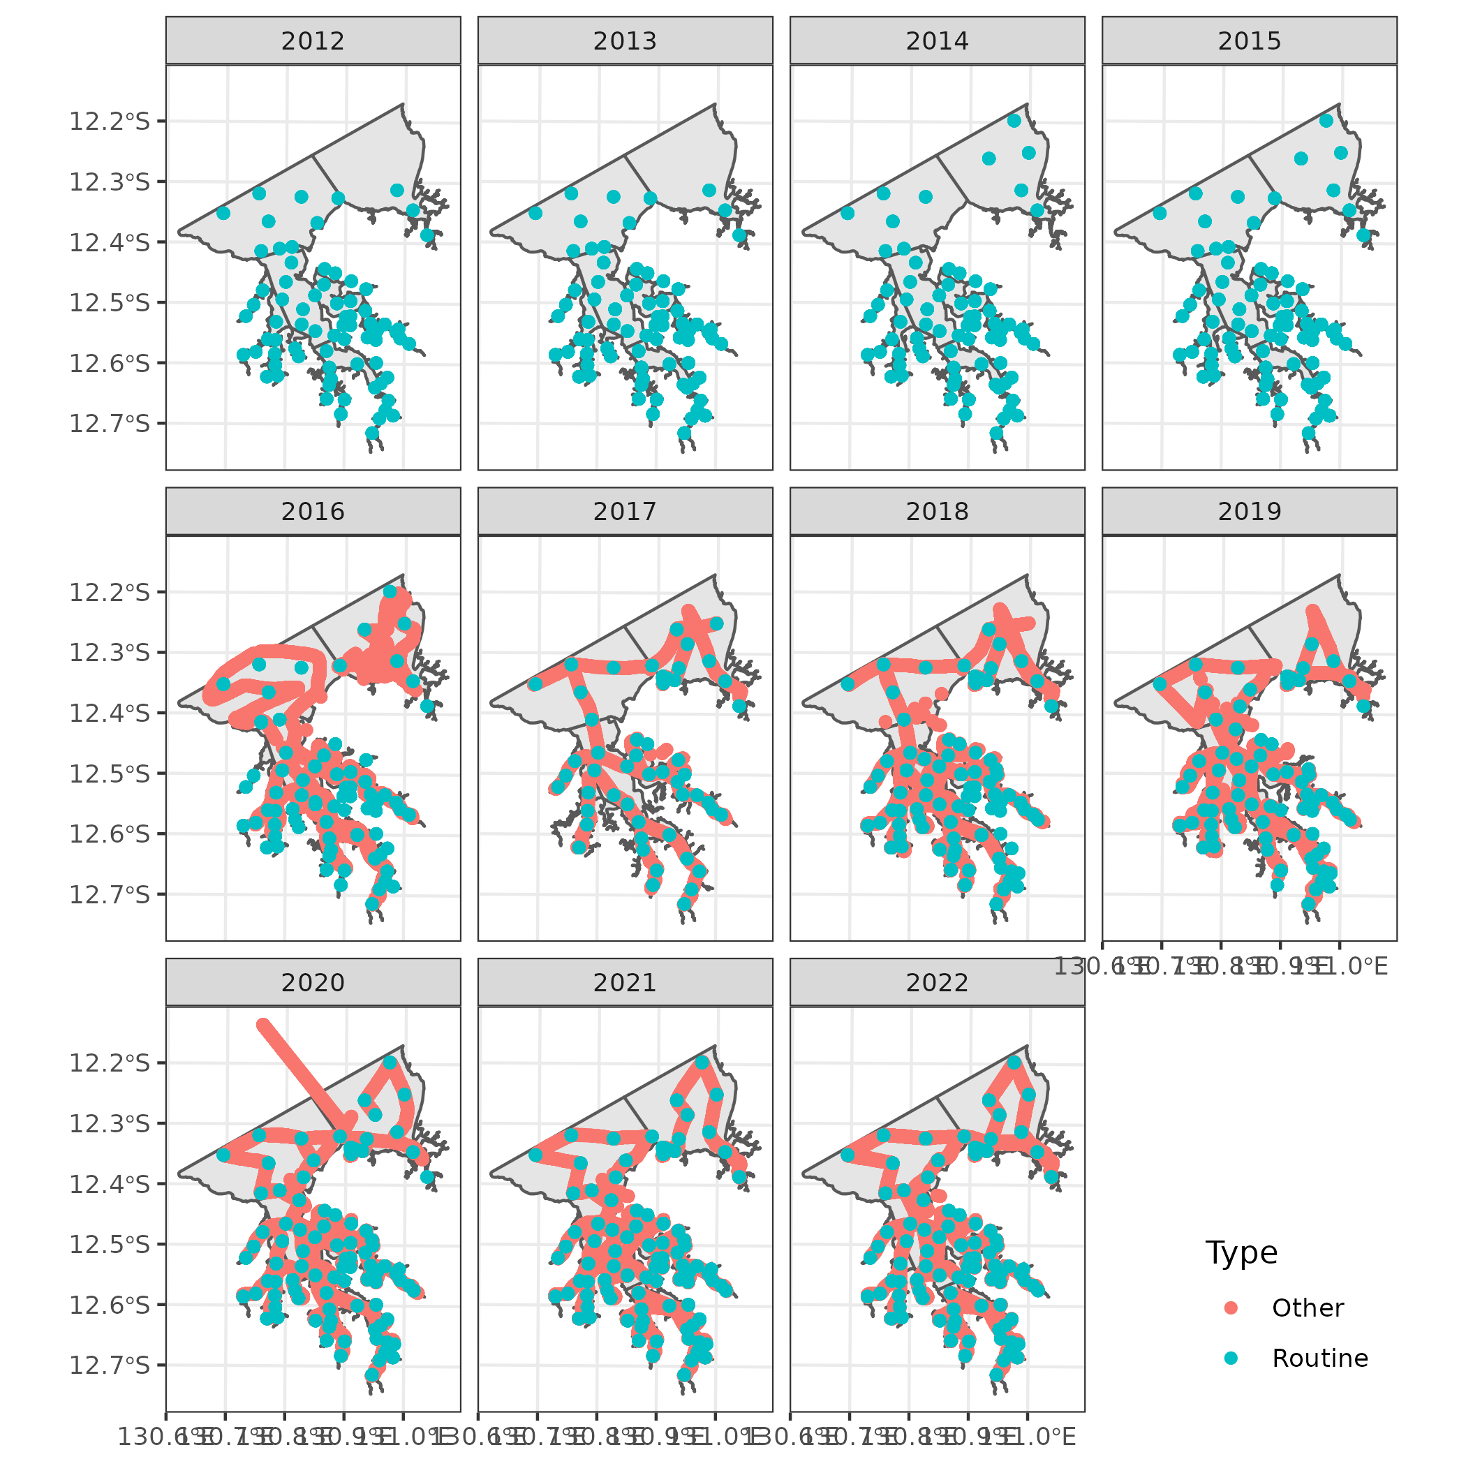

**Figure** **:** Spatio-temporal distribution of routine (and other) sampling locations between 2012 and 2022

#### Discrete samples

Figures and illustrate the spatio-temporal design configuration of the discrete water quality sampling sampling sites.

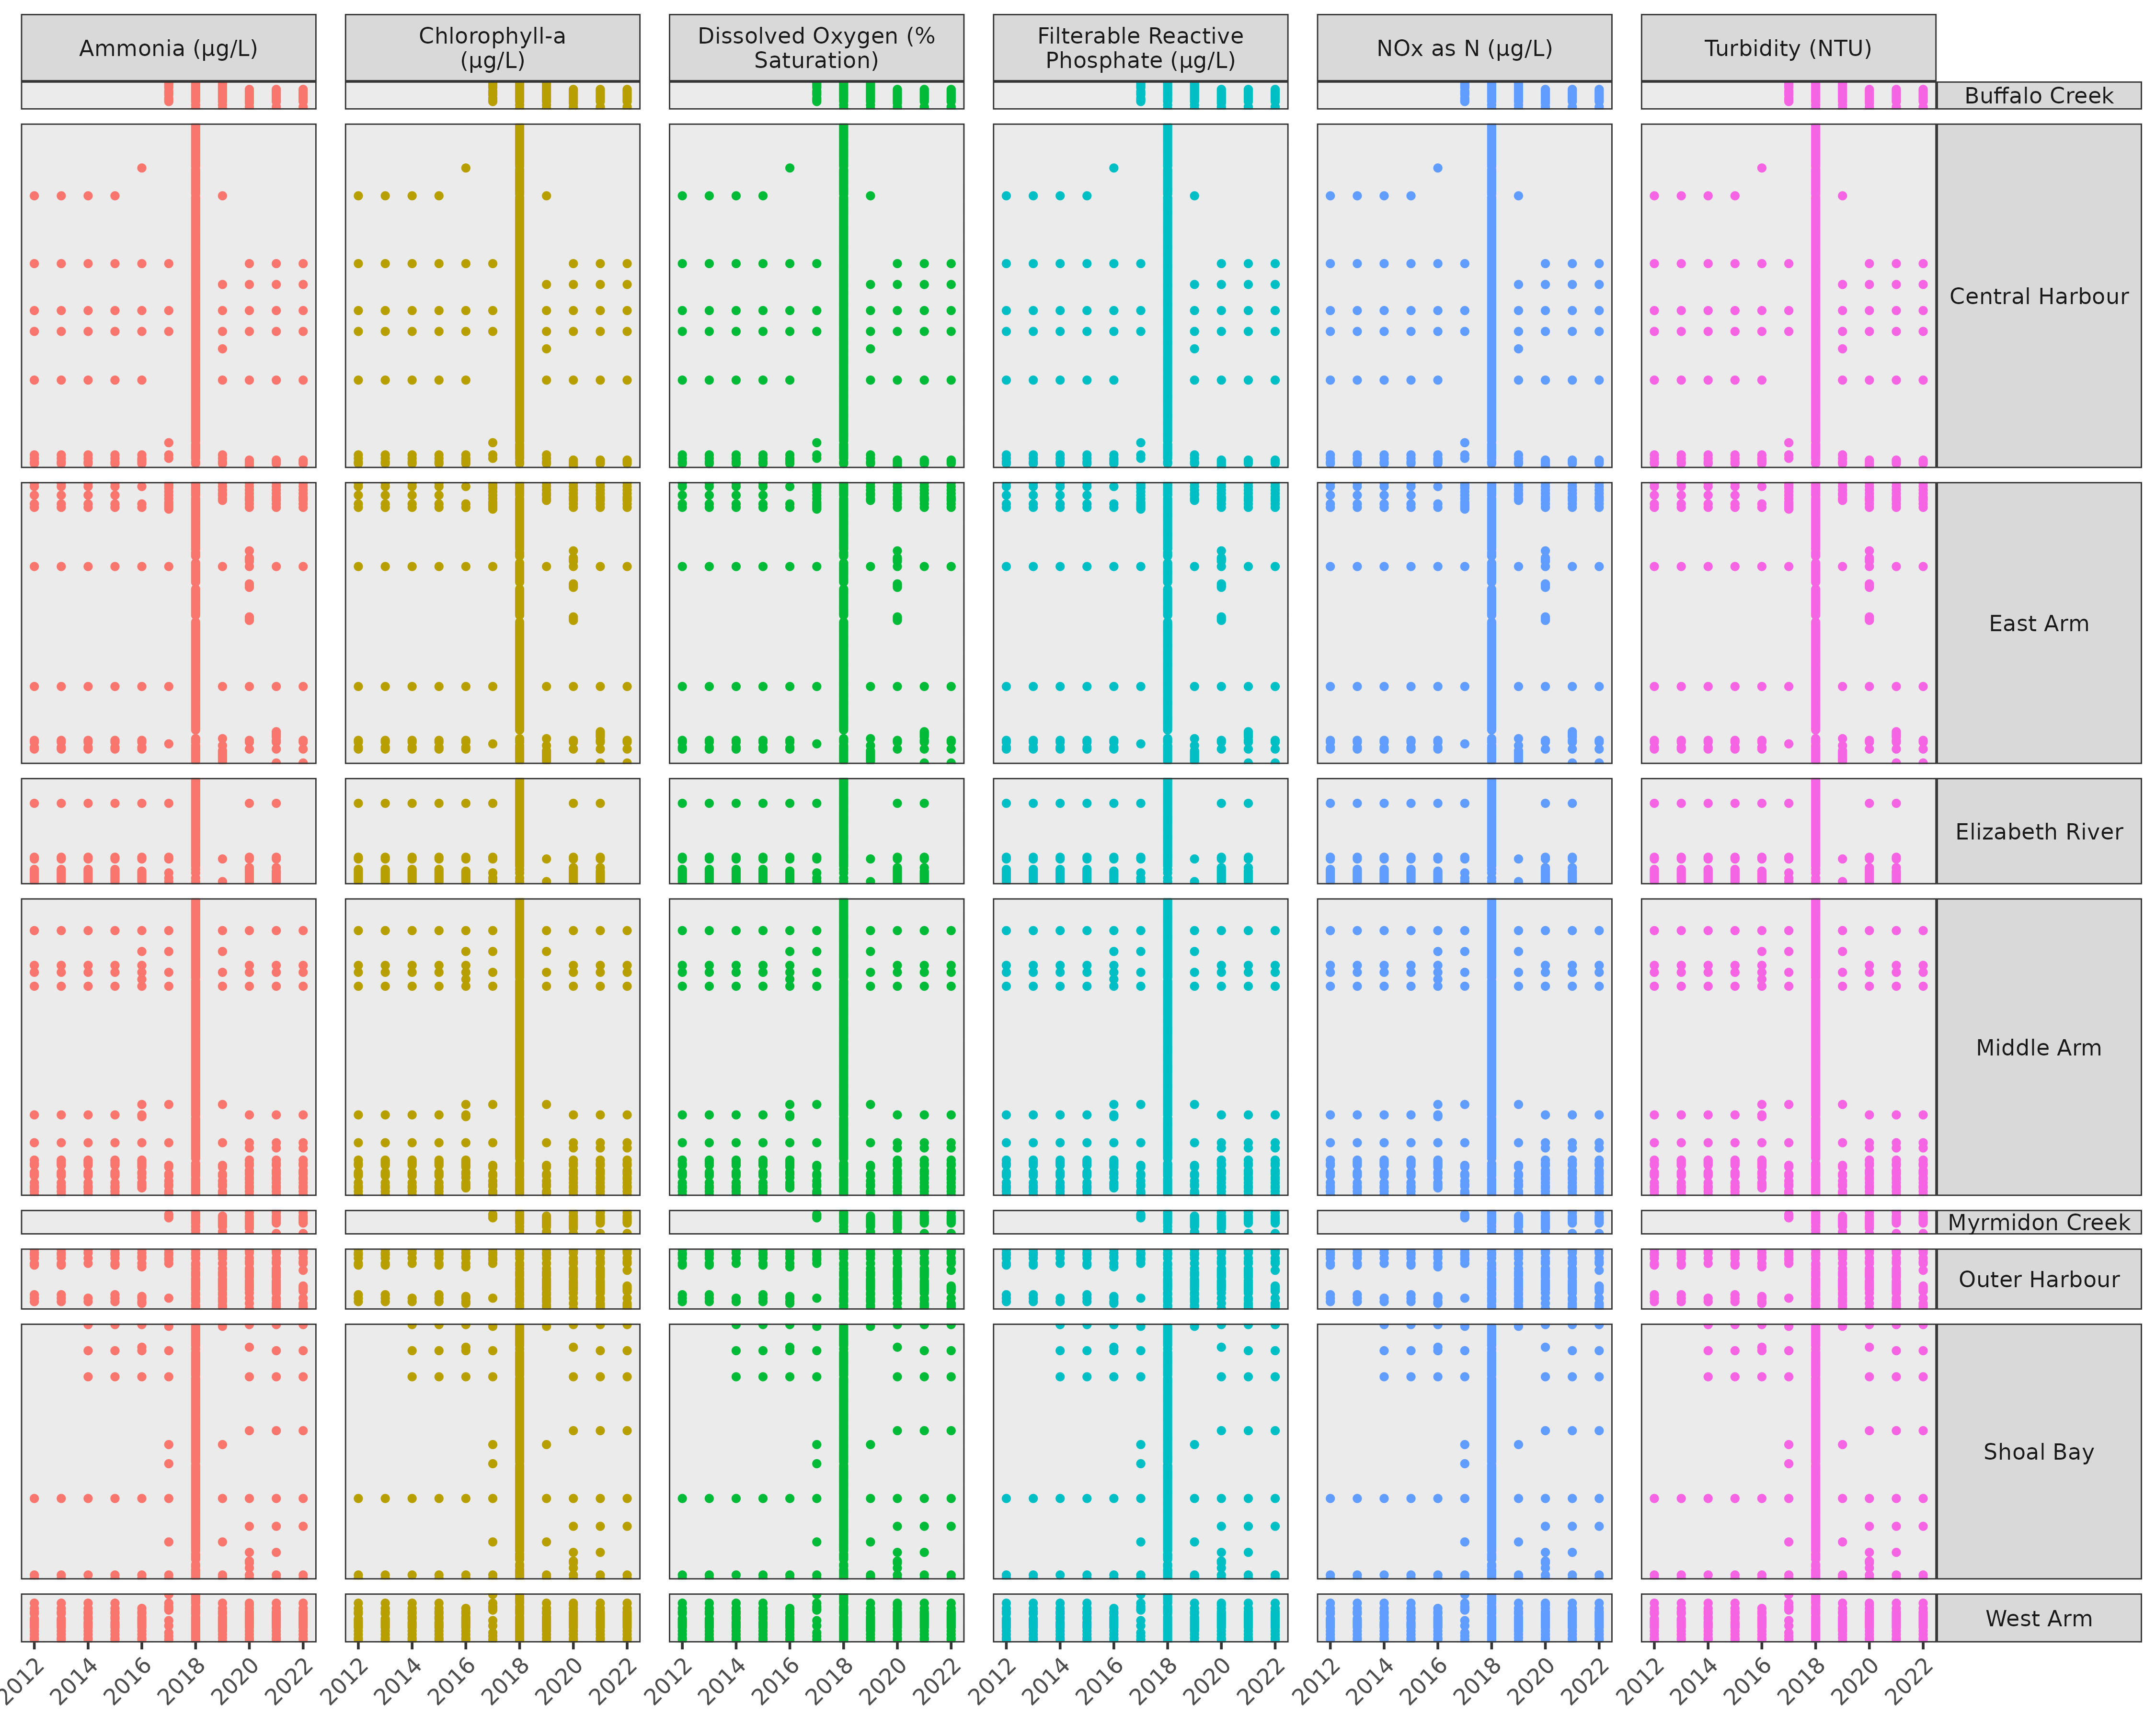

**Figure** **:** Broad spatio-temporal design of the discrete observed water quality data. Solid dots indicate the presence of data.

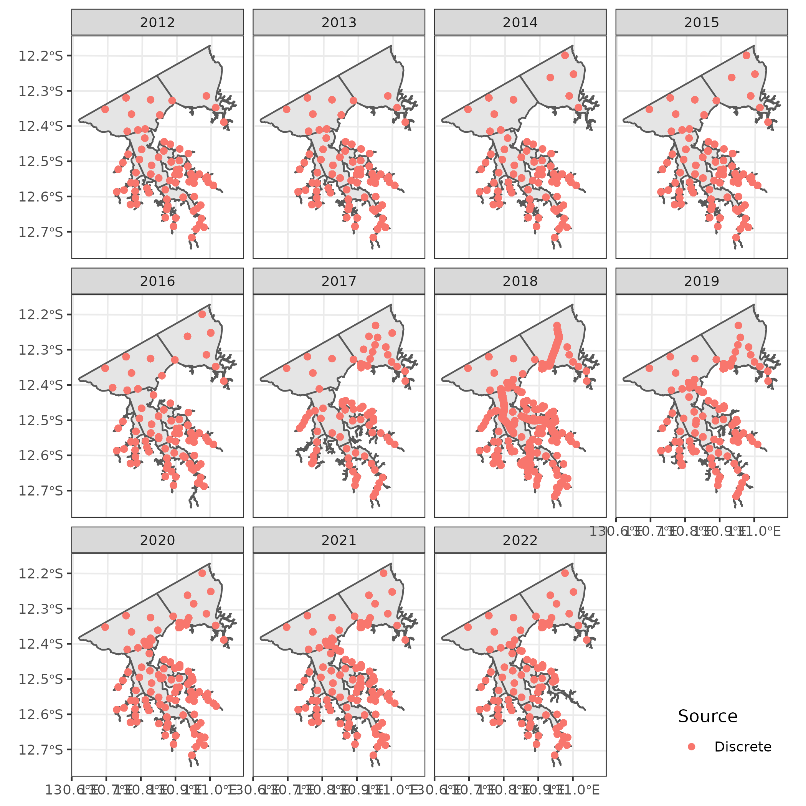

**Figure** **:** Spatio-temporal distribution of discrete sampling locations between 2012 and 2022

## Primary point data

The following data processing steps were applied in order to prepare the primary point data for analyses:

* correct spelling of Site of “Territory Generation DP1” to “Territory Generation ADP1”
* format date of year end
* there are duplicate values (multiple values collected on same date/site - these are all Waste Discharge Licence) - I will remove this category as it is not really a Parameter
* many of the fields in this dataset are superfluous or not fit for the current purpose (some because the fields are inconsistent). I will remove all but Site, Year, Load, Parameter, Latitude and Longitude.
* use a lookup table to fill in lat/longs that are missing in the data. The lookup table has lat/longs supplied via email by Lynda.
* provide spatial context (in the form of Catchement and ZoneName) by joining these data to sub-catchment spatial data.
* pivot wider so that Parameters are in new fields
* rename parameters so that they are easier to work with
* reorder the spatial data according to Catchment number

Additional problems that were corrected:

* there is at least one instance where Source of discharge differs for the same Site, Fin Year, Year ref, Lat/Long, Organisation - how is this possible. I am going to remove the “Source of discharge” field as this inconsistency is problematic.
* Financial year end and Year ref. are not consistent with Financial year end - see example rows 282:285 of Primary Point Source Dataset_22.xlsx. I am going to remove Financial year end

The spatio-temporal design of the primary point data are illustrated in figures and

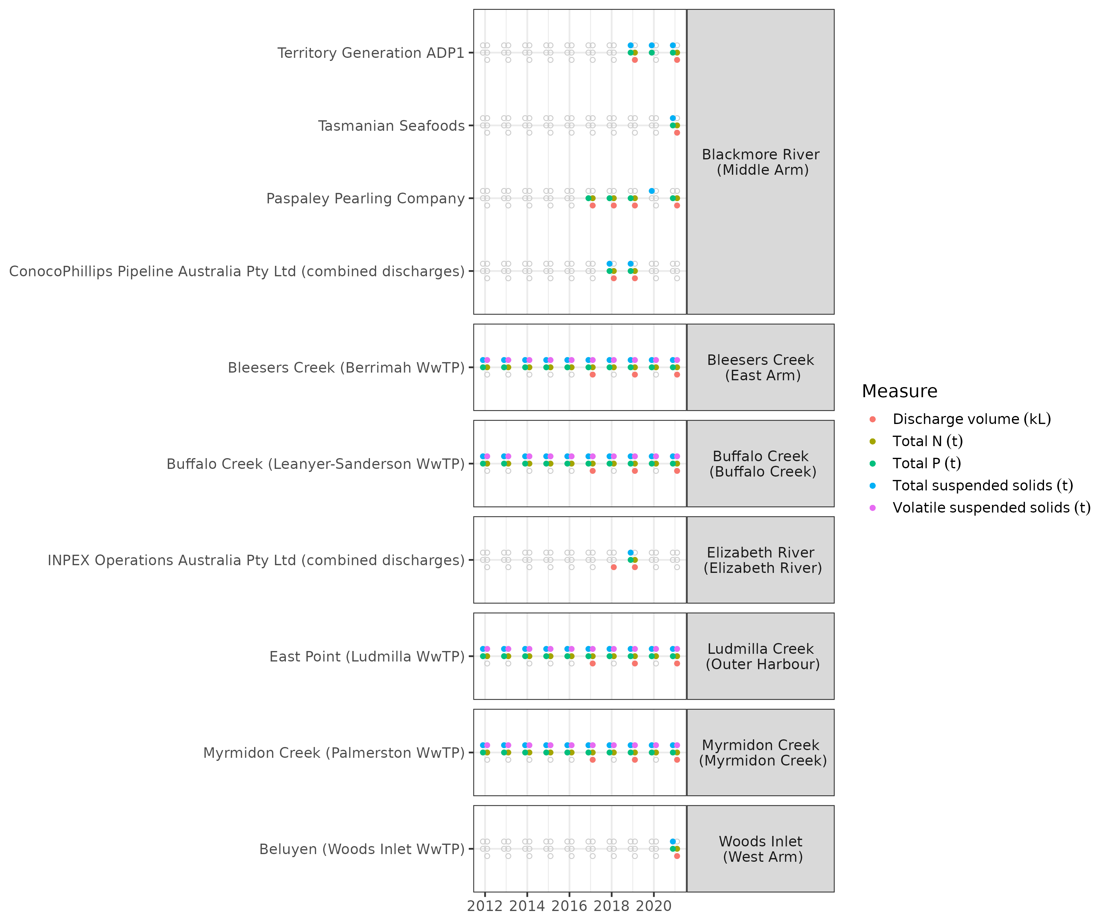

**Figure** **:** Broad spatio-temporal design of the observed primary point. Solid dots indicate the presence of data.

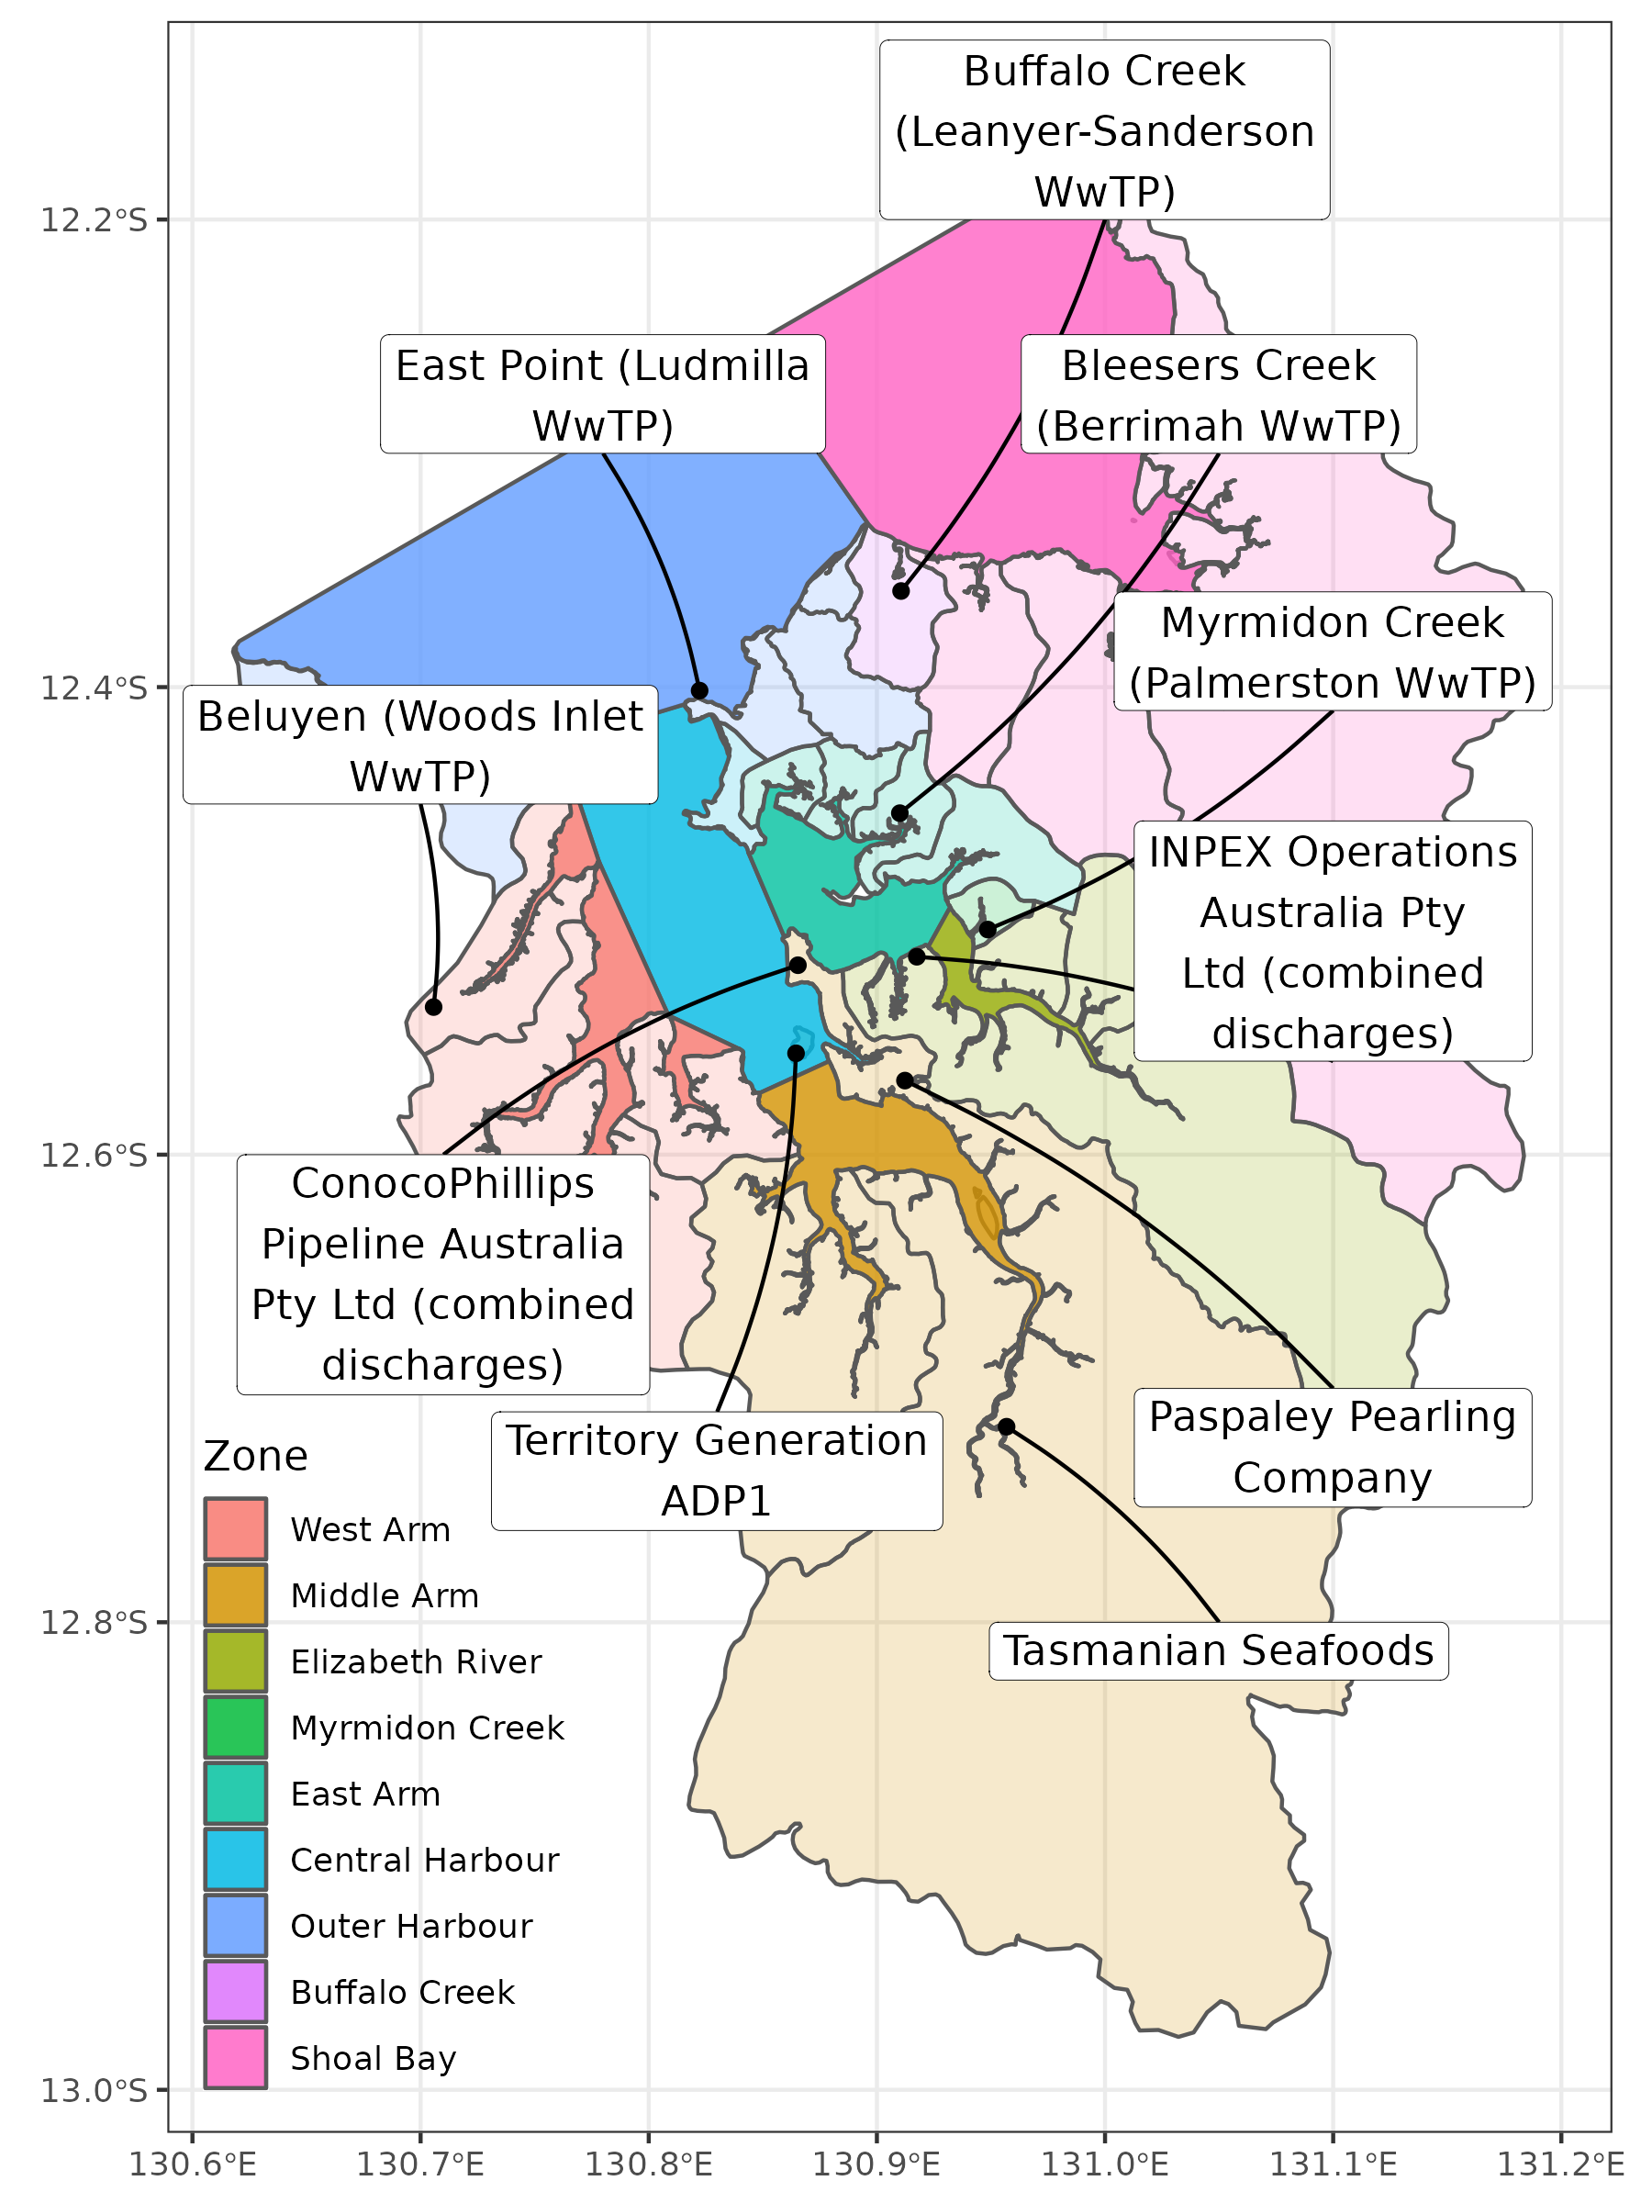

**Figure** **:** Spatial distribution of primary point sampling locations

## Estimated resident population (ERP) and gross regional product (GRP)

These data required no data processing except for renaming the parameters to make them a little more easy to work with. Furthermore, these data do not have any spatial context, and thus will be applied at the whole of harbour level.

## Catchment ERP

These data required the following data processing steps:

* remove the row sums
* replace - characters with NA
* ensure that all variables that begin with a four digit year are considered numeric
* pivot longer so that the main predictors are in a single column
* remove any rows with Value of NA
* separete the column into Year and Predictor
* pivot wider according to Predictor
* rename parameters so that they are easier to work with

The spatio-temporal design of the catchment estimated resident population data are illustrated in figures .

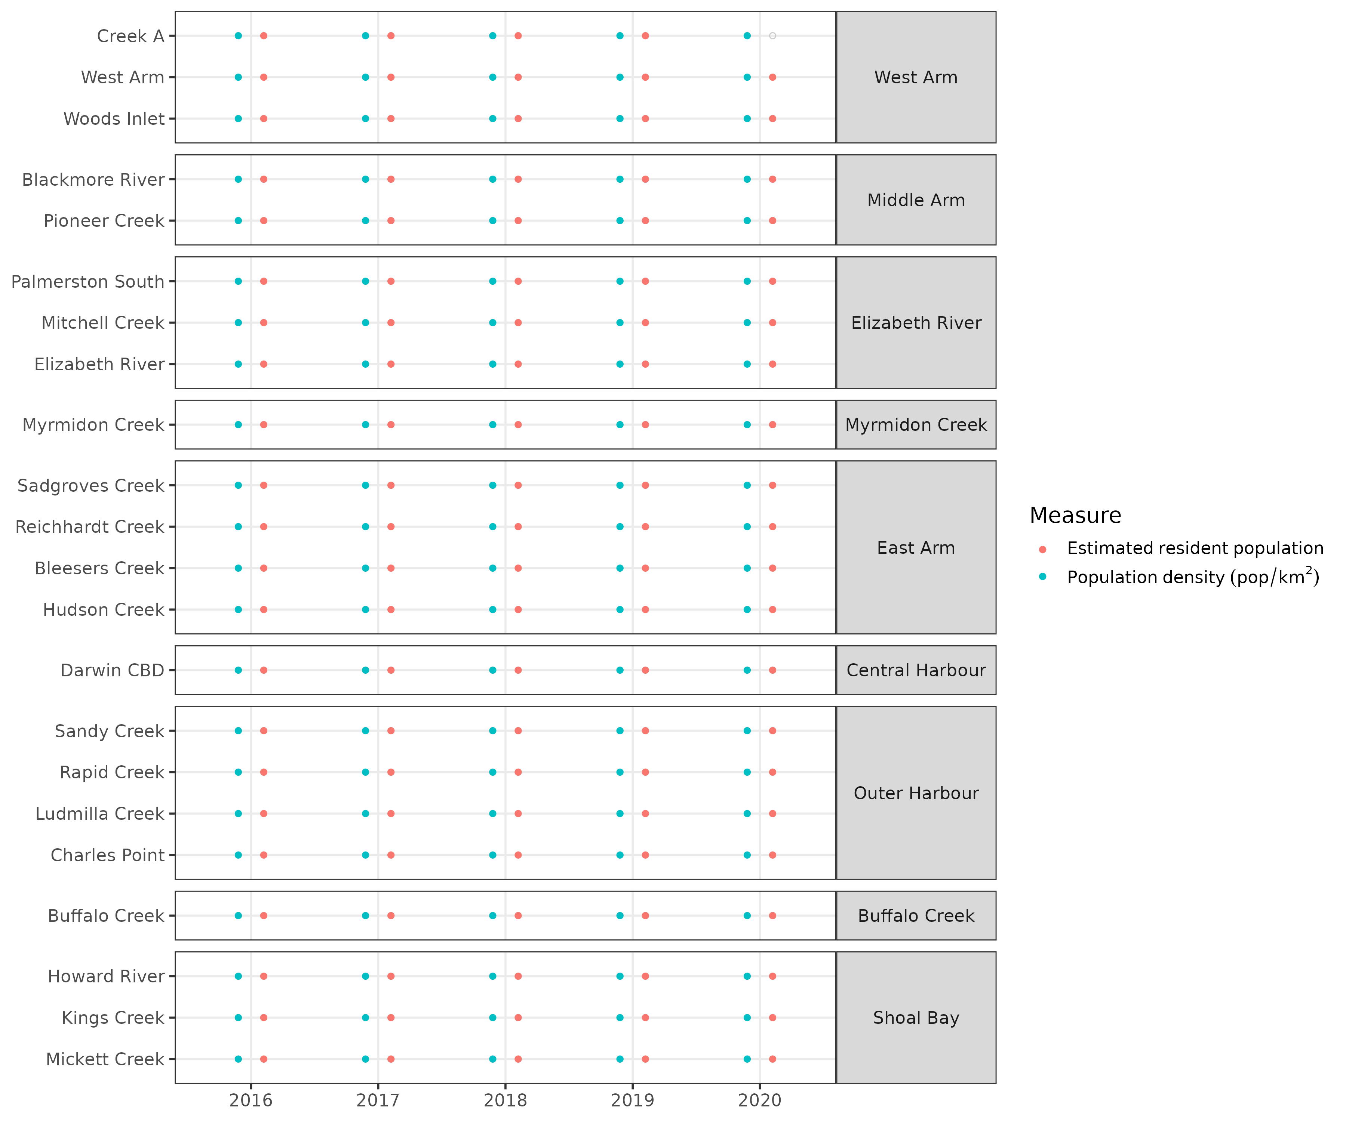

**Figure** **:** Broad spatio-temporal design of the observed catchment ERP data. Solid dots indicate the presence of data.

## Fire frequency

Data issues:

* There are two columns called “11-15 (WA)”. As a result, when imported, numbers are appended. Based on the naming patterns of the other columns, it is clear that the second of these “11-15 (WA)” columns should have been “11-15 (SD)”. Fix this up
* There is also some inconsistency in the format of the column names. Most of them are of the format “YR1_YR2 (STAT)”, however, the final few columns are of the format “YR1_YR2 STAT” (that is, no brackets) - fix this.

These data were processing according to the following steps:

* rename the errant columns
* remove the Overall summation row
* pivot the table longer such that each year is a separate row
* the input data represent the weighted averages and standard deviations over 5 year windows. For these data to be useful in an statistical analysis, we need to express this time range as a single year. I will take the last year of the range of years as the focal Year. The logic here is that the fire frequency has been experienced over that 5 year period.
* pivot wider to express both weighted average and standard deviation versions as separate predictors

The spatio-temporal design of the catchment estimated resident population data are illustrated in figures .

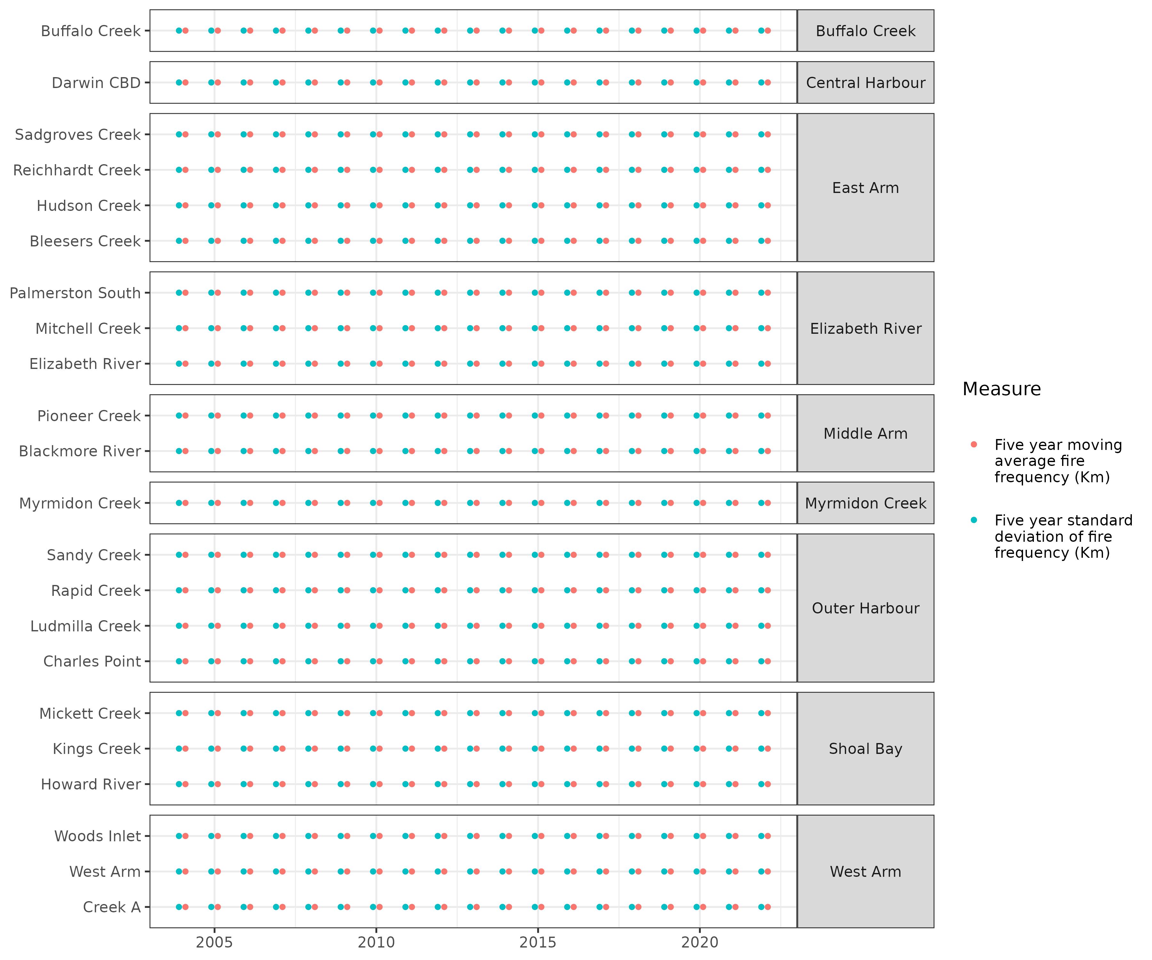

**Figure** **:** Broad spatio-temporal design of the observed fire frequency data. Solid dots indicate the presence of data.

## Fire areas

### Areas

These data (fire areas expressed in km²) were processed according to the following steps:

* exclude the “Overall” row from the data
* pivot the table longer such that each year is a separate row
* apply a lookup to ensure consistent (standardised) Catchment naming
* add spatial context (ZoneName)
* ensure that year is a numeric variable

### Percentages

These data (fire areas expressed in percentages) were processed according to the following steps:

* exclude the “Whole catchment area” row from the data
* pivot the table longer such that each year is a separate row
* perform some direct replacements to ensure consistent (standardised) Catchment naming
* add spatial context (ZoneName)
* ensure that year is a numeric variable

### Combined

The fire areas were then combined into a single data set, the spatio-temporal configuration of which is illustrated in figure .

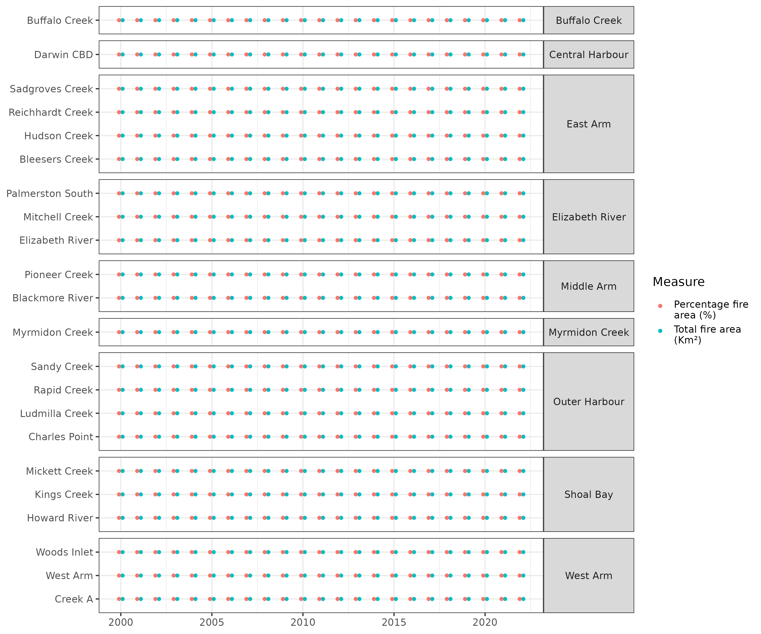

**Figure** **:** Broad spatio-temporal design of the observed fire frequency areas data. Solid dots indicate the presence of data.

## Sea levels

These data were processed according to the following steps:

* rename the columns for easier use according to a lookup
* remove the Financial year field

There is no spatial component to these data and thus the associated covariates will be similarity applied at all spatial scales.

## Temperature/Rainfall/Anomaly

### Annual rainfall (fin year)

These data were processed according to the following steps:

* rename the columns for easier use according to a lookup
* remove the Financial year field

There is no spatial component to these data and thus the associated covariates will be similarity applied at all spatial scales.

### Rainfall anomaly

These data were processed according to the following steps:

* rename the columns for easier use according to a lookup
* remove the Financial year field

There is no spatial component to these data and thus the associated covariates will be similarity applied at all spatial scales.

### Air temperature

These data were processed according to the following steps:

* rename Date to Year
* rename the columns for easier use according to a lookup
* remove superfluous fields

There is no spatial component to these data and thus the associated covariates will be similarity applied at all spatial scales.

### Air temperature anomaly

These data were processed according to the following steps:

* rename the columns for easier use according to a lookup
* remove superfluous fields

There is no spatial component to these data and thus the associated covariates will be similarity applied at all spatial scales.

## Southern Oscillation Index (SOI)

These data were processed according to the following steps:

* rename the columns for easier use according to a lookup
* reformat Year into a standard format

There is no spatial component to these data and thus the associated covariates will be similarity applied at all spatial scales.

## Sea Surface Temperature (SST) anomaly

These data were processed according to the following steps:

* rename the columns for easier use according to a lookup
* remove superfluous fields

There is no spatial component to these data and thus the associated covariates will be similarity applied at all spatial scales.

## Building activity

These data were processed according to the following steps:

* rename the columns for easier use according to a lookup
* remove superfluous fields

There is no spatial component to these data and thus the associated covariates will be similarity applied at all spatial scales.

## Shipping activity

These data were processed according to the following steps:

* rename the columns for easier use according to a lookup
* remove superfluous fields

There is no spatial component to these data and thus the associated covariates will be similarity applied at all spatial scales.

## Combine all data

In combining together the responses/stresses along with the pressures, it is important to recognise that they are collected on different spatial and temporal scales. Hence, to combine all the sources together, we need to do so via common spatial and temporal scales.

For temporal scales, it is simple enough to base this on the financial year since most of the data are already expressed this way, or else the conversions are simple enough. However, the spatial scales are more difficult, particularly considering that the water quality data (stresses) are collected in water and the pressures are predominantly collected terrestrially. The only real way to address this is to be able to associate each of the *Sub-catchments* to a single harbour *Zone*.

Consequently, all analyses will be conducted on the Zone/Year scale (in addition to a whole harbour/Year scale). There are many instances (both stresses and pressures) in which there are multiple observations collected per Zone/Year. As a result, when the multiple sources are combined together, the number of data set rows will increase dramatically. For example, a given water quality observation might appear multiple times, once for each pressure observation at that Zone/Year scale.

This duplication is not necessarily an issue, however, we need to be mindful of it so as to prevent it from artificially over or under weighting some effects and some observations. To help with this, unique record identifiers were added to the water quality components.

The alternative is to aggregate all data to the Zone/Year level such that there are no more than one observation (per stress and predictor) per Zone/Year. Although this would simplify things, it has the potential to loose vast quantities of information.

# Exploratory data analyses

Prior to fitting any statistical models, it is prudent to first explore the distributions and temporal patterns in each of the stressors (responses) and pressures (covariates).

## Pressures (Covariates)

### Total N (t)

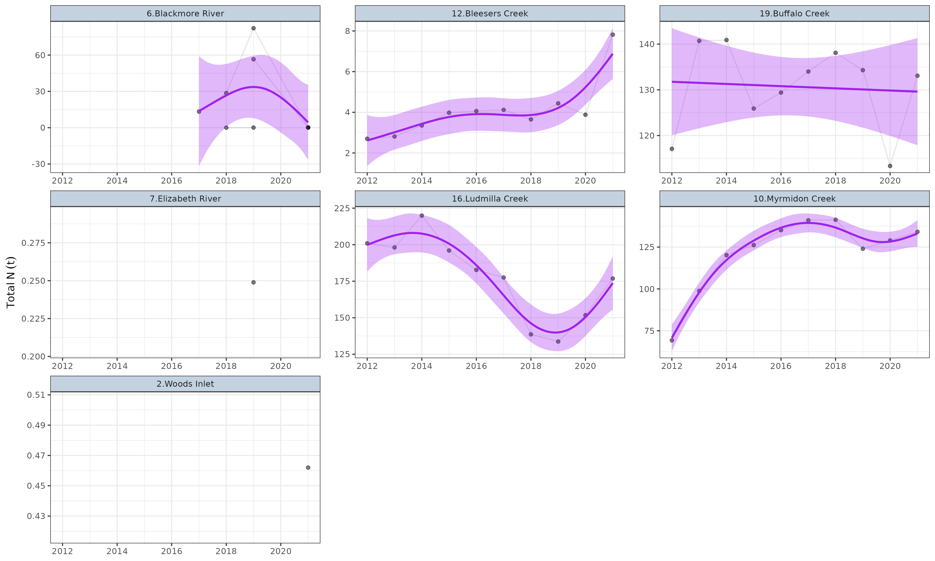

**Figure** **:** Temporal trends in Total N (t) within each of the Zones. Points represent collected observations at unique lat/long/Year combinations. Each individual point is 80% transparent, and thus darker points represent a greater quantity of observations with similar values. Faint lines join sets of observations collected at the same lat/long over time. Purple lines represent simple Generalized Additive Modeling splines with 95% confidence envelopes. Note, these are purely simple models that do not take into account any dependency structures (e.g. do not include random effects or autoregressive terms).

### Total P (t)

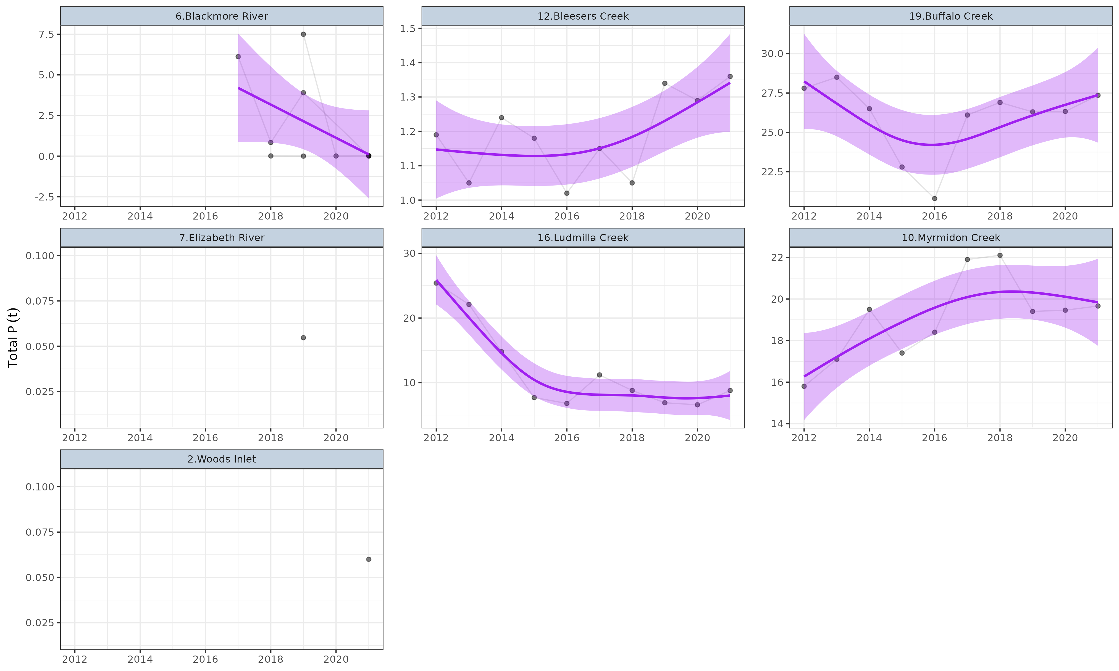

**Figure** **:** Temporal trends in Total P (t) within each of the Zones. Points represent collected observations at unique lat/long/Year combinations. Each individual point is 80% transparent, and thus darker points represent a greater quantity of observations with similar values. Faint lines join sets of observations collected at the same lat/long over time. Purple lines represent simple Generalized Additive Modeling splines with 95% confidence envelopes. Note, these are purely simple models that do not take into account any dependency structures (e.g. do not include random effects or autoregressive terms).

### Discharge volume (annual kL)

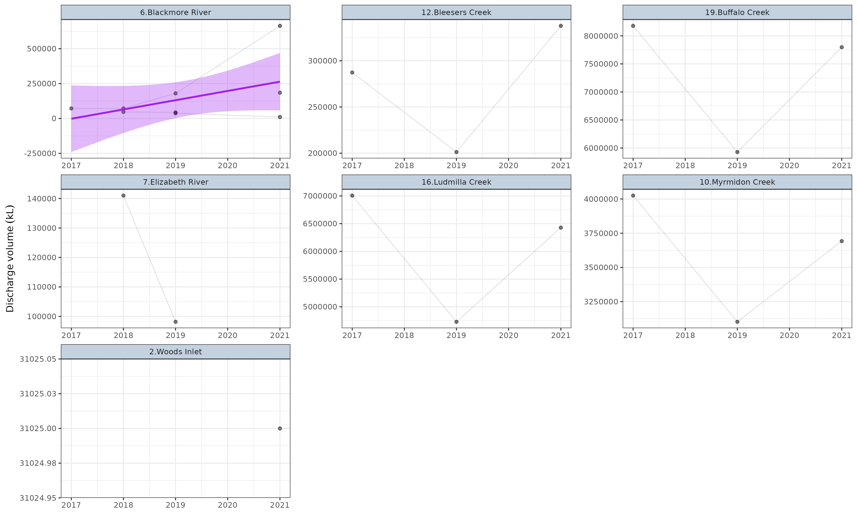

**Figure** **:** Temporal trends in Discharge volume (annual kL) within each of the Zones. Points represent collected observations at unique lat/long/Year combinations. Each individual point is 80% transparent, and thus darker points represent a greater quantity of observations with similar values. Faint lines join sets of observations collected at the same lat/long over time. Purple lines represent simple Generalized Additive Modeling splines with 95% confidence envelopes. Note, these are purely simple models that do not take into account any dependency structures (e.g. do not include random effects or autoregressive terms).

### Total suspended solids (t)

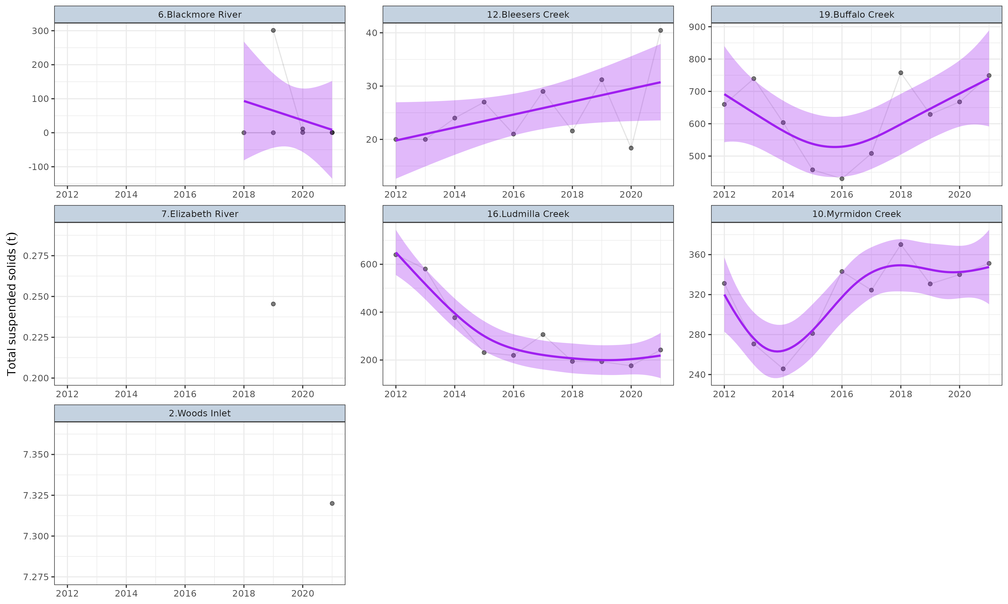

**Figure** **:** Temporal trends in Total suspended solids (t) within each of the Zones. Points represent collected observations at unique lat/long/Year combinations. Each individual point is 80% transparent, and thus darker points represent a greater quantity of observations with similar values. Faint lines join sets of observations collected at the same lat/long over time. Purple lines represent simple Generalized Additive Modeling splines with 95% confidence envelopes. Note, these are purely simple models that do not take into account any dependency structures (e.g. do not include random effects or autoregressive terms).

### Volatile suspended solids (t)

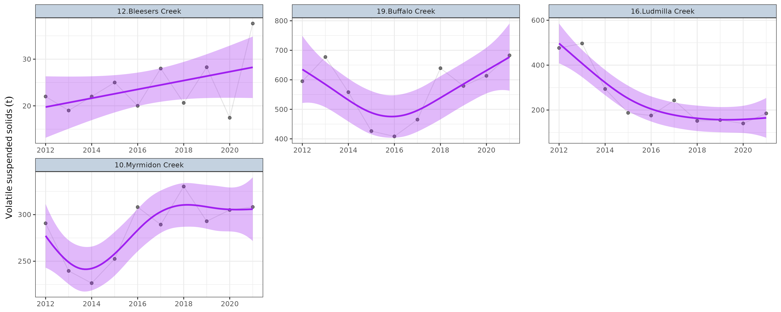

**Figure** **:** Temporal trends in Volatile suspended solids (t) within each of the Zones. Points represent collected observations at unique lat/long/Year combinations. Each individual point is 80% transparent, and thus darker points represent a greater quantity of observations with similar values. Faint lines join sets of observations collected at the same lat/long over time. Purple lines represent simple Generalized Additive Modeling splines with 95% confidence envelopes. Note, these are purely simple models that do not take into account any dependency structures (e.g. do not include random effects or autoregressive terms).

### Estimated resident population

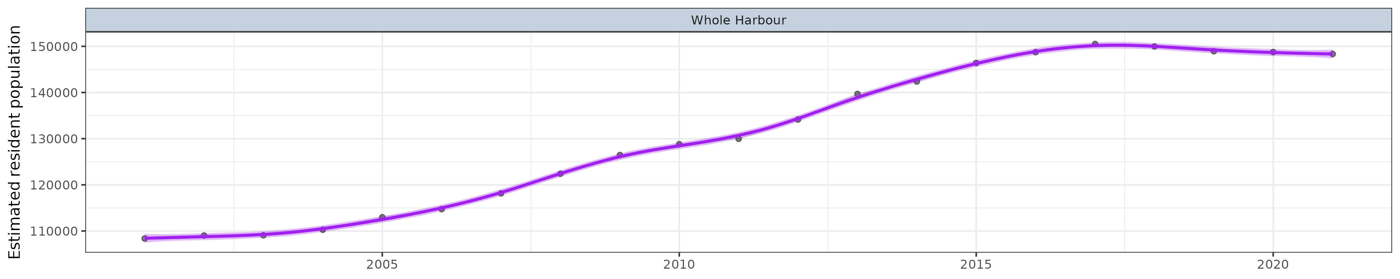

**Figure** **:** Temporal trends in Estimated Resident Population (ERP) within each of the Zones. Points represent collected observations at unique lat/long/Year combinations. Each individual point is 80% transparent, and thus darker points represent a greater quantity of observations with similar values. Faint lines join sets of observations collected at the same lat/long over time. Purple lines represent simple Generalized Additive Modeling splines with 95% confidence envelopes. Note, these are purely simple models that do not take into account any dependency structures (e.g. do not include random effects or autoregressive terms).

### Estimated resident population growth

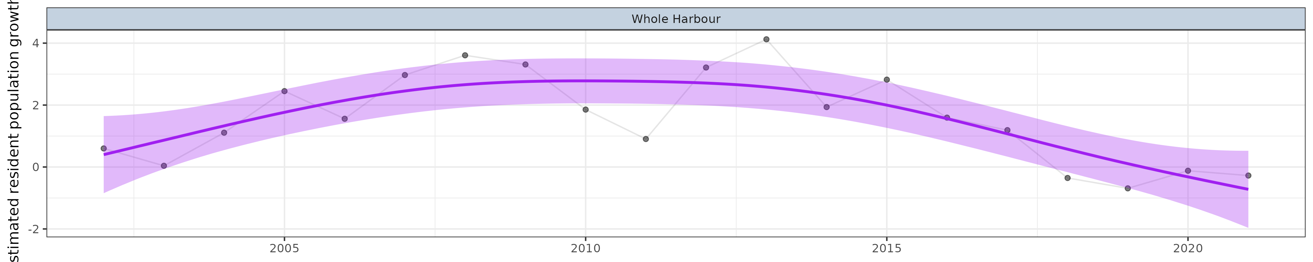

**Figure** **:** Temporal trends in Estimated Resident Population (ERP) growth within each of the Zones. Points represent collected observations at unique lat/long/Year combinations. Each individual point is 80% transparent, and thus darker points represent a greater quantity of observations with similar values. Faint lines join sets of observations collected at the same lat/long over time. Purple lines represent simple Generalized Additive Modeling splines with 95% confidence envelopes. Note, these are purely simple models that do not take into account any dependency structures (e.g. do not include random effects or autoregressive terms).

### Gross regional product ($M)

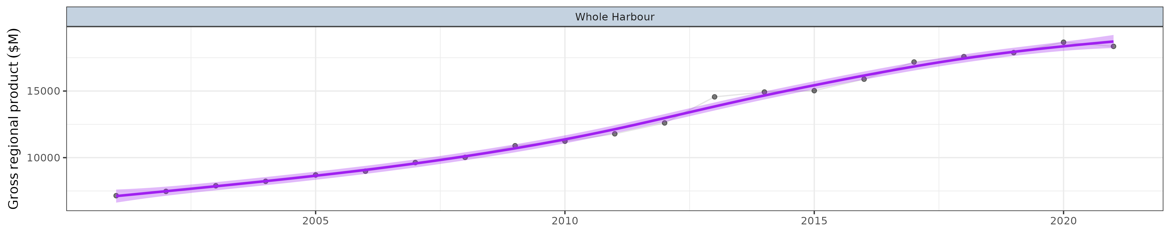

**Figure** **:** Temporal trends in Gross regional product ($M) within each of the Zones. Points represent collected observations at unique lat/long/Year combinations. Each individual point is 80% transparent, and thus darker points represent a greater quantity of observations with similar values. Faint lines join sets of observations collected at the same lat/long over time. Purple lines represent simple Generalized Additive Modeling splines with 95% confidence envelopes. Note, these are purely simple models that do not take into account any dependency structures (e.g. do not include random effects or autoregressive terms).

### Gross regional product change (%)

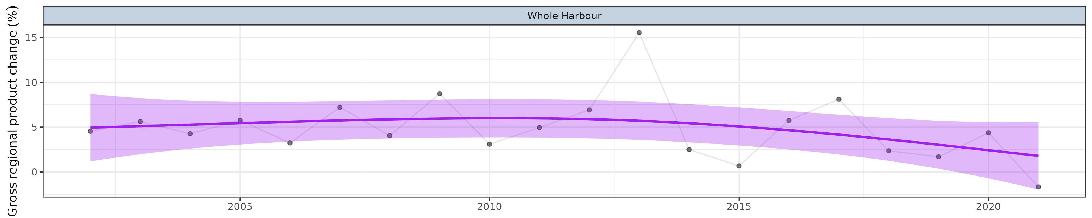

**Figure** **:** Temporal trends in Gross regional product change (%) within each of the Zones. Points represent collected observations at unique lat/long/Year combinations. Each individual point is 80% transparent, and thus darker points represent a greater quantity of observations with similar values. Faint lines join sets of observations collected at the same lat/long over time. Purple lines represent simple Generalized Additive Modeling splines with 95% confidence envelopes. Note, these are purely simple models that do not take into account any dependency structures (e.g. do not include random effects or autoregressive terms).

### Catchment estimated resident population

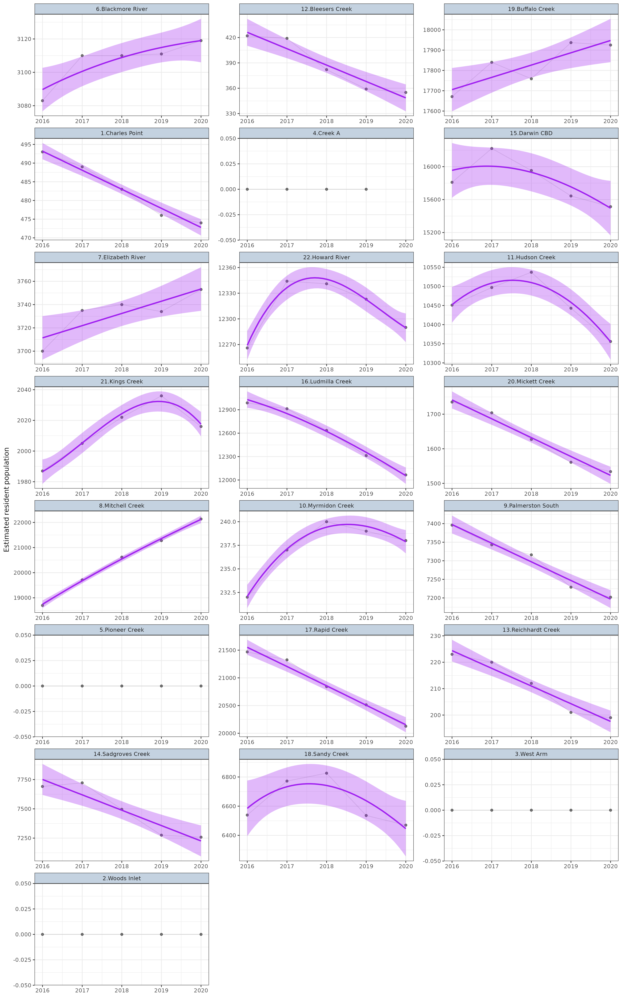

**Figure** **:** Temporal trends in Catchment estimated Resident Population (Catch-ERP) within each of the Zones. Points represent collected observations at unique lat/long/Year combinations. Each individual point is 80% transparent, and thus darker points represent a greater quantity of observations with similar values. Faint lines join sets of observations collected at the same lat/long over time. Purple lines represent simple Generalized Additive Modeling splines with 95% confidence envelopes. Note, these are purely simple models that do not take into account any dependency structures (e.g. do not include random effects or autoregressive terms).

### Population density (pop/km²)

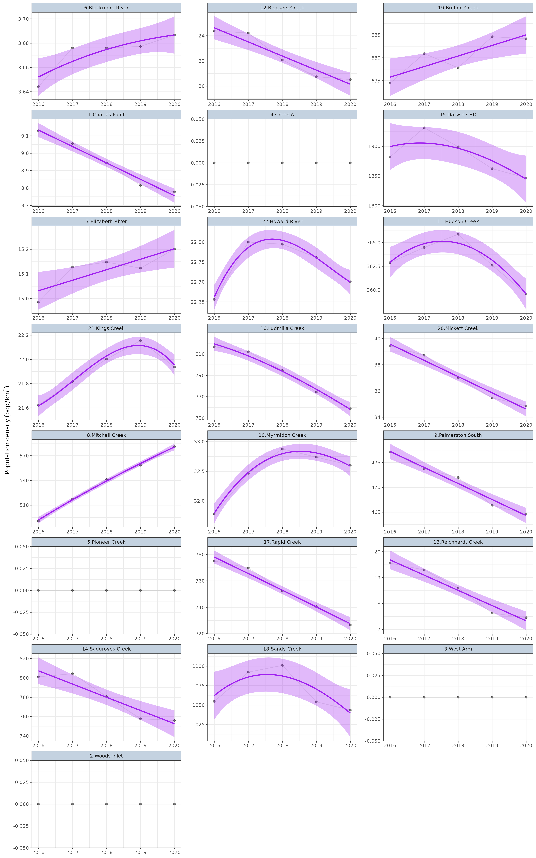

**Figure** **:** Temporal trends in Population density (pop/km²) within each of the Zones. Points represent collected observations at unique lat/long/Year combinations. Each individual point is 80% transparent, and thus darker points represent a greater quantity of observations with similar values. Faint lines join sets of observations collected at the same lat/long over time. Purple lines represent simple Generalized Additive Modeling splines with 95% confidence envelopes. Note, these are purely simple models that do not take into account any dependency structures (e.g. do not include random effects or autoregressive terms).

### Mean sea level (m)

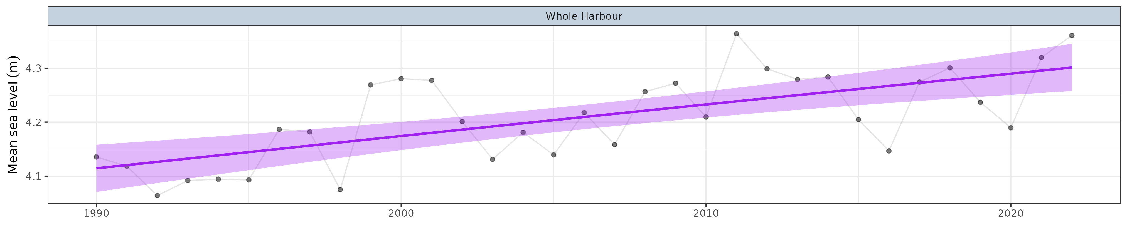

**Figure** **:** Temporal trends in Mean sea level (m) within each of the Zones. Points represent collected observations at unique lat/long/Year combinations. Each individual point is 80% transparent, and thus darker points represent a greater quantity of observations with similar values. Faint lines join sets of observations collected at the same lat/long over time. Purple lines represent simple Generalized Additive Modeling splines with 95% confidence envelopes. Note, these are purely simple models that do not take into account any dependency structures (e.g. do not include random effects or autoregressive terms).

### Rainfall anomaly (mm)

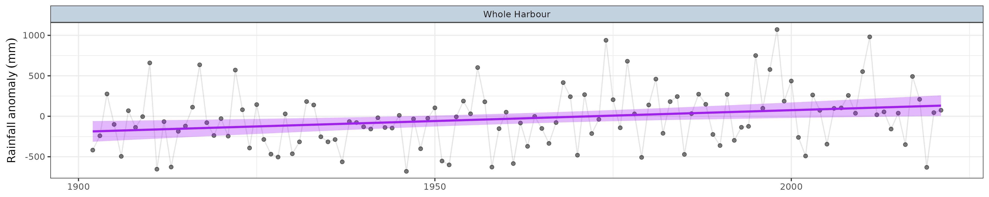

**Figure** **:** Temporal trends in Rainfall anomaly (mm) within each of the Zones. Points represent collected observations at unique lat/long/Year combinations. Each individual point is 80% transparent, and thus darker points represent a greater quantity of observations with similar values. Faint lines join sets of observations collected at the same lat/long over time. Purple lines represent simple Generalized Additive Modeling splines with 95% confidence envelopes. Note, these are purely simple models that do not take into account any dependency structures (e.g. do not include random effects or autoregressive terms).

### Mean air temperature (℃)

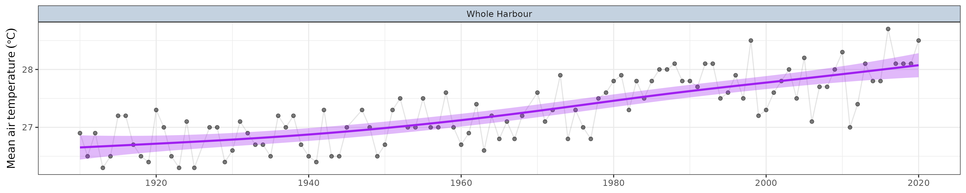

**Figure** **:** Temporal trends in Mean air temperature (℃) within each of the Zones. Points represent collected observations at unique lat/long/Year combinations. Each individual point is 80% transparent, and thus darker points represent a greater quantity of observations with similar values. Faint lines join sets of observations collected at the same lat/long over time. Purple lines represent simple Generalized Additive Modeling splines with 95% confidence envelopes. Note, these are purely simple models that do not take into account any dependency structures (e.g. do not include random effects or autoregressive terms).

### Mean air temperature anomaly (℃)

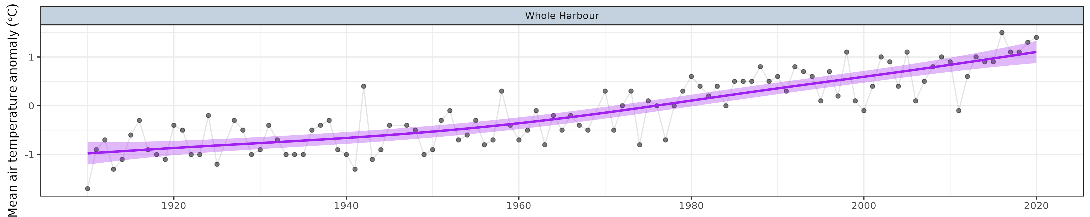

**Figure** **:** Temporal trends in Mean air temperature anomaly (℃) within each of the Zones. Points represent collected observations at unique lat/long/Year combinations. Each individual point is 80% transparent, and thus darker points represent a greater quantity of observations with similar values. Faint lines join sets of observations collected at the same lat/long over time. Purple lines represent simple Generalized Additive Modeling splines with 95% confidence envelopes. Note, these are purely simple models that do not take into account any dependency structures (e.g. do not include random effects or autoregressive terms).

### Southern Oscillation Index

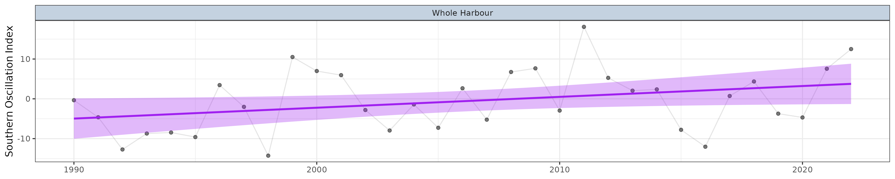

**Figure** **:** Temporal trends in Southern Oscillation Index within each of the Zones. Points represent collected observations at unique lat/long/Year combinations. Each individual point is 80% transparent, and thus darker points represent a greater quantity of observations with similar values. Faint lines join sets of observations collected at the same lat/long over time. Purple lines represent simple Generalized Additive Modeling splines with 95% confidence envelopes. Note, these are purely simple models that do not take into account any dependency structures (e.g. do not include random effects or autoregressive terms).

### Sea surface temperature anomaly (℃)

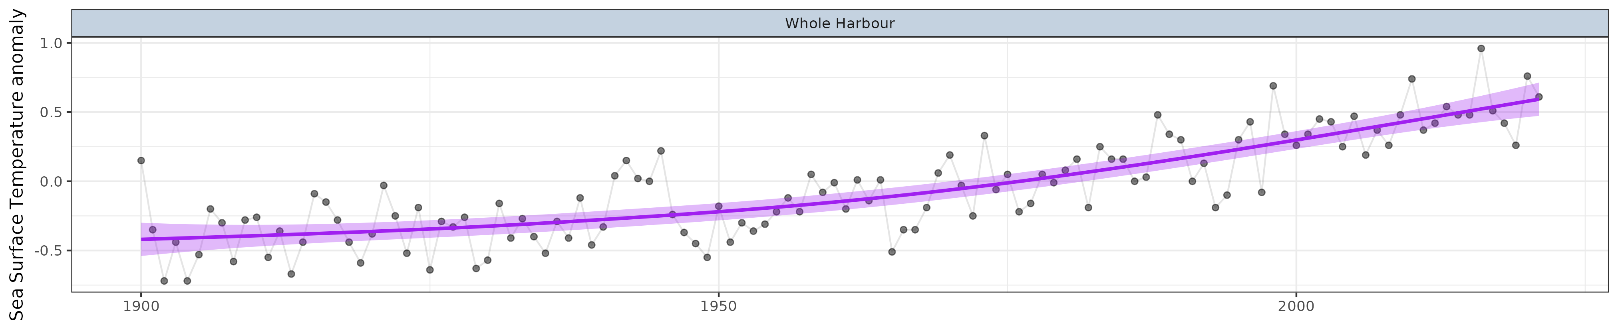

**Figure** **:** Temporal trends in Sea surface temperature anomaly (℃) within each of the Zones. Points represent collected observations at unique lat/long/Year combinations. Each individual point is 80% transparent, and thus darker points represent a greater quantity of observations with similar values. Faint lines join sets of observations collected at the same lat/long over time. Purple lines represent simple Generalized Additive Modeling splines with 95% confidence envelopes. Note, these are purely simple models that do not take into account any dependency structures (e.g. do not include random effects or autoregressive terms).

### Total building activity ($B)

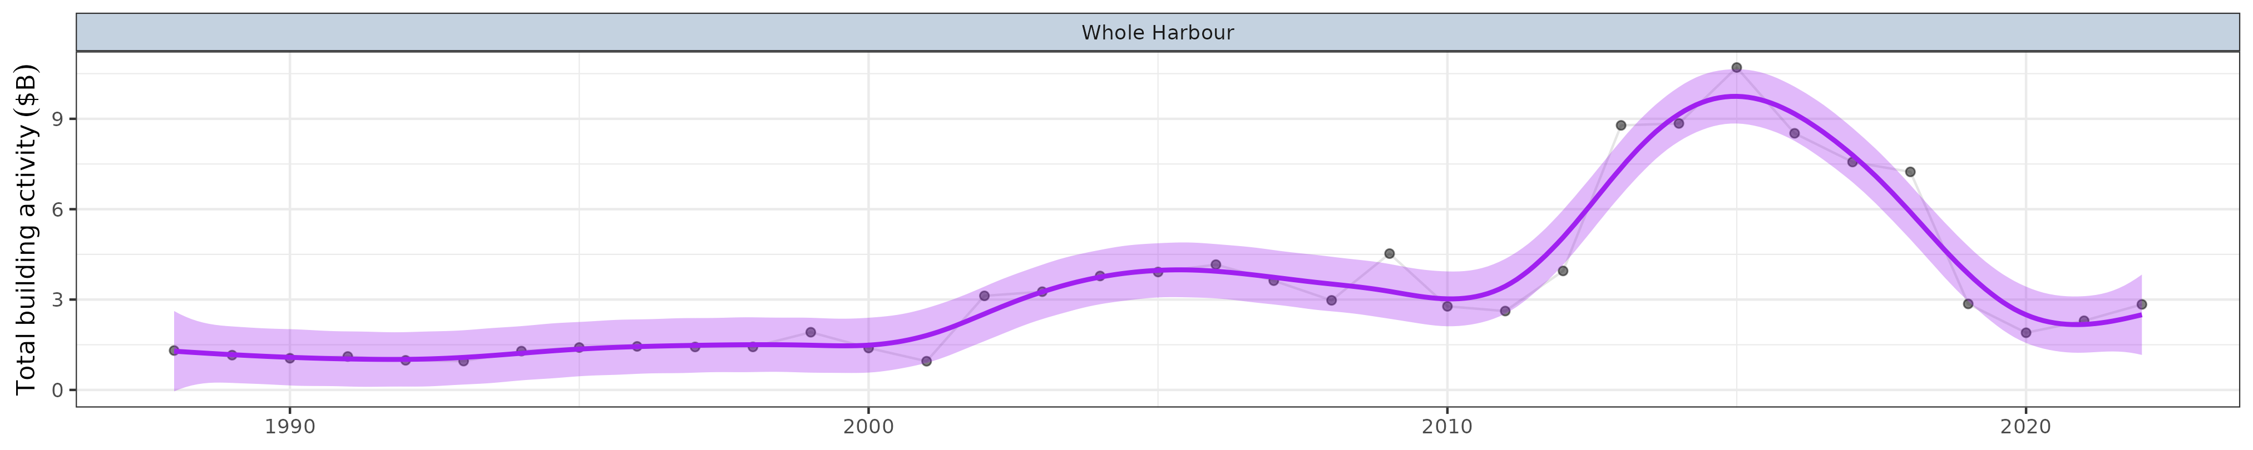

**Figure** **:** Temporal trends in Total building activity ($B) within each of the Zones. Points represent collected observations at unique lat/long/Year combinations. Each individual point is 80% transparent, and thus darker points represent a greater quantity of observations with similar values. Faint lines join sets of observations collected at the same lat/long over time. Purple lines represent simple Generalized Additive Modeling splines with 95% confidence envelopes. Note, these are purely simple models that do not take into account any dependency structures (e.g. do not include random effects or autoregressive terms).

### Engineering building activity ($B)

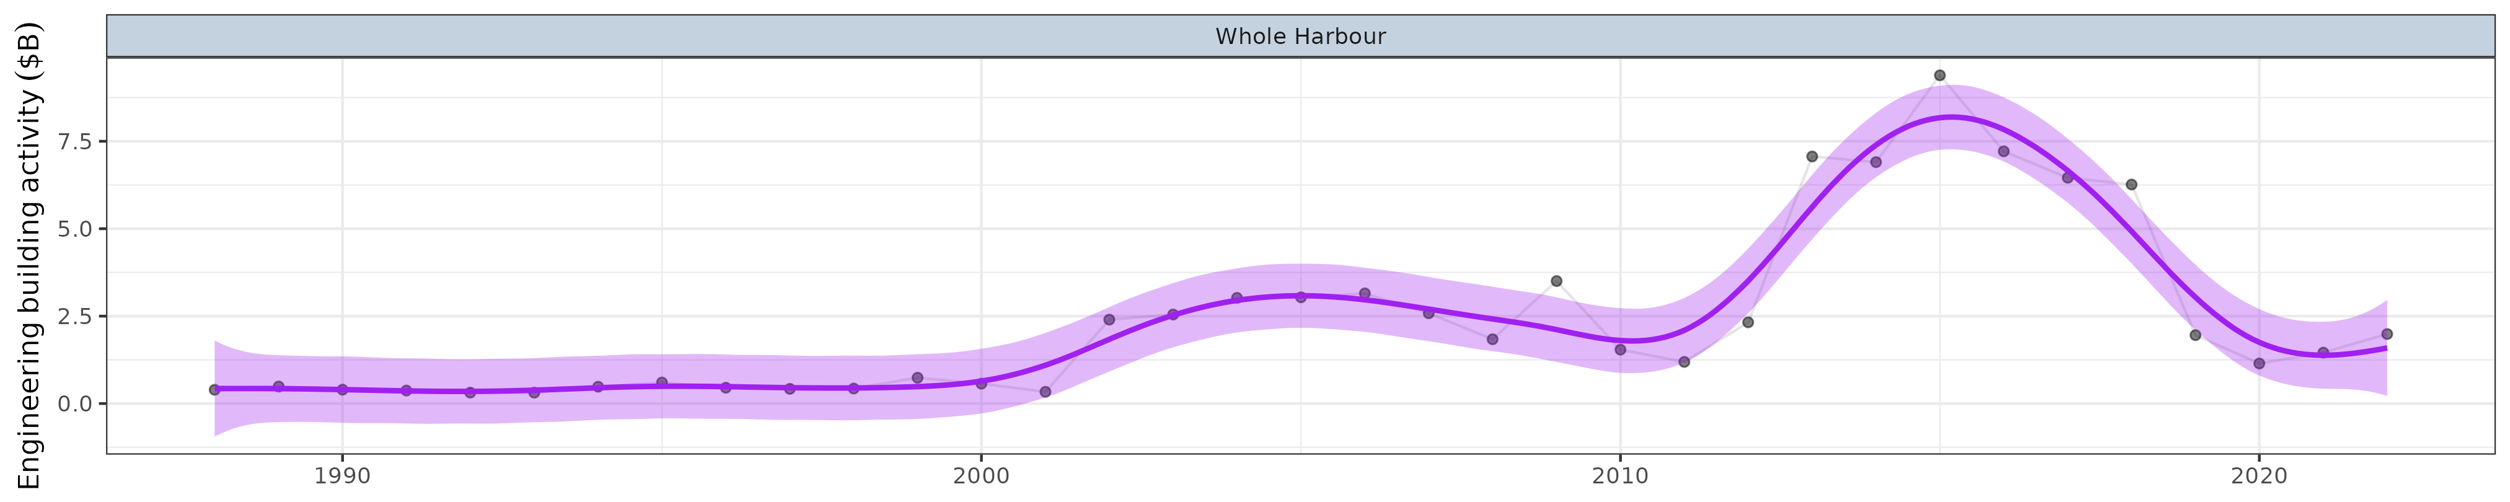

**Figure** **:** Temporal trends in Engineering building activity ($B) within each of the Zones. Points represent collected observations at unique lat/long/Year combinations. Each individual point is 80% transparent, and thus darker points represent a greater quantity of observations with similar values. Faint lines join sets of observations collected at the same lat/long over time. Purple lines represent simple Generalized Additive Modeling splines with 95% confidence envelopes. Note, these are purely simple models that do not take into account any dependency structures (e.g. do not include random effects or autoregressive terms).

### Non-Residential building activity ($B)

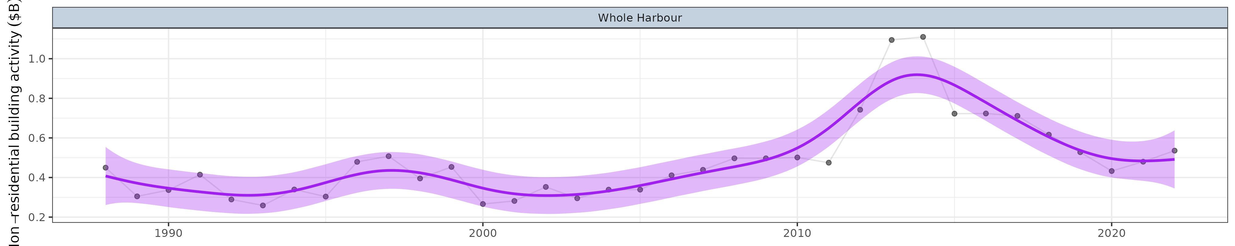

**Figure** **:** Temporal trends in Non-Residential building activity ($B) within each of the Zones. Points represent collected observations at unique lat/long/Year combinations. Each individual point is 80% transparent, and thus darker points represent a greater quantity of observations with similar values. Faint lines join sets of observations collected at the same lat/long over time. Purple lines represent simple Generalized Additive Modeling splines with 95% confidence envelopes. Note, these are purely simple models that do not take into account any dependency structures (e.g. do not include random effects or autoregressive terms).

### Residential building activity ($B)

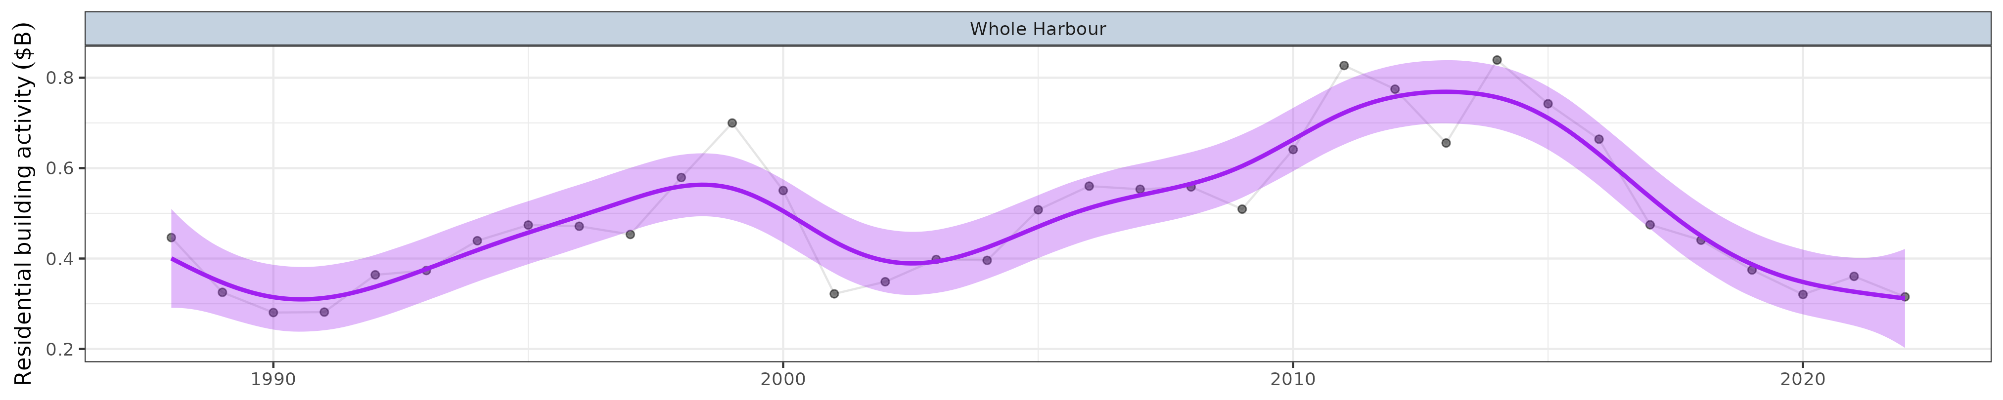

**Figure** **:** Temporal trends in Residential building activity ($B) within each of the Zones. Points represent collected observations at unique lat/long/Year combinations. Each individual point is 80% transparent, and thus darker points represent a greater quantity of observations with similar values. Faint lines join sets of observations collected at the same lat/long over time. Purple lines represent simple Generalized Additive Modeling splines with 95% confidence envelopes. Note, these are purely simple models that do not take into account any dependency structures (e.g. do not include random effects or autoregressive terms).

### Number of trade ships

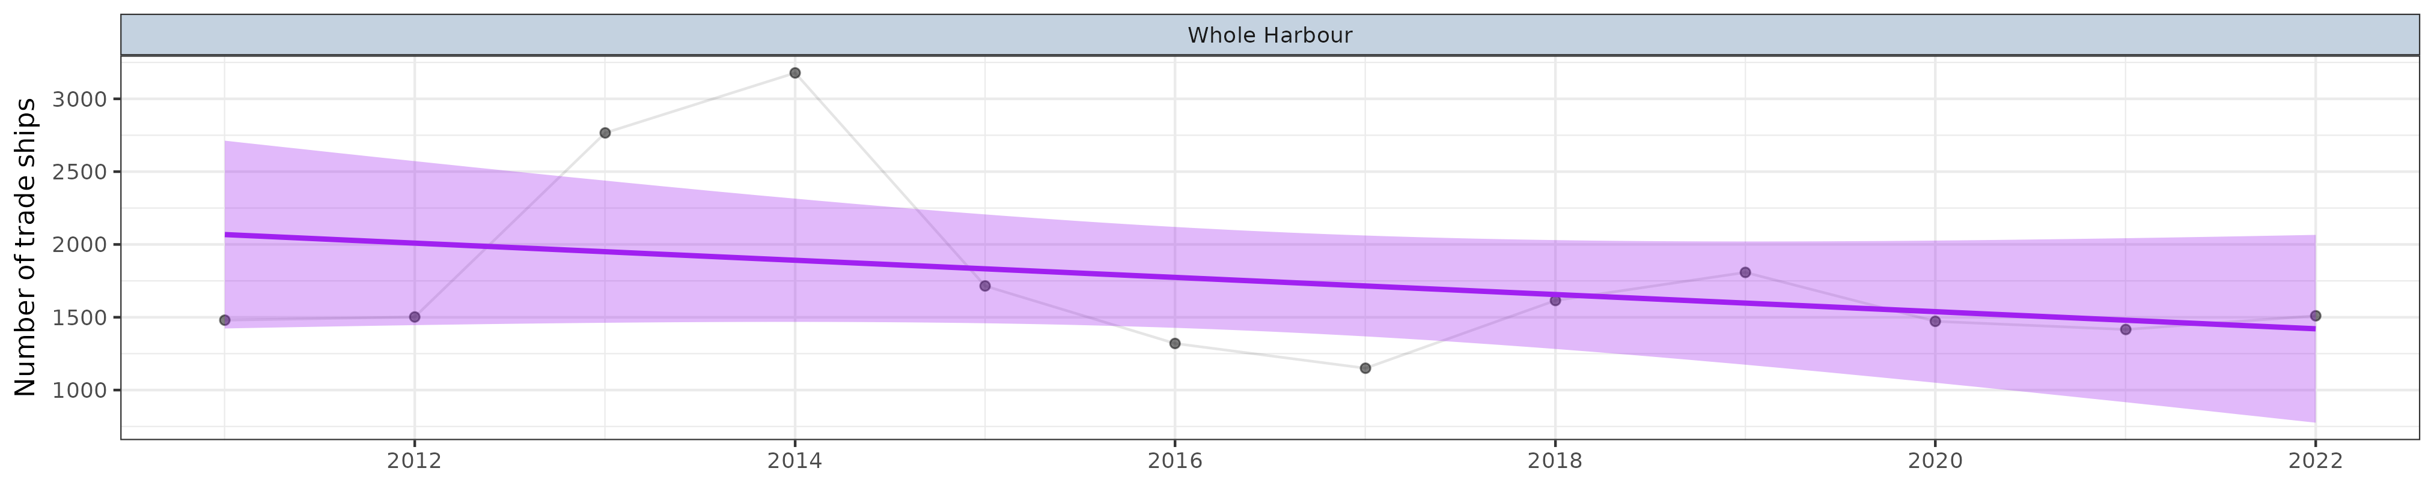

**Figure** **:** Temporal trends in number of trade ships within each of the Zones. Points represent collected observations at unique lat/long/Year combinations. Each individual point is 80% transparent, and thus darker points represent a greater quantity of observations with similar values. Faint lines join sets of observations collected at the same lat/long over time. Purple lines represent simple Generalized Additive Modeling splines with 95% confidence envelopes. Note, these are purely simple models that do not take into account any dependency structures (e.g. do not include random effects or autoregressive terms).

### Number of container ships

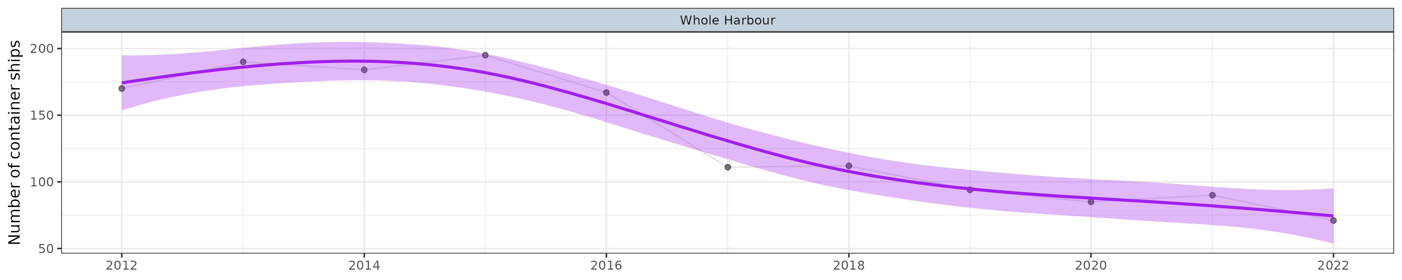

**Figure** **:** Temporal trends in number of container ships within each of the Zones. Points represent collected observations at unique lat/long/Year combinations. Each individual point is 80% transparent, and thus darker points represent a greater quantity of observations with similar values. Faint lines join sets of observations collected at the same lat/long over time. Purple lines represent simple Generalized Additive Modeling splines with 95% confidence envelopes. Note, these are purely simple models that do not take into account any dependency structures (e.g. do not include random effects or autoregressive terms).

### Number of liquid bulk ships

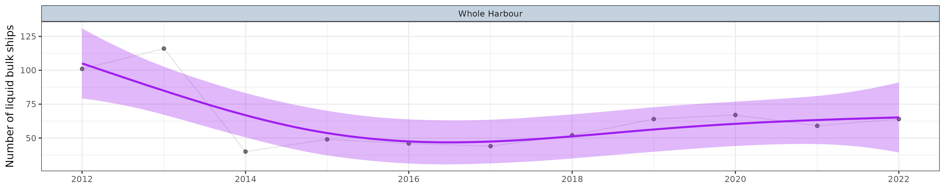

**Figure** **:** Temporal trends in number of liquid bulk ships within each of the Zones. Points represent collected observations at unique lat/long/Year combinations. Each individual point is 80% transparent, and thus darker points represent a greater quantity of observations with similar values. Faint lines join sets of observations collected at the same lat/long over time. Purple lines represent simple Generalized Additive Modeling splines with 95% confidence envelopes. Note, these are purely simple models that do not take into account any dependency structures (e.g. do not include random effects or autoregressive terms).

### Number of car carrier ships

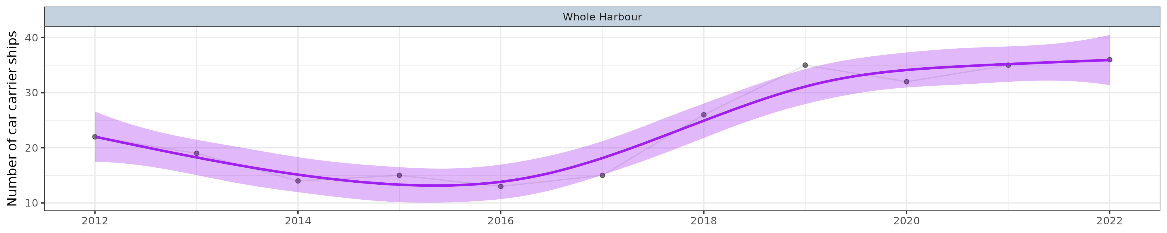

**Figure** **:** Temporal trends in number of car carrier ships within each of the Zones. Points represent collected observations at unique lat/long/Year combinations. Each individual point is 80% transparent, and thus darker points represent a greater quantity of observations with similar values. Faint lines join sets of observations collected at the same lat/long over time. Purple lines represent simple Generalized Additive Modeling splines with 95% confidence envelopes. Note, these are purely simple models that do not take into account any dependency structures (e.g. do not include random effects or autoregressive terms).

### Number of rig tenders ships

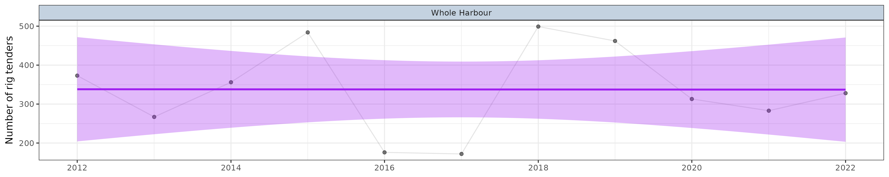

**Figure** **:** Temporal trends in number of rig tenders ships within each of the Zones. Points represent collected observations at unique lat/long/Year combinations. Each individual point is 80% transparent, and thus darker points represent a greater quantity of observations with similar values. Faint lines join sets of observations collected at the same lat/long over time. Purple lines represent simple Generalized Additive Modeling splines with 95% confidence envelopes. Note, these are purely simple models that do not take into account any dependency structures (e.g. do not include random effects or autoregressive terms).

### Number of livestock ships

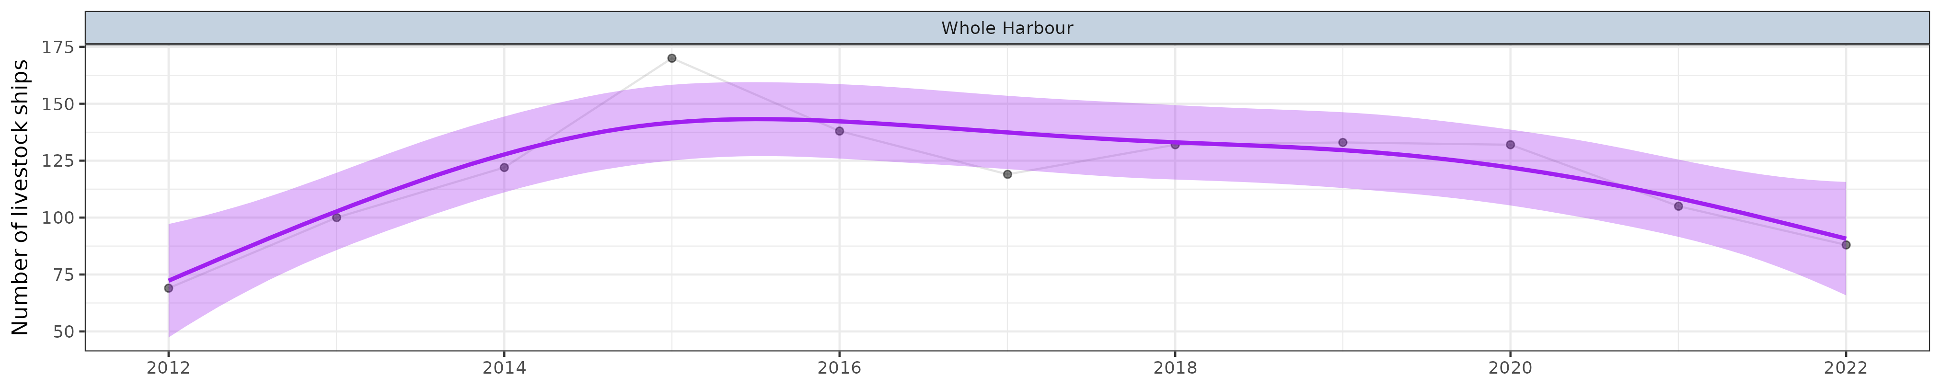

**Figure** **:** Temporal trends in number of livestock ships within each of the Zones. Points represent collected observations at unique lat/long/Year combinations. Each individual point is 80% transparent, and thus darker points represent a greater quantity of observations with similar values. Faint lines join sets of observations collected at the same lat/long over time. Purple lines represent simple Generalized Additive Modeling splines with 95% confidence envelopes. Note, these are purely simple models that do not take into account any dependency structures (e.g. do not include random effects or autoregressive terms).

### Number of cruise ships

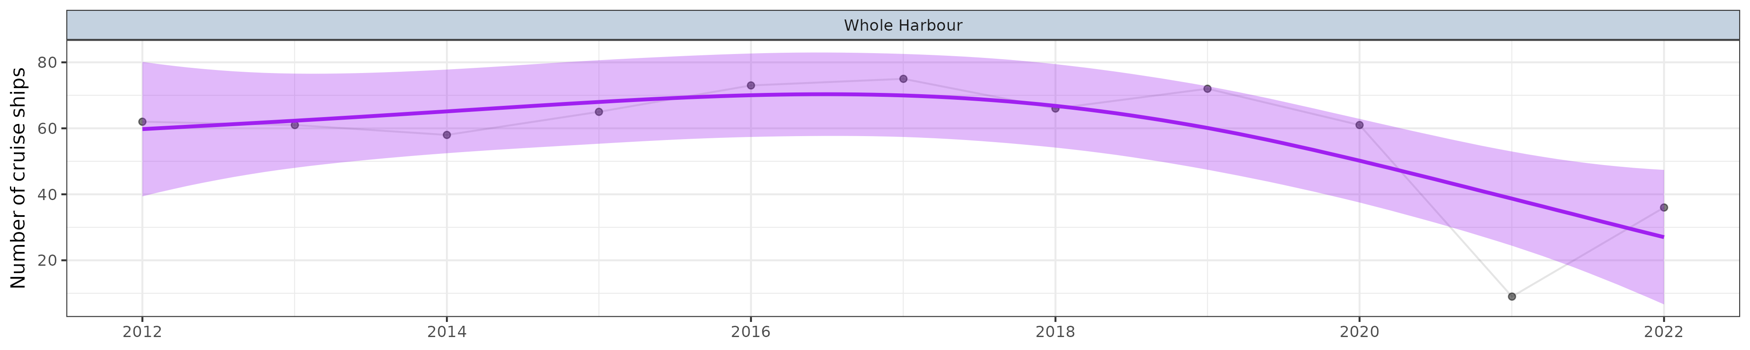

**Figure** **:** Temporal trends in number of cruise ships within each of the Zones. Points represent collected observations at unique lat/long/Year combinations. Each individual point is 80% transparent, and thus darker points represent a greater quantity of observations with similar values. Faint lines join sets of observations collected at the same lat/long over time. Purple lines represent simple Generalized Additive Modeling splines with 95% confidence envelopes. Note, these are purely simple models that do not take into account any dependency structures (e.g. do not include random effects or autoregressive terms).

### Number of dry bulk ships

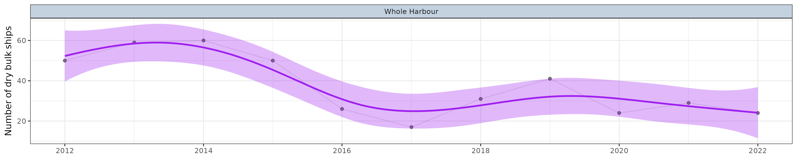

**Figure** **:** Temporal trends in number of dry bulk ships within each of the Zones. Points represent collected observations at unique lat/long/Year combinations. Each individual point is 80% transparent, and thus darker points represent a greater quantity of observations with similar values. Faint lines join sets of observations collected at the same lat/long over time. Purple lines represent simple Generalized Additive Modeling splines with 95% confidence envelopes. Note, these are purely simple models that do not take into account any dependency structures (e.g. do not include random effects or autoregressive terms).

### Five year moving average fire frequency (Km)

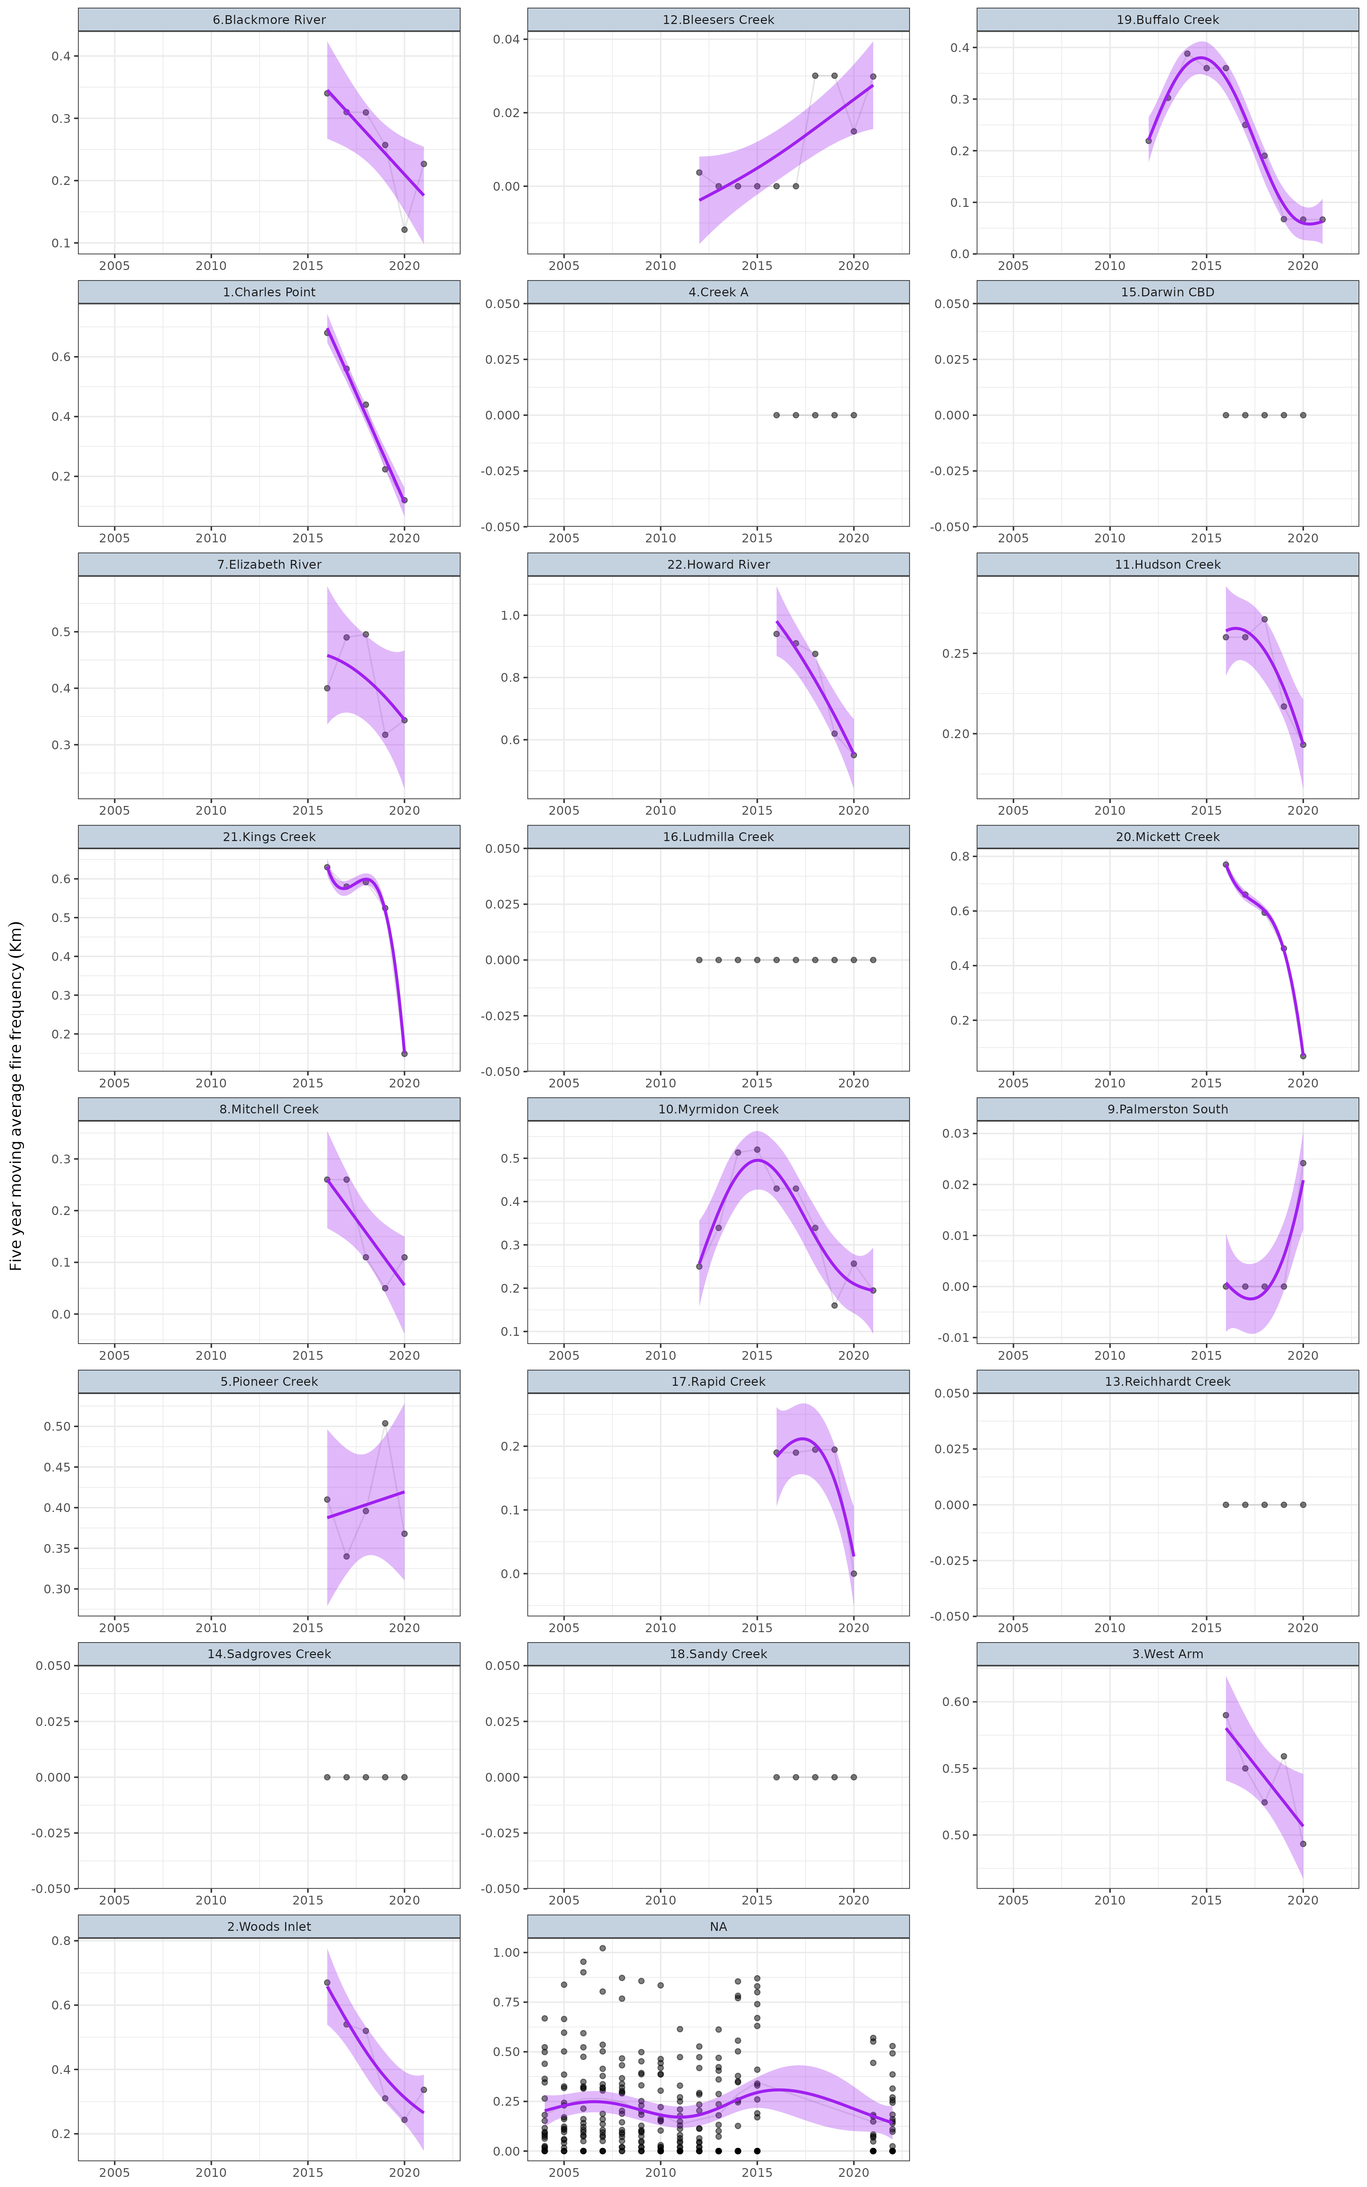

**Figure** **:** Temporal trends in Five year moving average fire frequency (Km) within each of the Zones. Points represent collected observations at unique lat/long/Year combinations. Each individual point is 80% transparent, and thus darker points represent a greater quantity of observations with similar values. Faint lines join sets of observations collected at the same lat/long over time. Purple lines represent simple Generalized Additive Modeling splines with 95% confidence envelopes. Note, these are purely simple models that do not take into account any dependency structures (e.g. do not include random effects or autoregressive terms).

### Five year standard deviation fire frequency (Km)

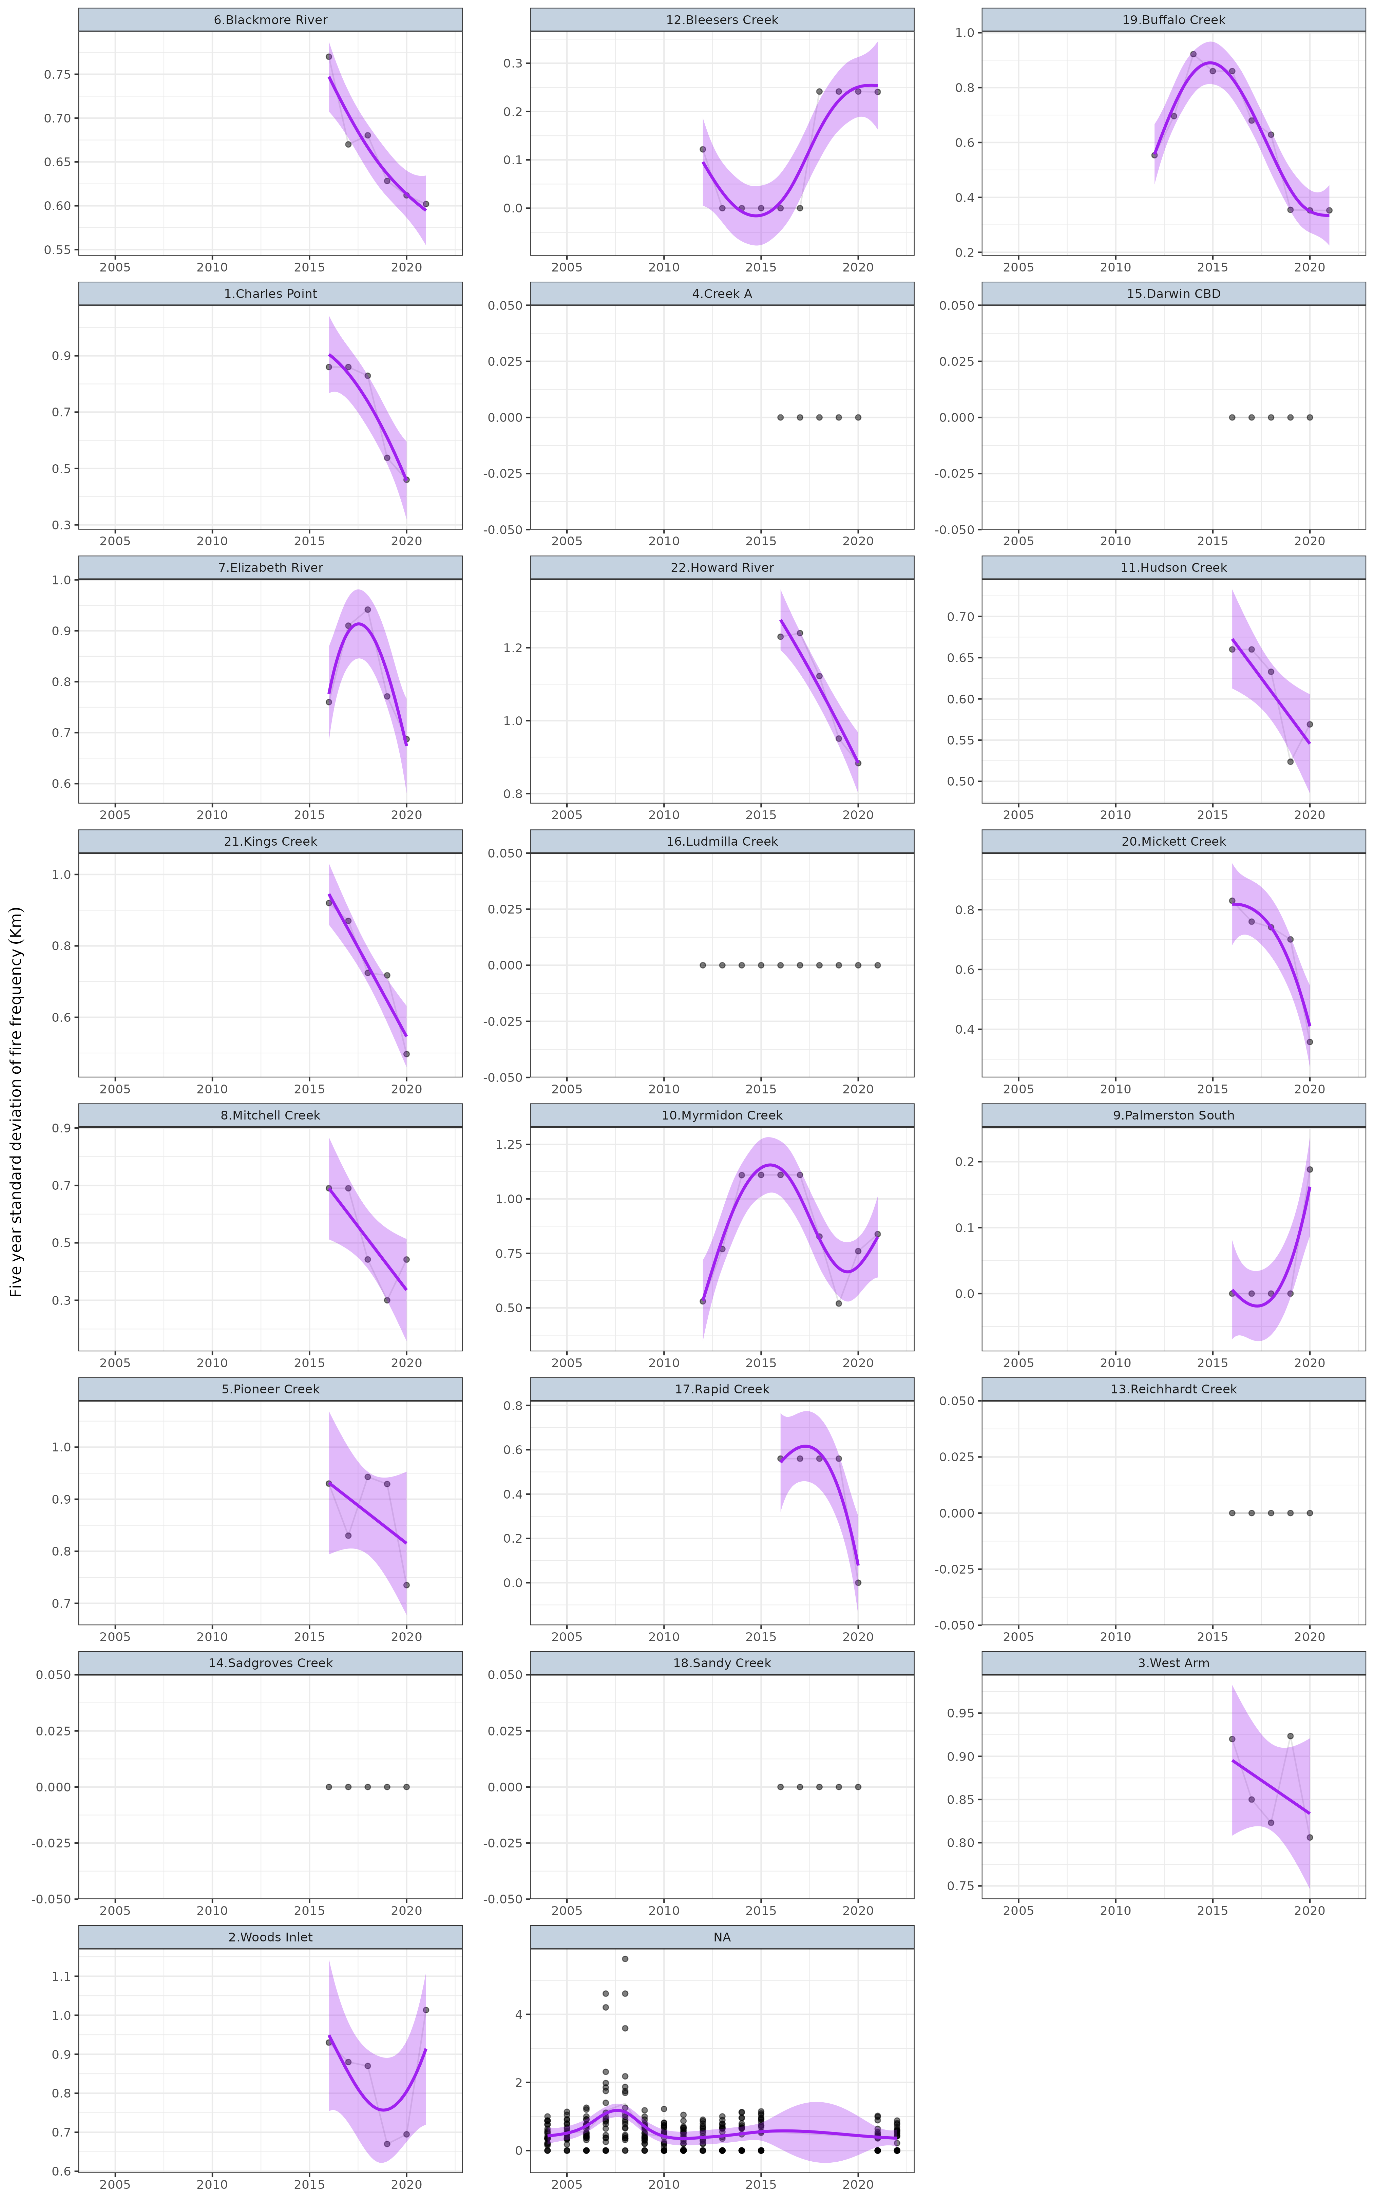

**Figure** **:** Temporal trends in Five year standard deviation fire frequency (Km) within each of the Zones. Points represent collected observations at unique lat/long/Year combinations. Each individual point is 80% transparent, and thus darker points represent a greater quantity of observations with similar values. Faint lines join sets of observations collected at the same lat/long over time. Purple lines represent simple Generalized Additive Modeling splines with 95% confidence envelopes. Note, these are purely simple models that do not take into account any dependency structures (e.g. do not include random effects or autoregressive terms).

### Total fire area (Km²)

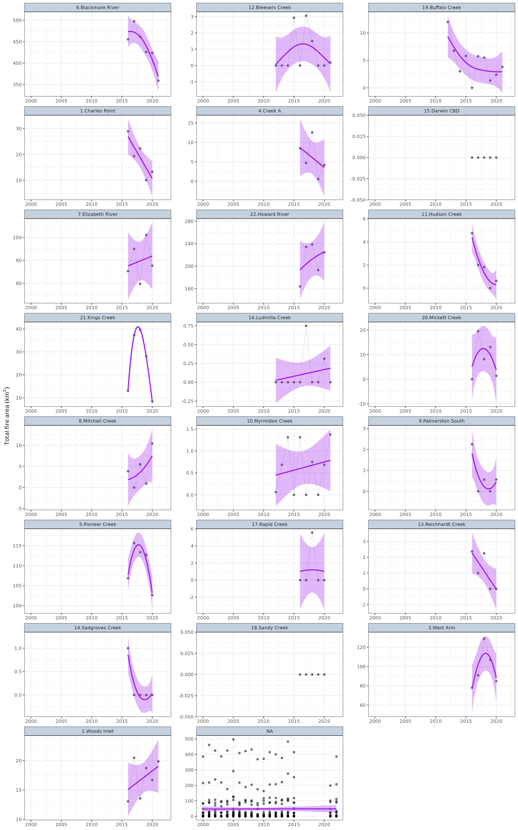

**Figure** **:** Temporal trends in Total fire area (Km²) within each of the Zones. Points represent collected observations at unique lat/long/Year combinations. Each individual point is 80% transparent, and thus darker points represent a greater quantity of observations with similar values. Faint lines join sets of observations collected at the same lat/long over time. Purple lines represent simple Generalized Additive Modeling splines with 95% confidence envelopes. Note, these are purely simple models that do not take into account any dependency structures (e.g. do not include random effects or autoregressive terms).

### Percentage fire area (%)

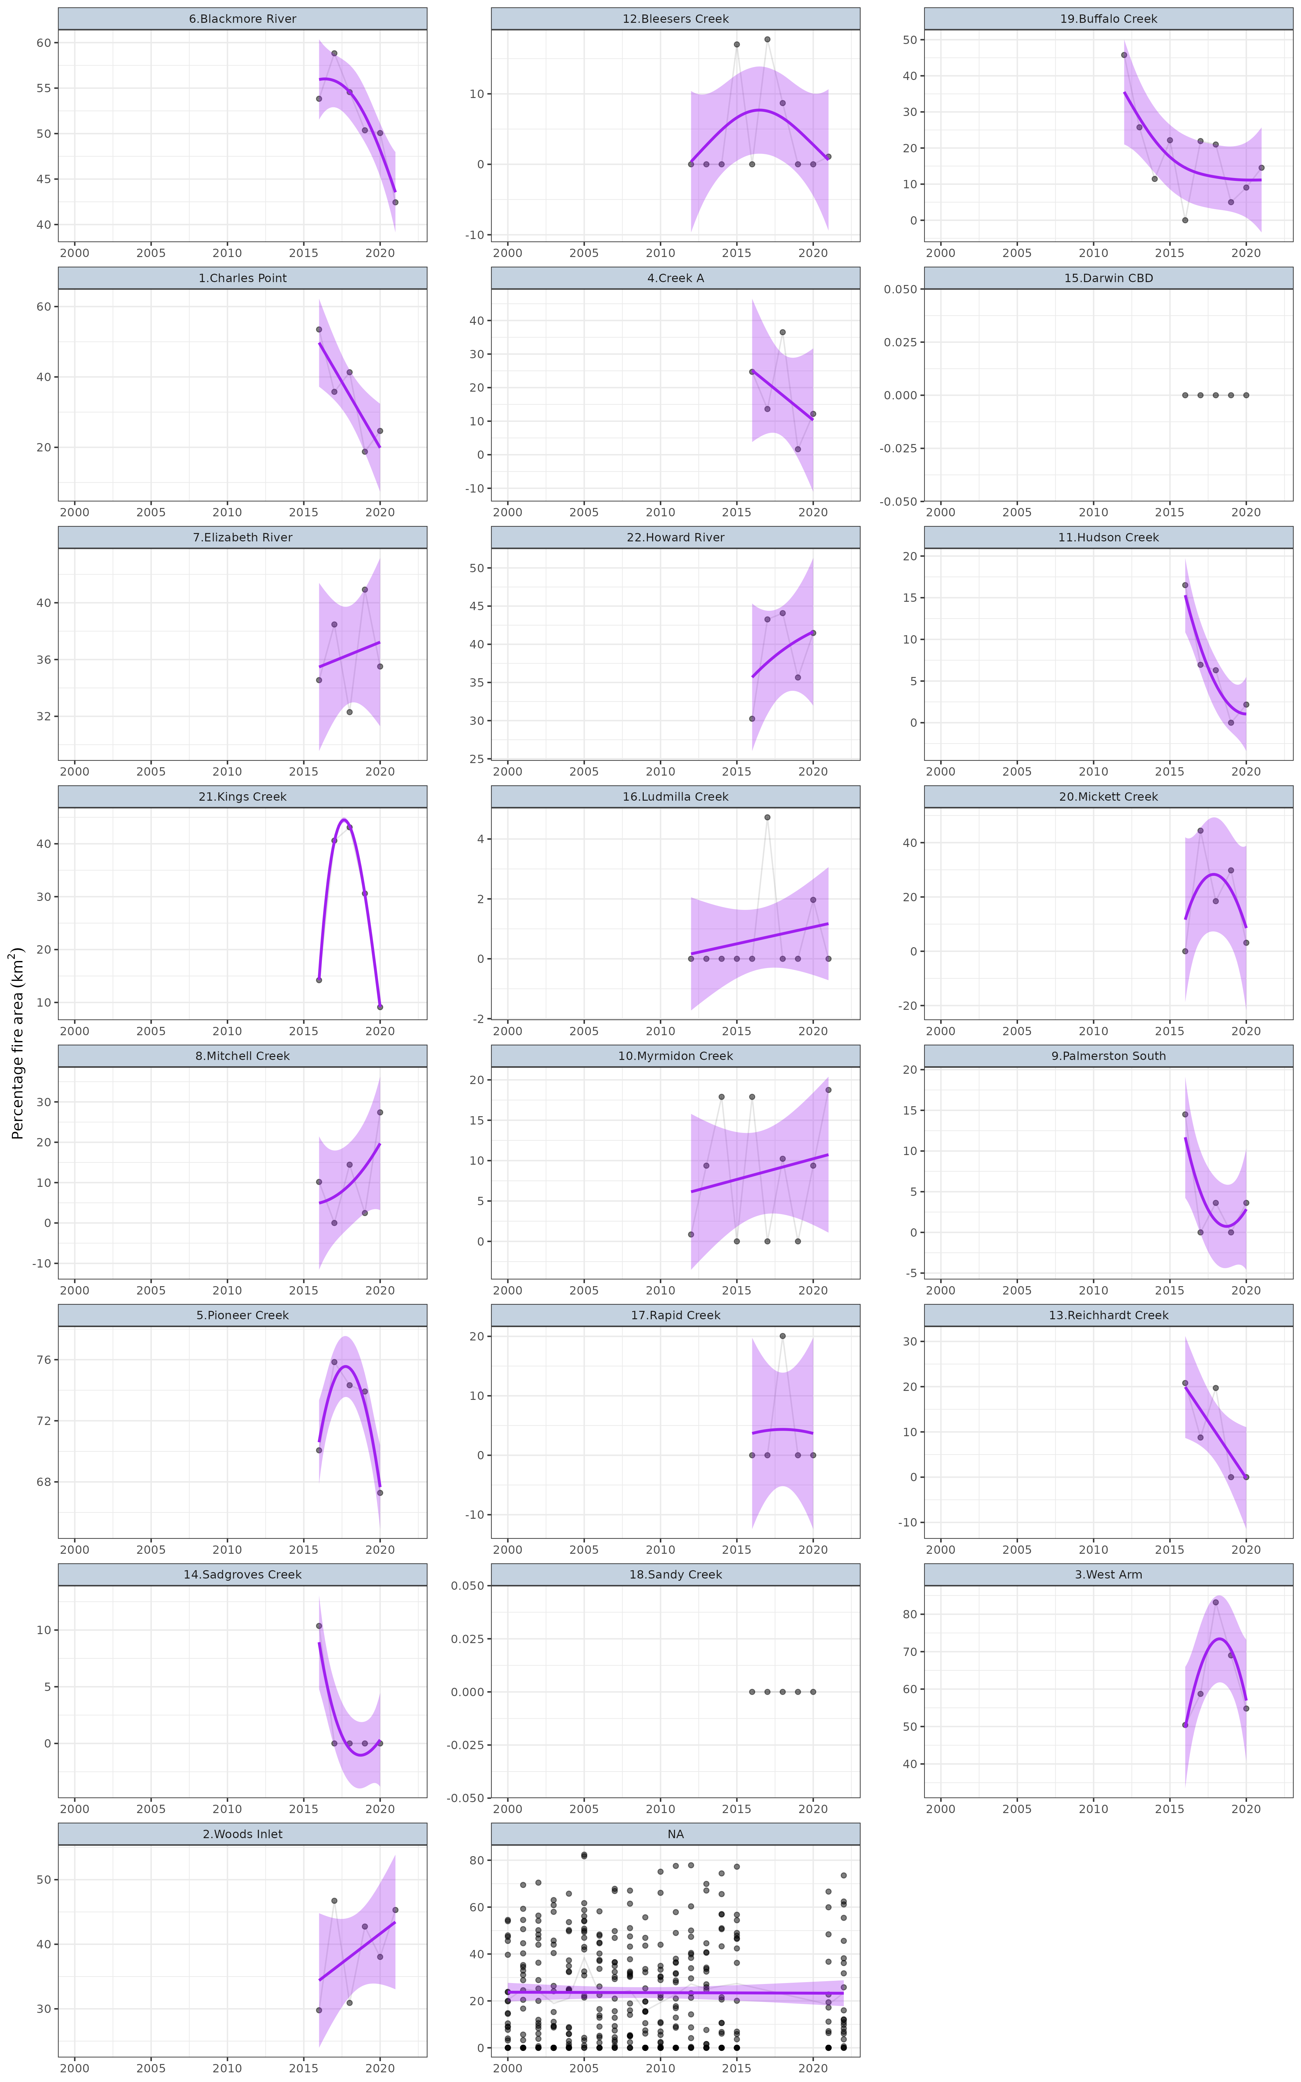

**Figure** **:** Temporal trends in Percentage fire area (%) within each of the Zones. Points represent collected observations at unique lat/long/Year combinations. Each individual point is 80% transparent, and thus darker points represent a greater quantity of observations with similar values. Faint lines join sets of observations collected at the same lat/long over time. Purple lines represent simple Generalized Additive Modeling splines with 95% confidence envelopes. Note, these are purely simple models that do not take into account any dependency structures (e.g. do not include random effects or autoregressive terms).

## Routine samples (stressors)

### Chlorophyl-a (µg/L)

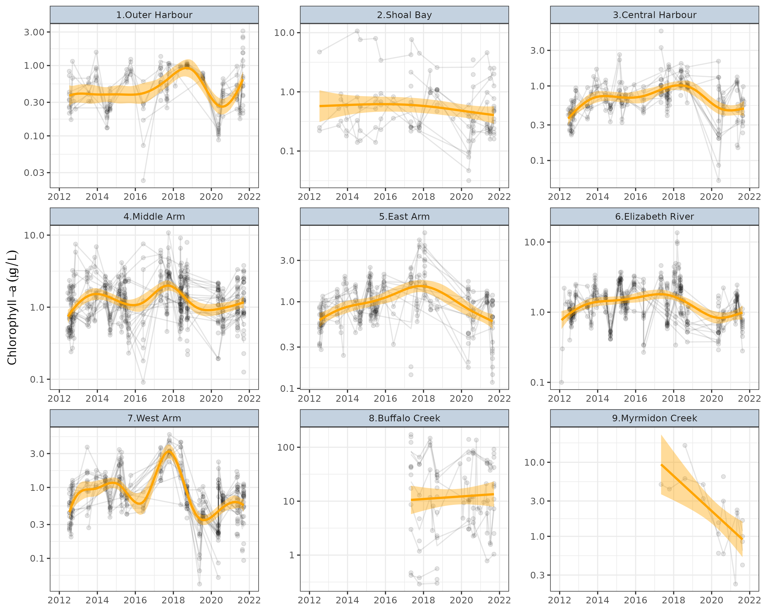

**Figure** **:** Temporal trends in Chlorophyll-a (µg/L) for routine sites within each of the Zones. Points represent collected observations at unique lat/long/Year combinations. Each individual point is 80% transparent, and thus darker points represent a greater quantity of observations with similar values. Faint lines join sets of observations collected at the same lat/long over time. Orange lines represent simple Generalized Additive Modeling splines with 95% confidence envelopes. Note, these are purely simple models that do not take into account any dependency structures (e.g. do not include random effects or autoregressive terms).

### Turbidity (NTU)

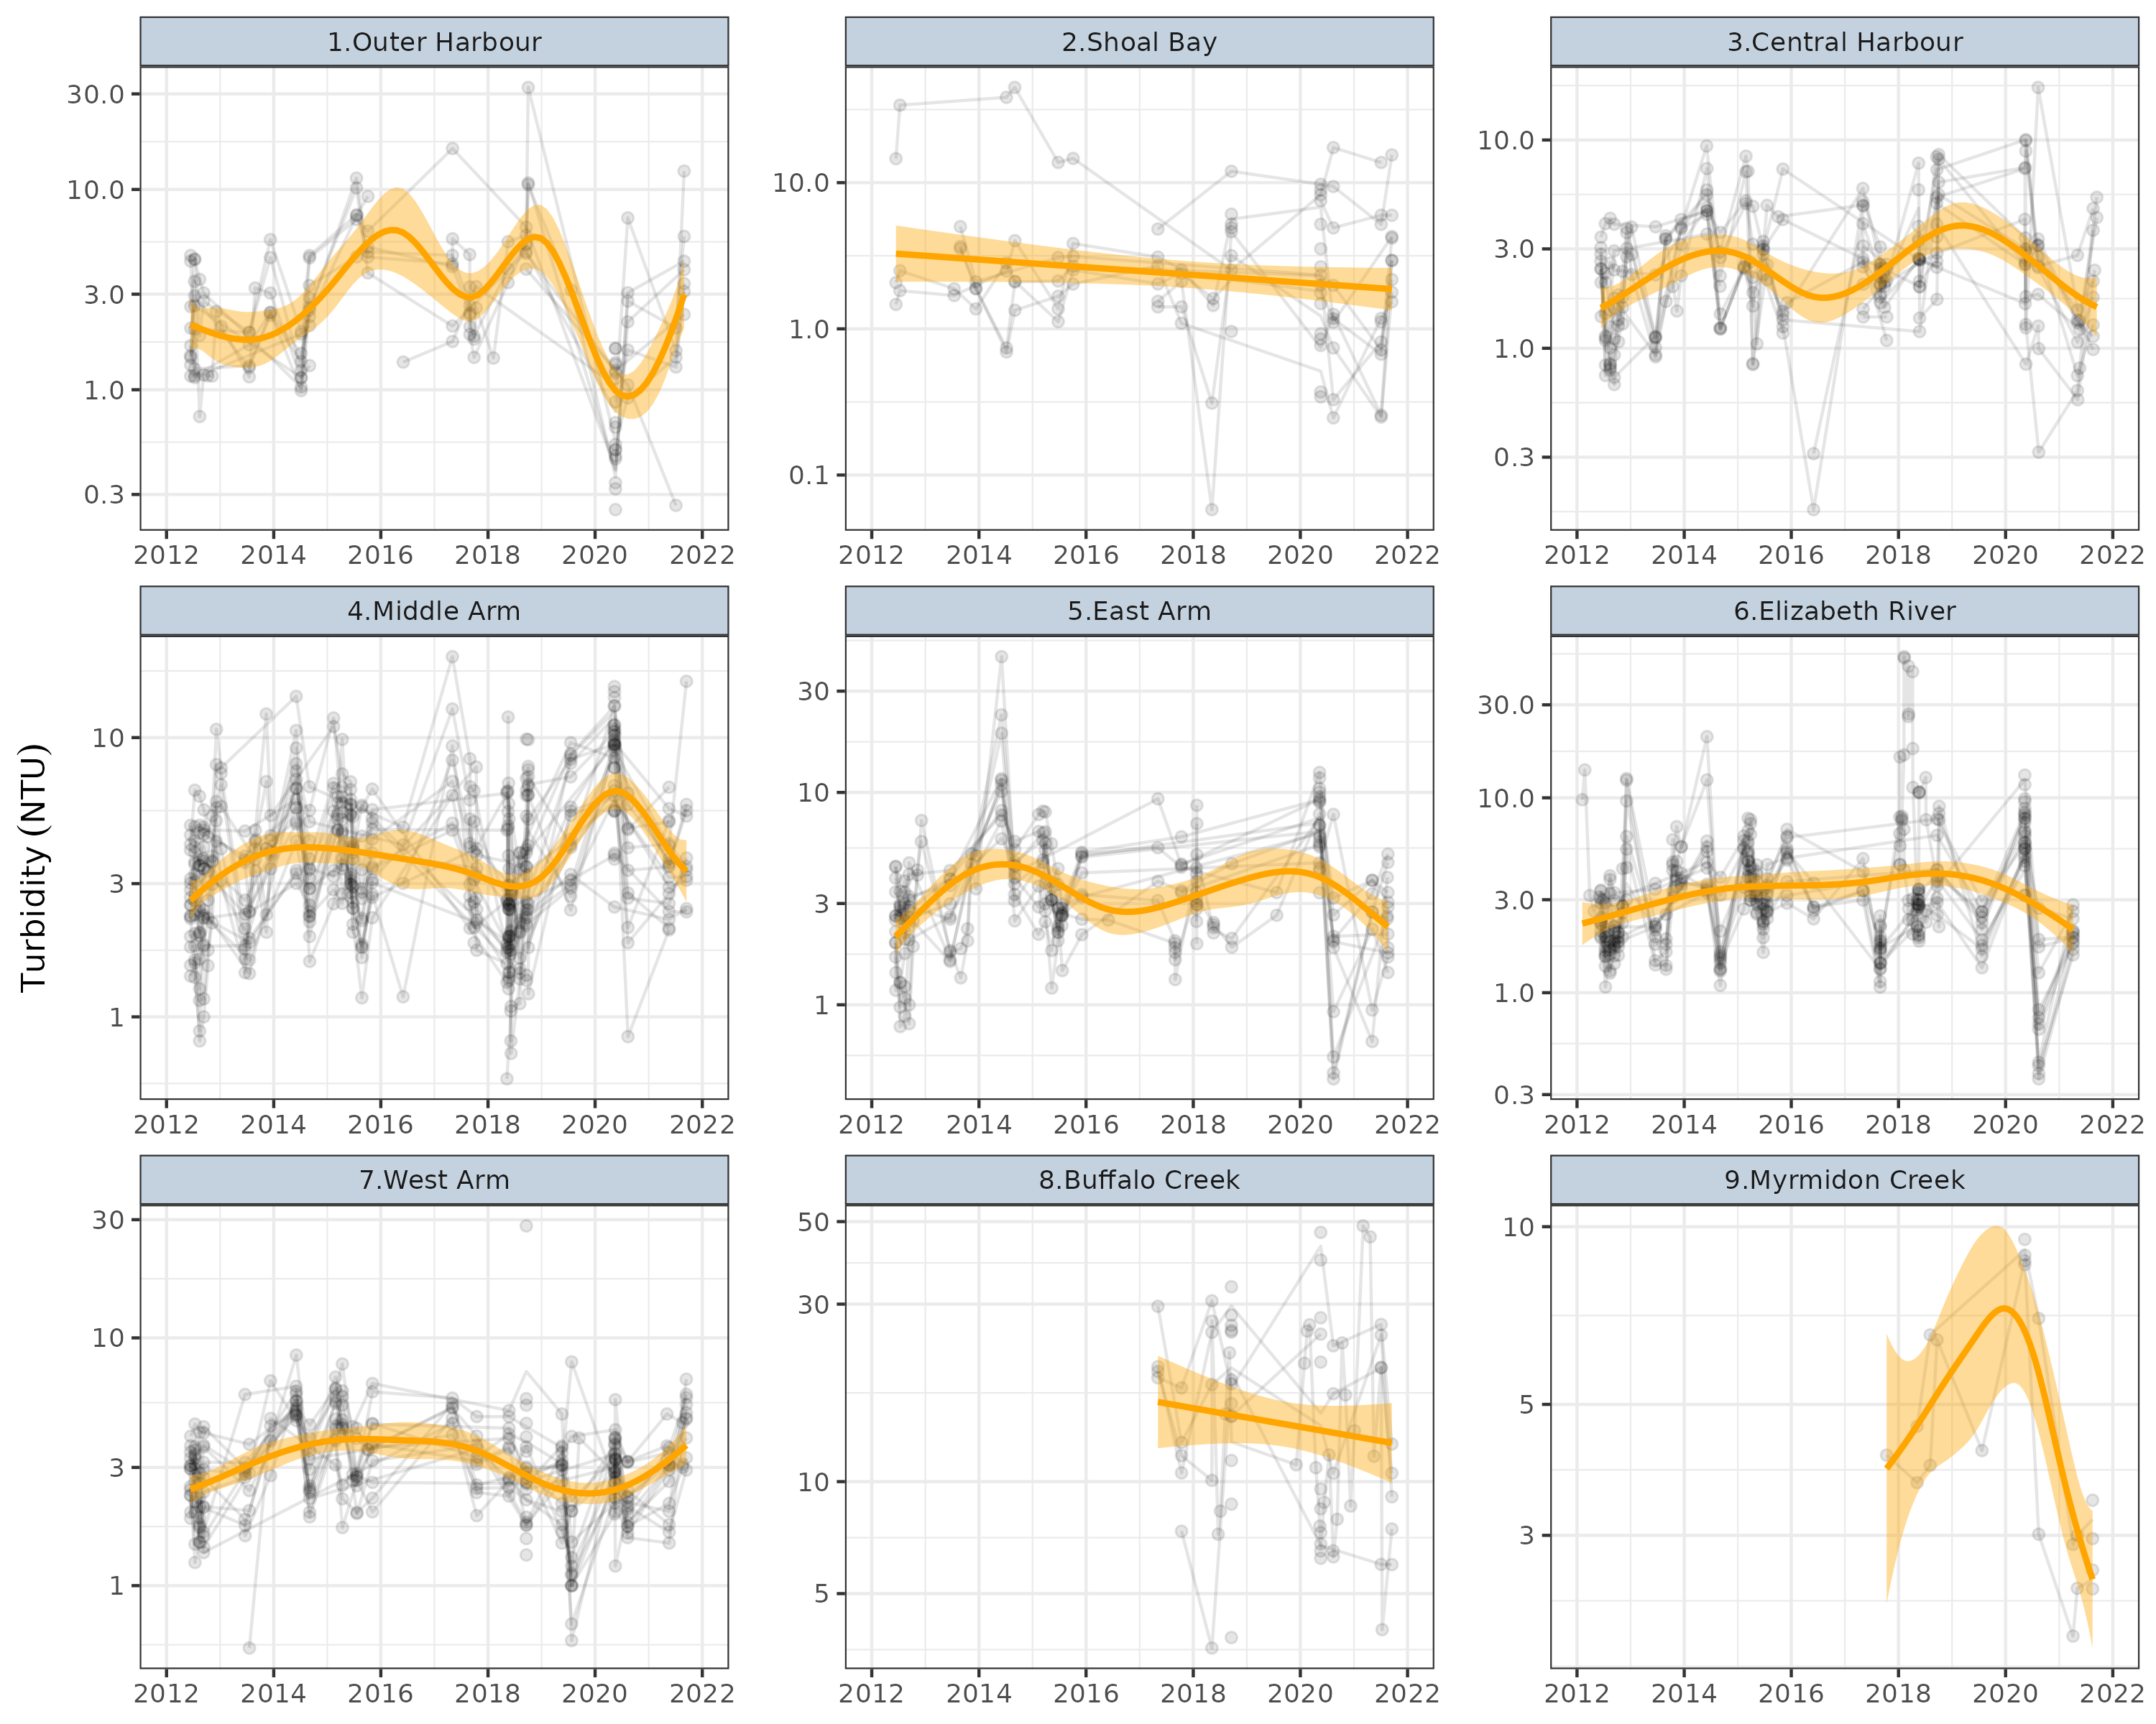

**Figure** **:** Temporal trends in Turbidity (NTU) for routine sites within each of the Zones. Points represent collected observations at unique lat/long/Year combinations. Each individual point is 80% transparent, and thus darker points represent a greater quantity of observations with similar values. Faint lines join sets of observations collected at the same lat/long over time. Orange lines represent simple Generalized Additive Modeling splines with 95% confidence envelopes. Note, these are purely simple models that do not take into account any dependency structures (e.g. do not include random effects or autoregressive terms).

### Dissolved Oxygen (% Saturation)

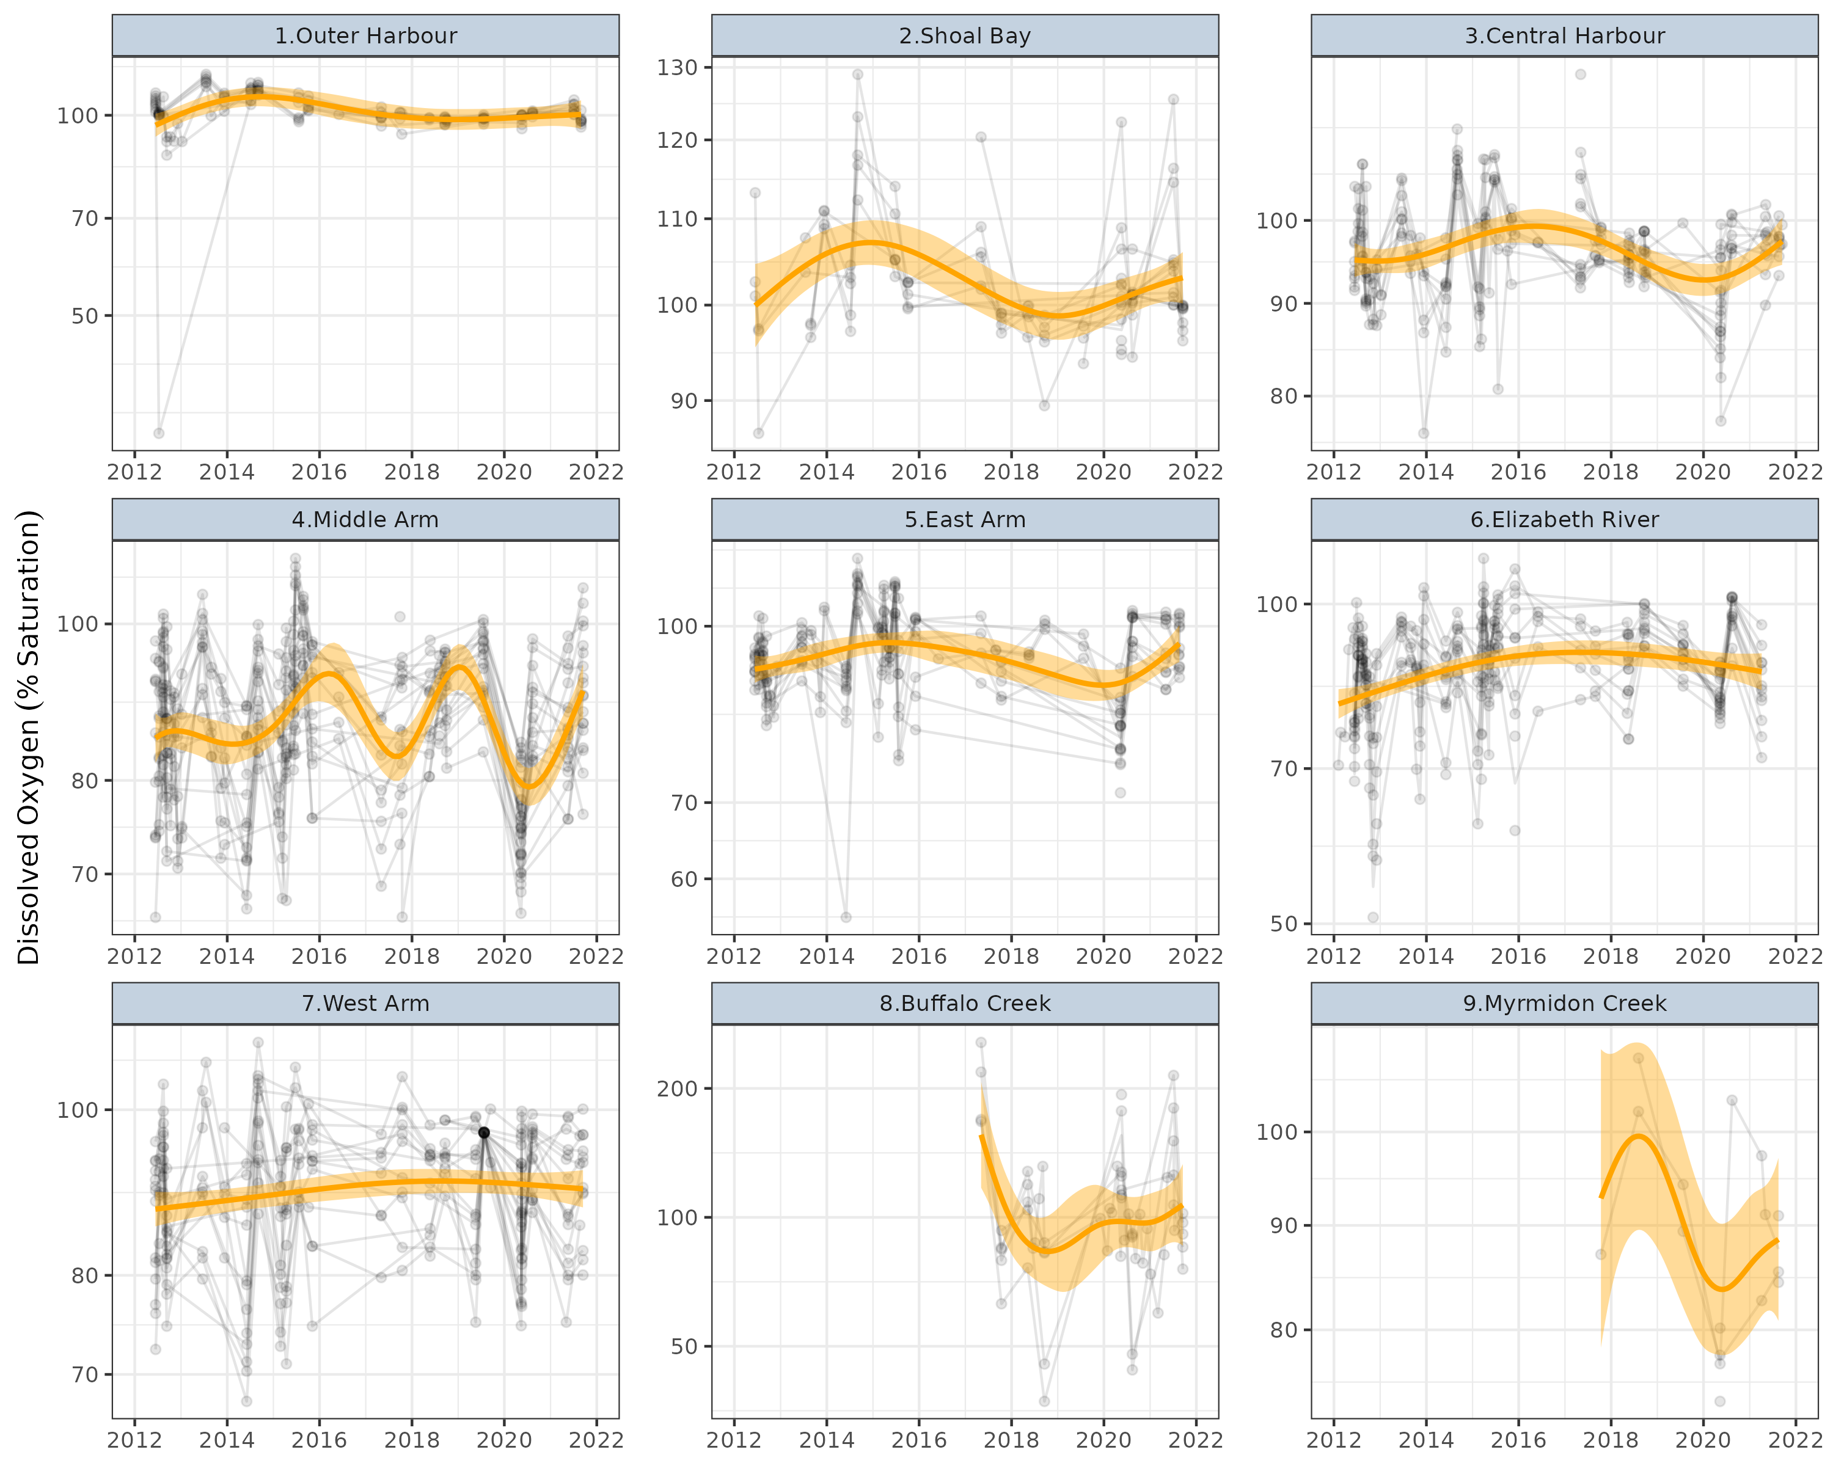

**Figure** **:** Temporal trends in Dissolved Oxygen (% Saturation) for routine sites within each of the Zones. Points represent collected observations at unique lat/long/Year combinations. Each individual point is 80% transparent, and thus darker points represent a greater quantity of observations with similar values. Faint lines join sets of observations collected at the same lat/long over time. Orange lines represent simple Generalized Additive Modeling splines with 95% confidence envelopes. Note, these are purely simple models that do not take into account any dependency structures (e.g. do not include random effects or autoregressive terms).

### Ammonia (µg/L)

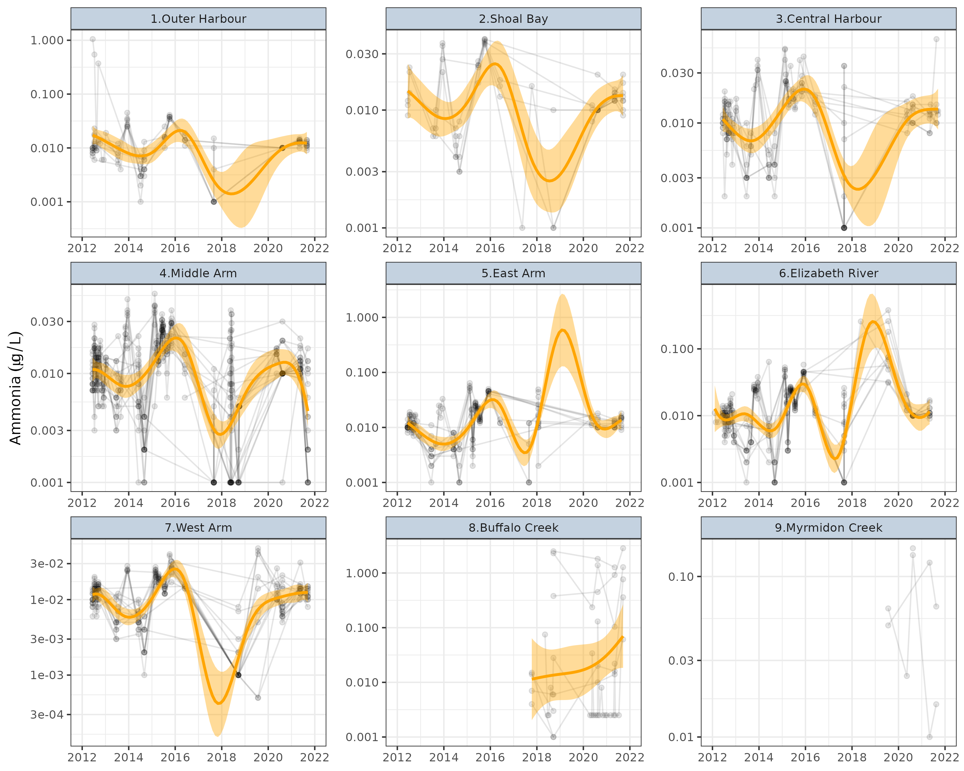

**Figure** **:** Temporal trends in Ammonia (µg/L) for routine sites within each of the Zones. Points represent collected observations at unique lat/long/Year combinations. Each individual point is 80% transparent, and thus darker points represent a greater quantity of observations with similar values. Faint lines join sets of observations collected at the same lat/long over time. Orange lines represent simple Generalized Additive Modeling splines with 95% confidence envelopes. Note, these are purely simple models that do not take into account any dependency structures (e.g. do not include random effects or autoregressive terms).

### Filterable Reactive Phosphate (µg/L)

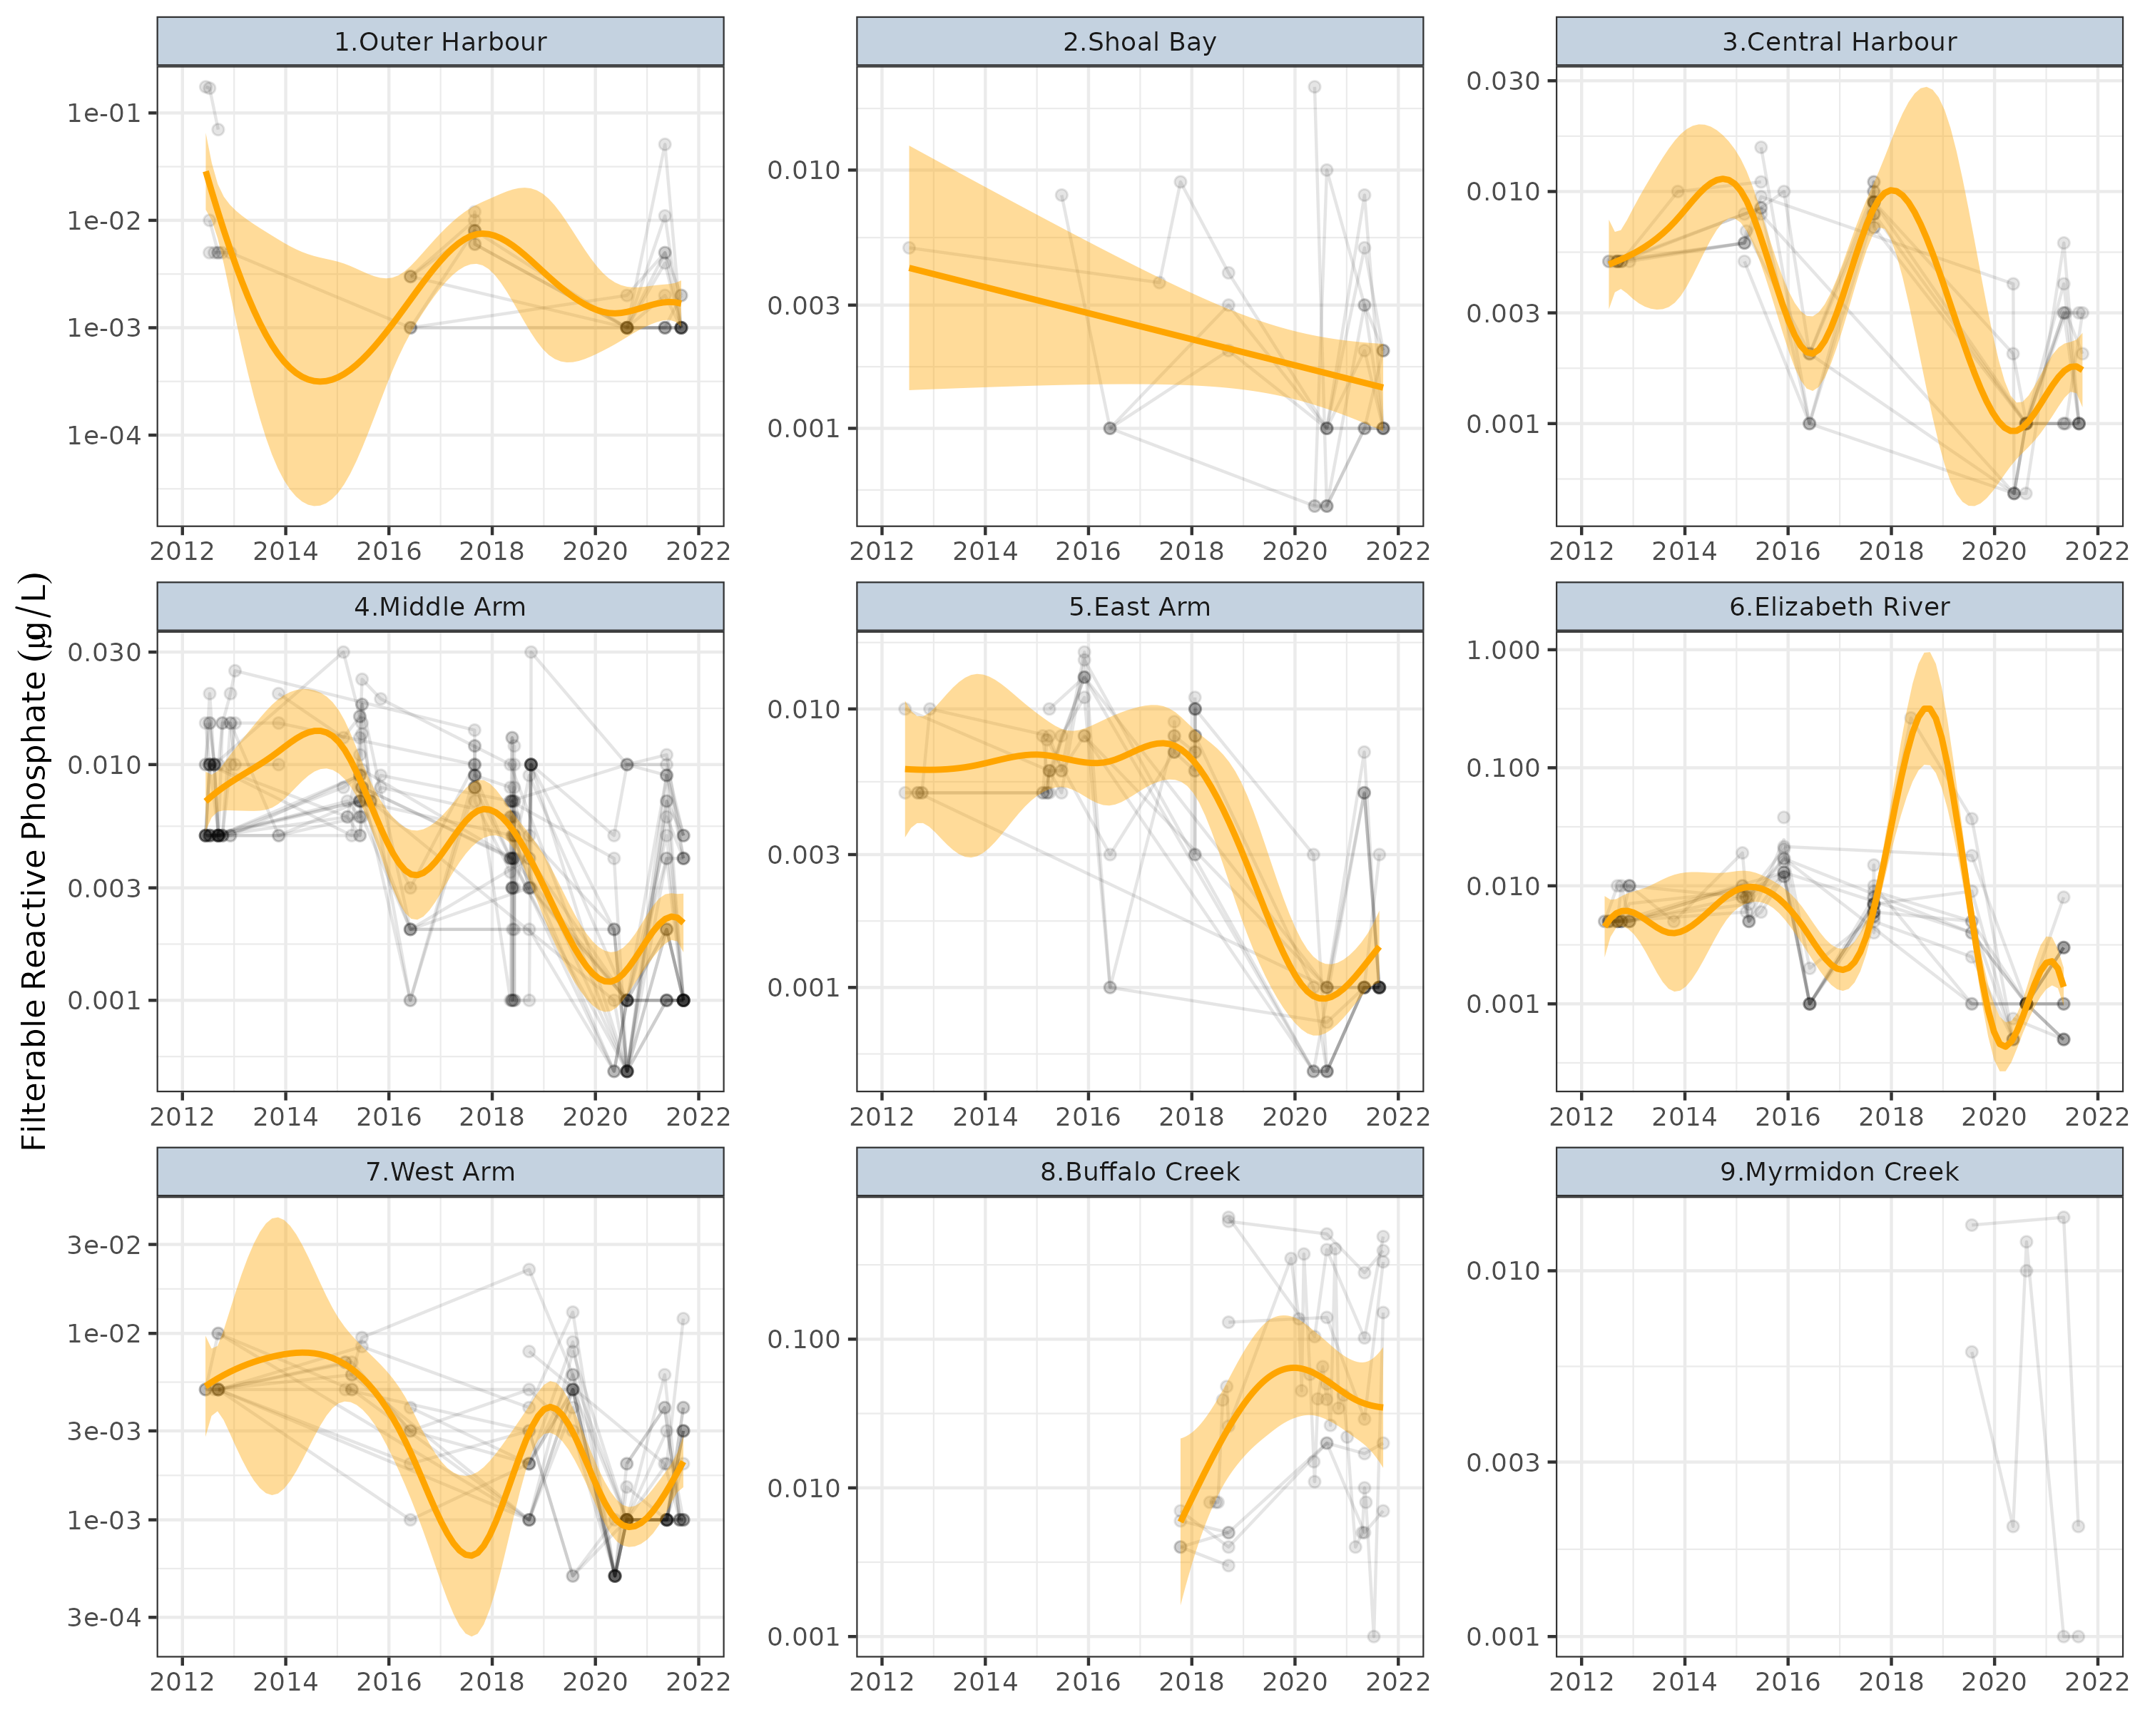

**Figure** **:** Temporal trends in Filterable Reactive Phosphate (µg/L) for routine sites within each of the Zones. Points represent collected observations at unique lat/long/Year combinations. Each individual point is 80% transparent, and thus darker points represent a greater quantity of observations with similar values. Faint lines join sets of observations collected at the same lat/long over time. Orange lines represent simple Generalized Additive Modeling splines with 95% confidence envelopes. Note, these are purely simple models that do not take into account any dependency structures (e.g. do not include random effects or autoregressive terms).

### NOx as N (µg/L)

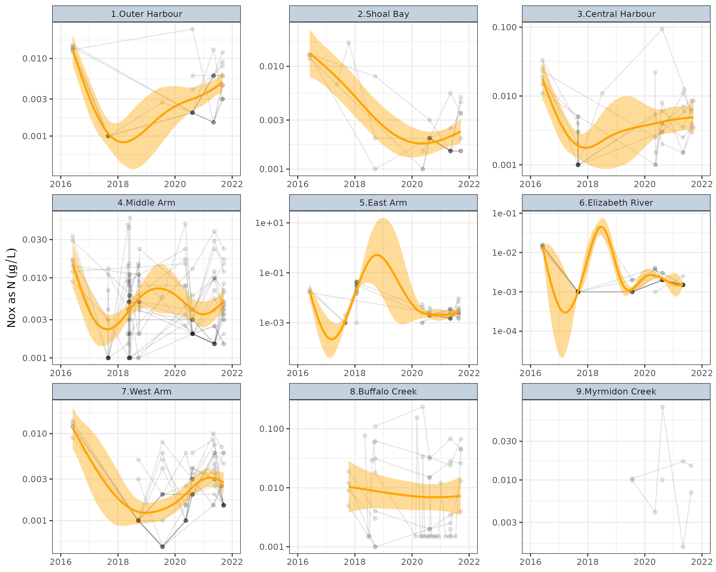

**Figure** **:** Temporal trends in NOx as N (µg/L) for routine sites within each of the Zones. Points represent collected observations at unique lat/long/Year combinations. Each individual point is 80% transparent, and thus darker points represent a greater quantity of observations with similar values. Faint lines join sets of observations collected at the same lat/long over time. Orange lines represent simple Generalized Additive Modeling splines with 95% confidence envelopes. Note, these are purely simple models that do not take into account any dependency structures (e.g. do not include random effects or autoregressive terms).

## Discrete samples (stressors)

### Chlorophyl-a (µg/L)

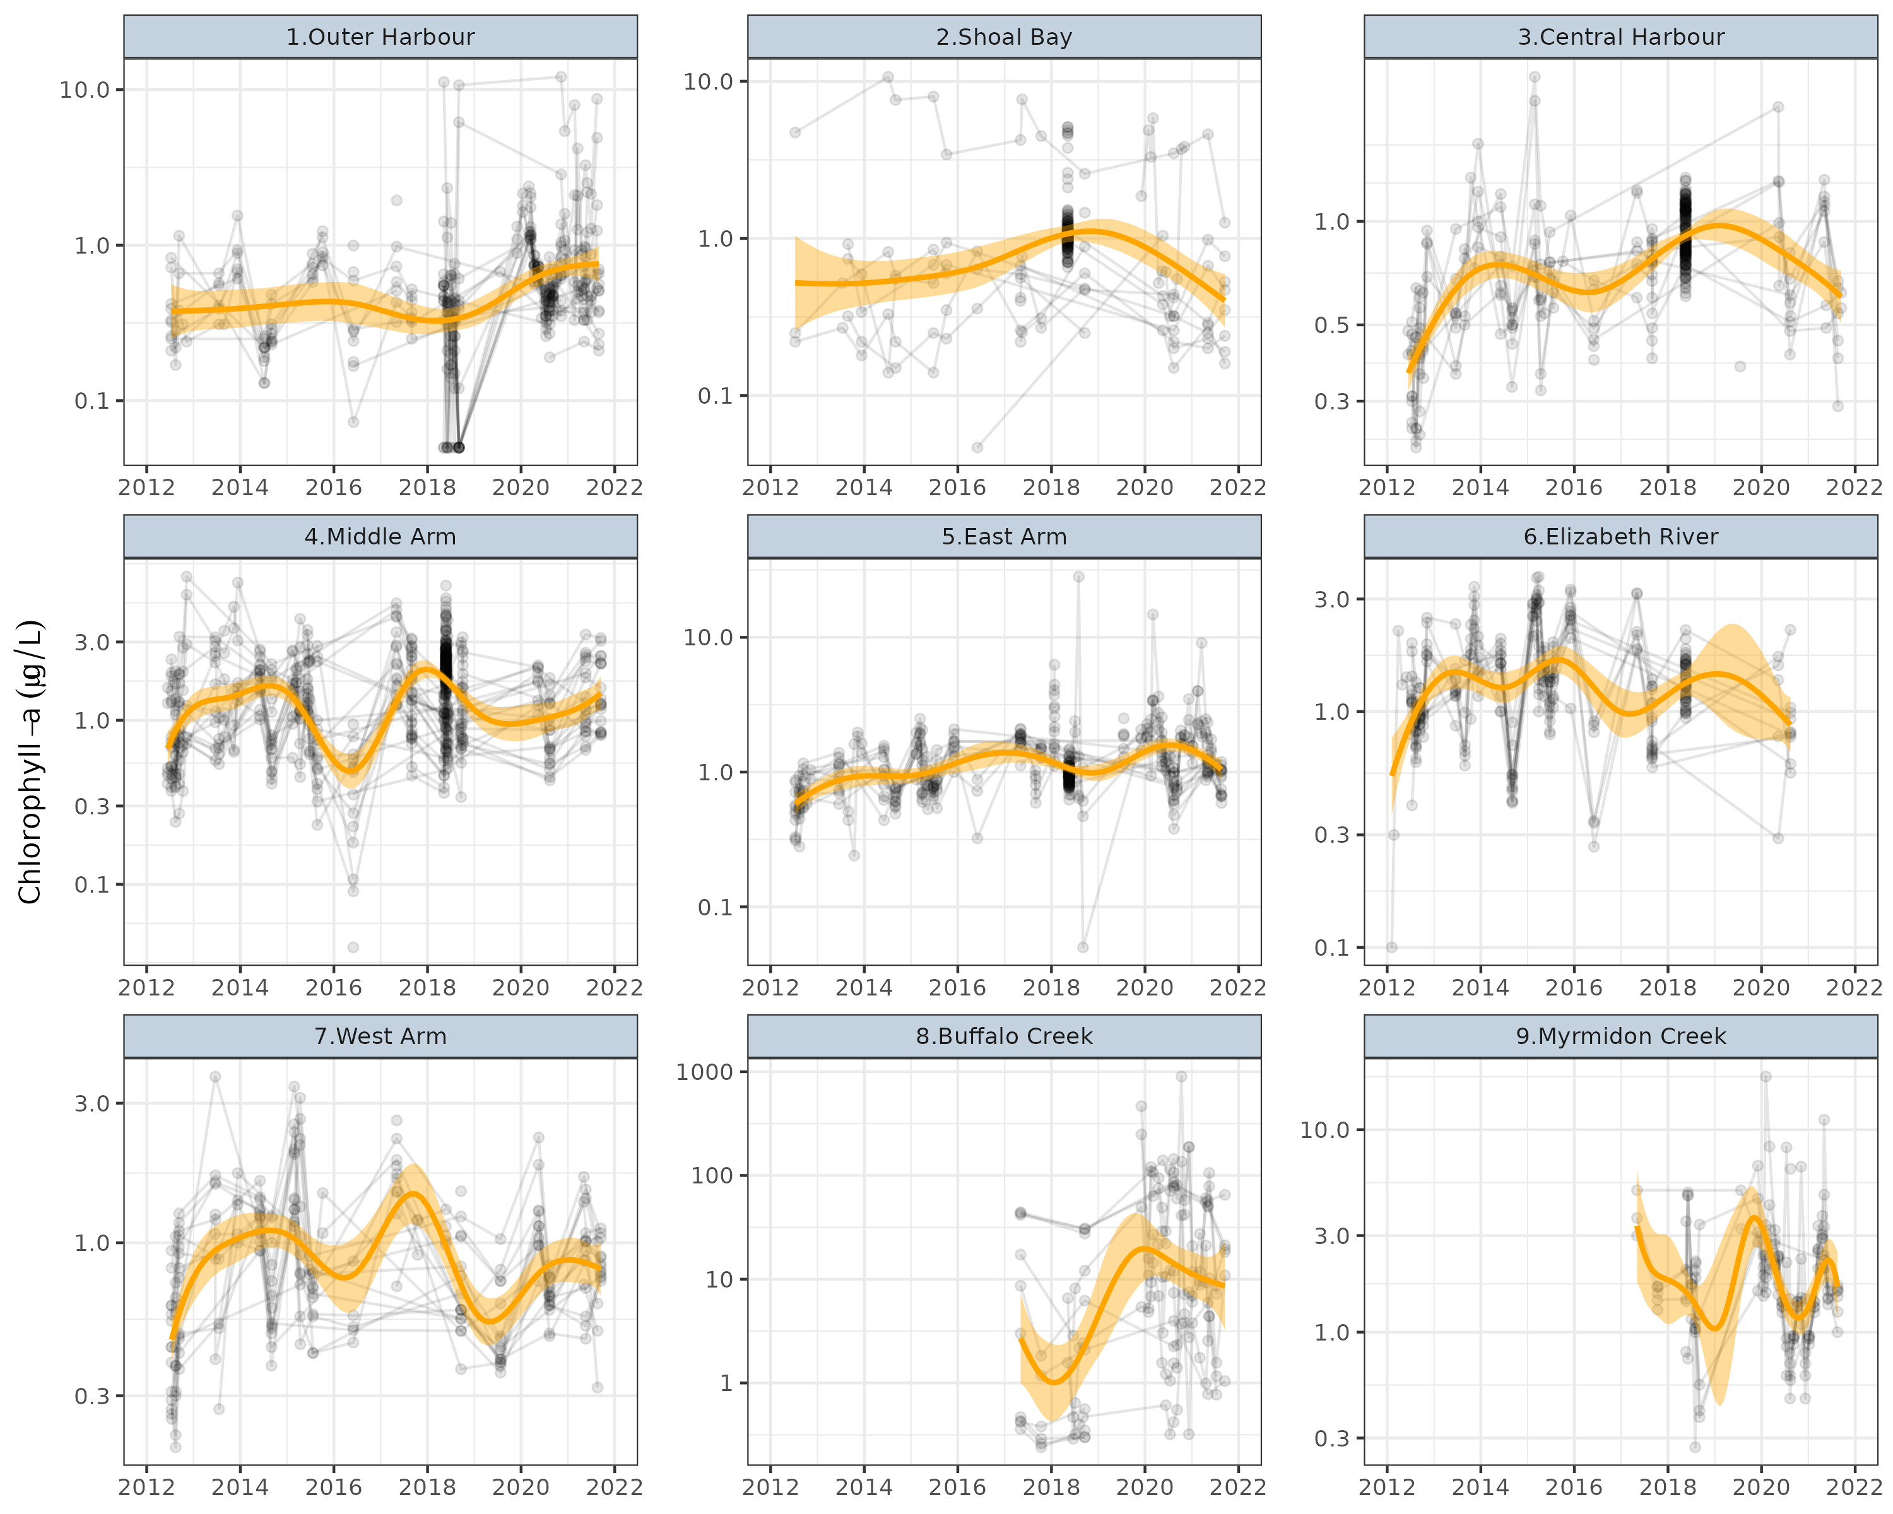

**Figure** **:** Temporal trends in Chlorophyll-a (µg/L) for discrete sites within each of the Zones. Points represent collected observations at unique lat/long/Year combinations. Each individual point is 80% transparent, and thus darker points represent a greater quantity of observations with similar values. Faint lines join sets of observations collected at the same lat/long over time. Orange lines represent simple Generalized Additive Modeling splines with 95% confidence envelopes. Note, these are purely simple models that do not take into account any dependency structures (e.g. do not include random effects or autoregressive terms).

### Turbidity (NTU)

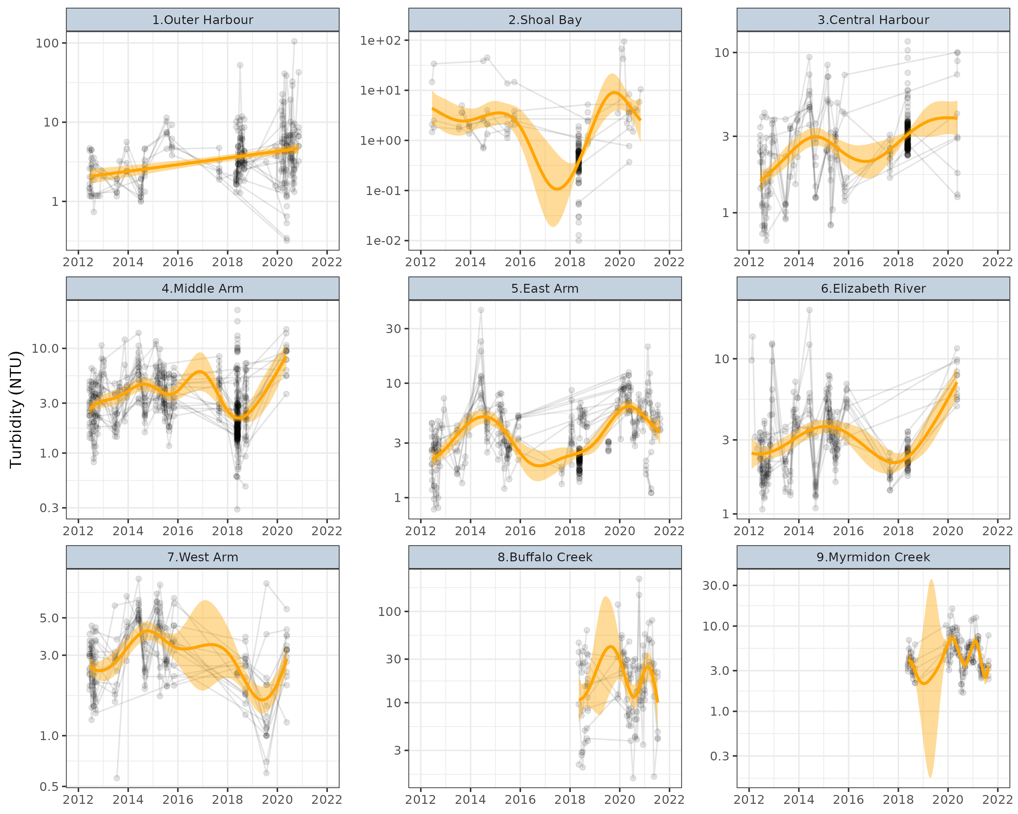

**Figure** **:** Temporal trends in Turbidity (NTU) for routine sites within each of the Zones. Points represent collected observations at unique lat/long/Year combinations. Each individual point is 80% transparent, and thus darker points represent a greater quantity of observations with similar values. Faint lines join sets of observations collected at the same lat/long over time. Orange lines represent simple Generalized Additive Modeling splines with 95% confidence envelopes. Note, these are purely simple models that do not take into account any dependency structures (e.g. do not include random effects or autoregressive terms).

### Dissolved Oxygen (% Saturation)

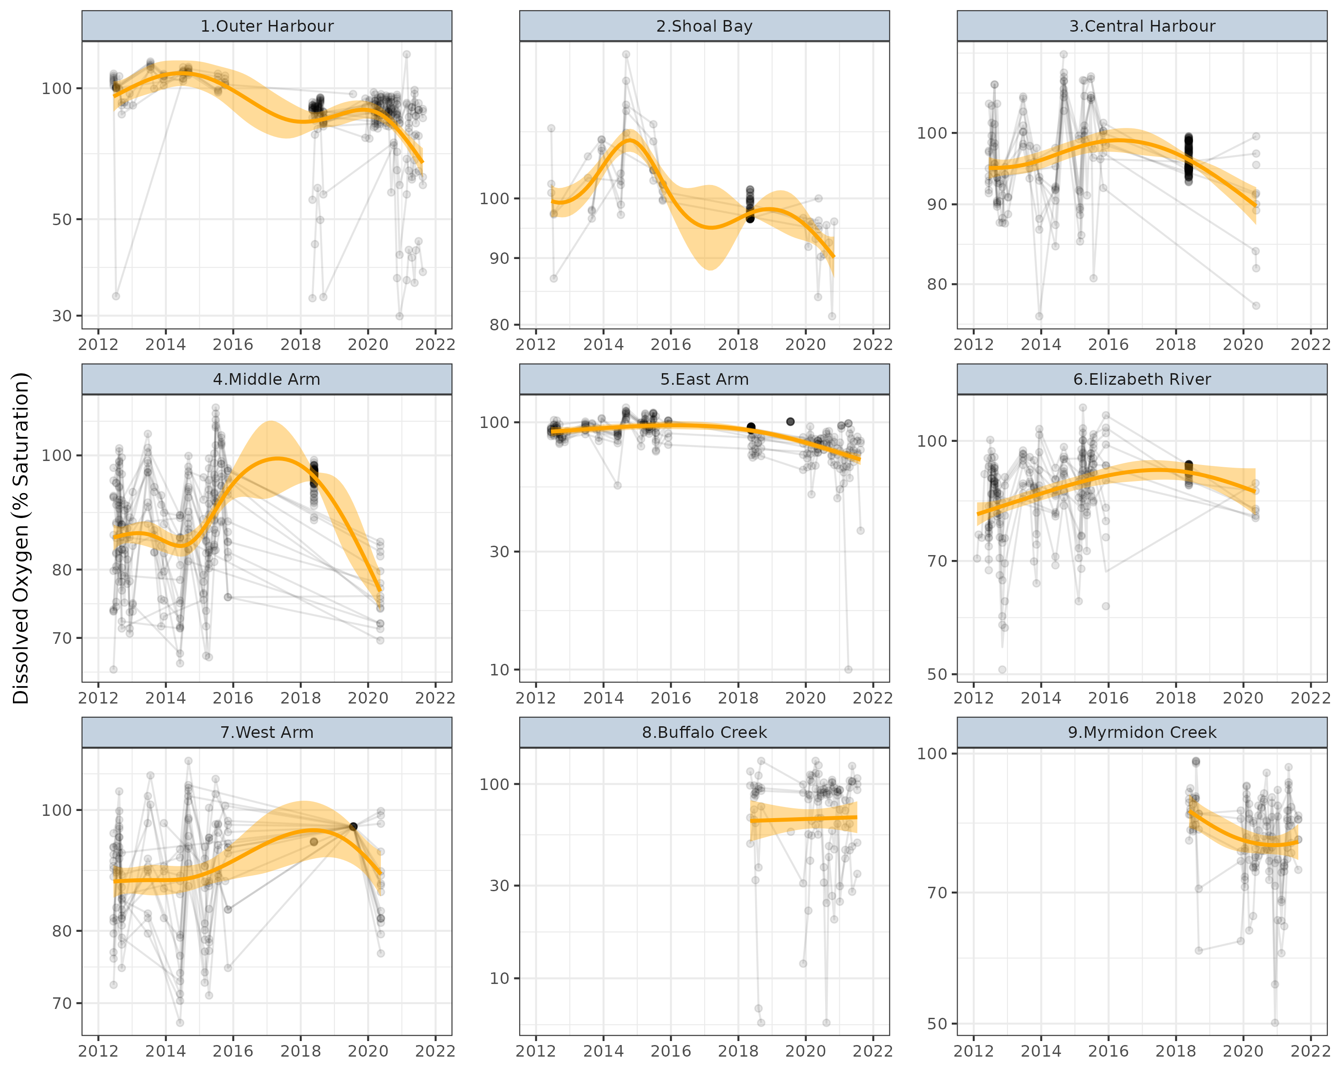

**Figure** **:** Temporal trends in Dissolved Oxygen (% Saturation) for discrete sites within each of the Zones. Points represent collected observations at unique lat/long/Year combinations. Each individual point is 80% transparent, and thus darker points represent a greater quantity of observations with similar values. Faint lines join sets of observations collected at the same lat/long over time. Orange lines represent simple Generalized Additive Modeling splines with 95% confidence envelopes. Note, these are purely simple models that do not take into account any dependency structures (e.g. do not include random effects or autoregressive terms).

### Ammonia (µg/L)

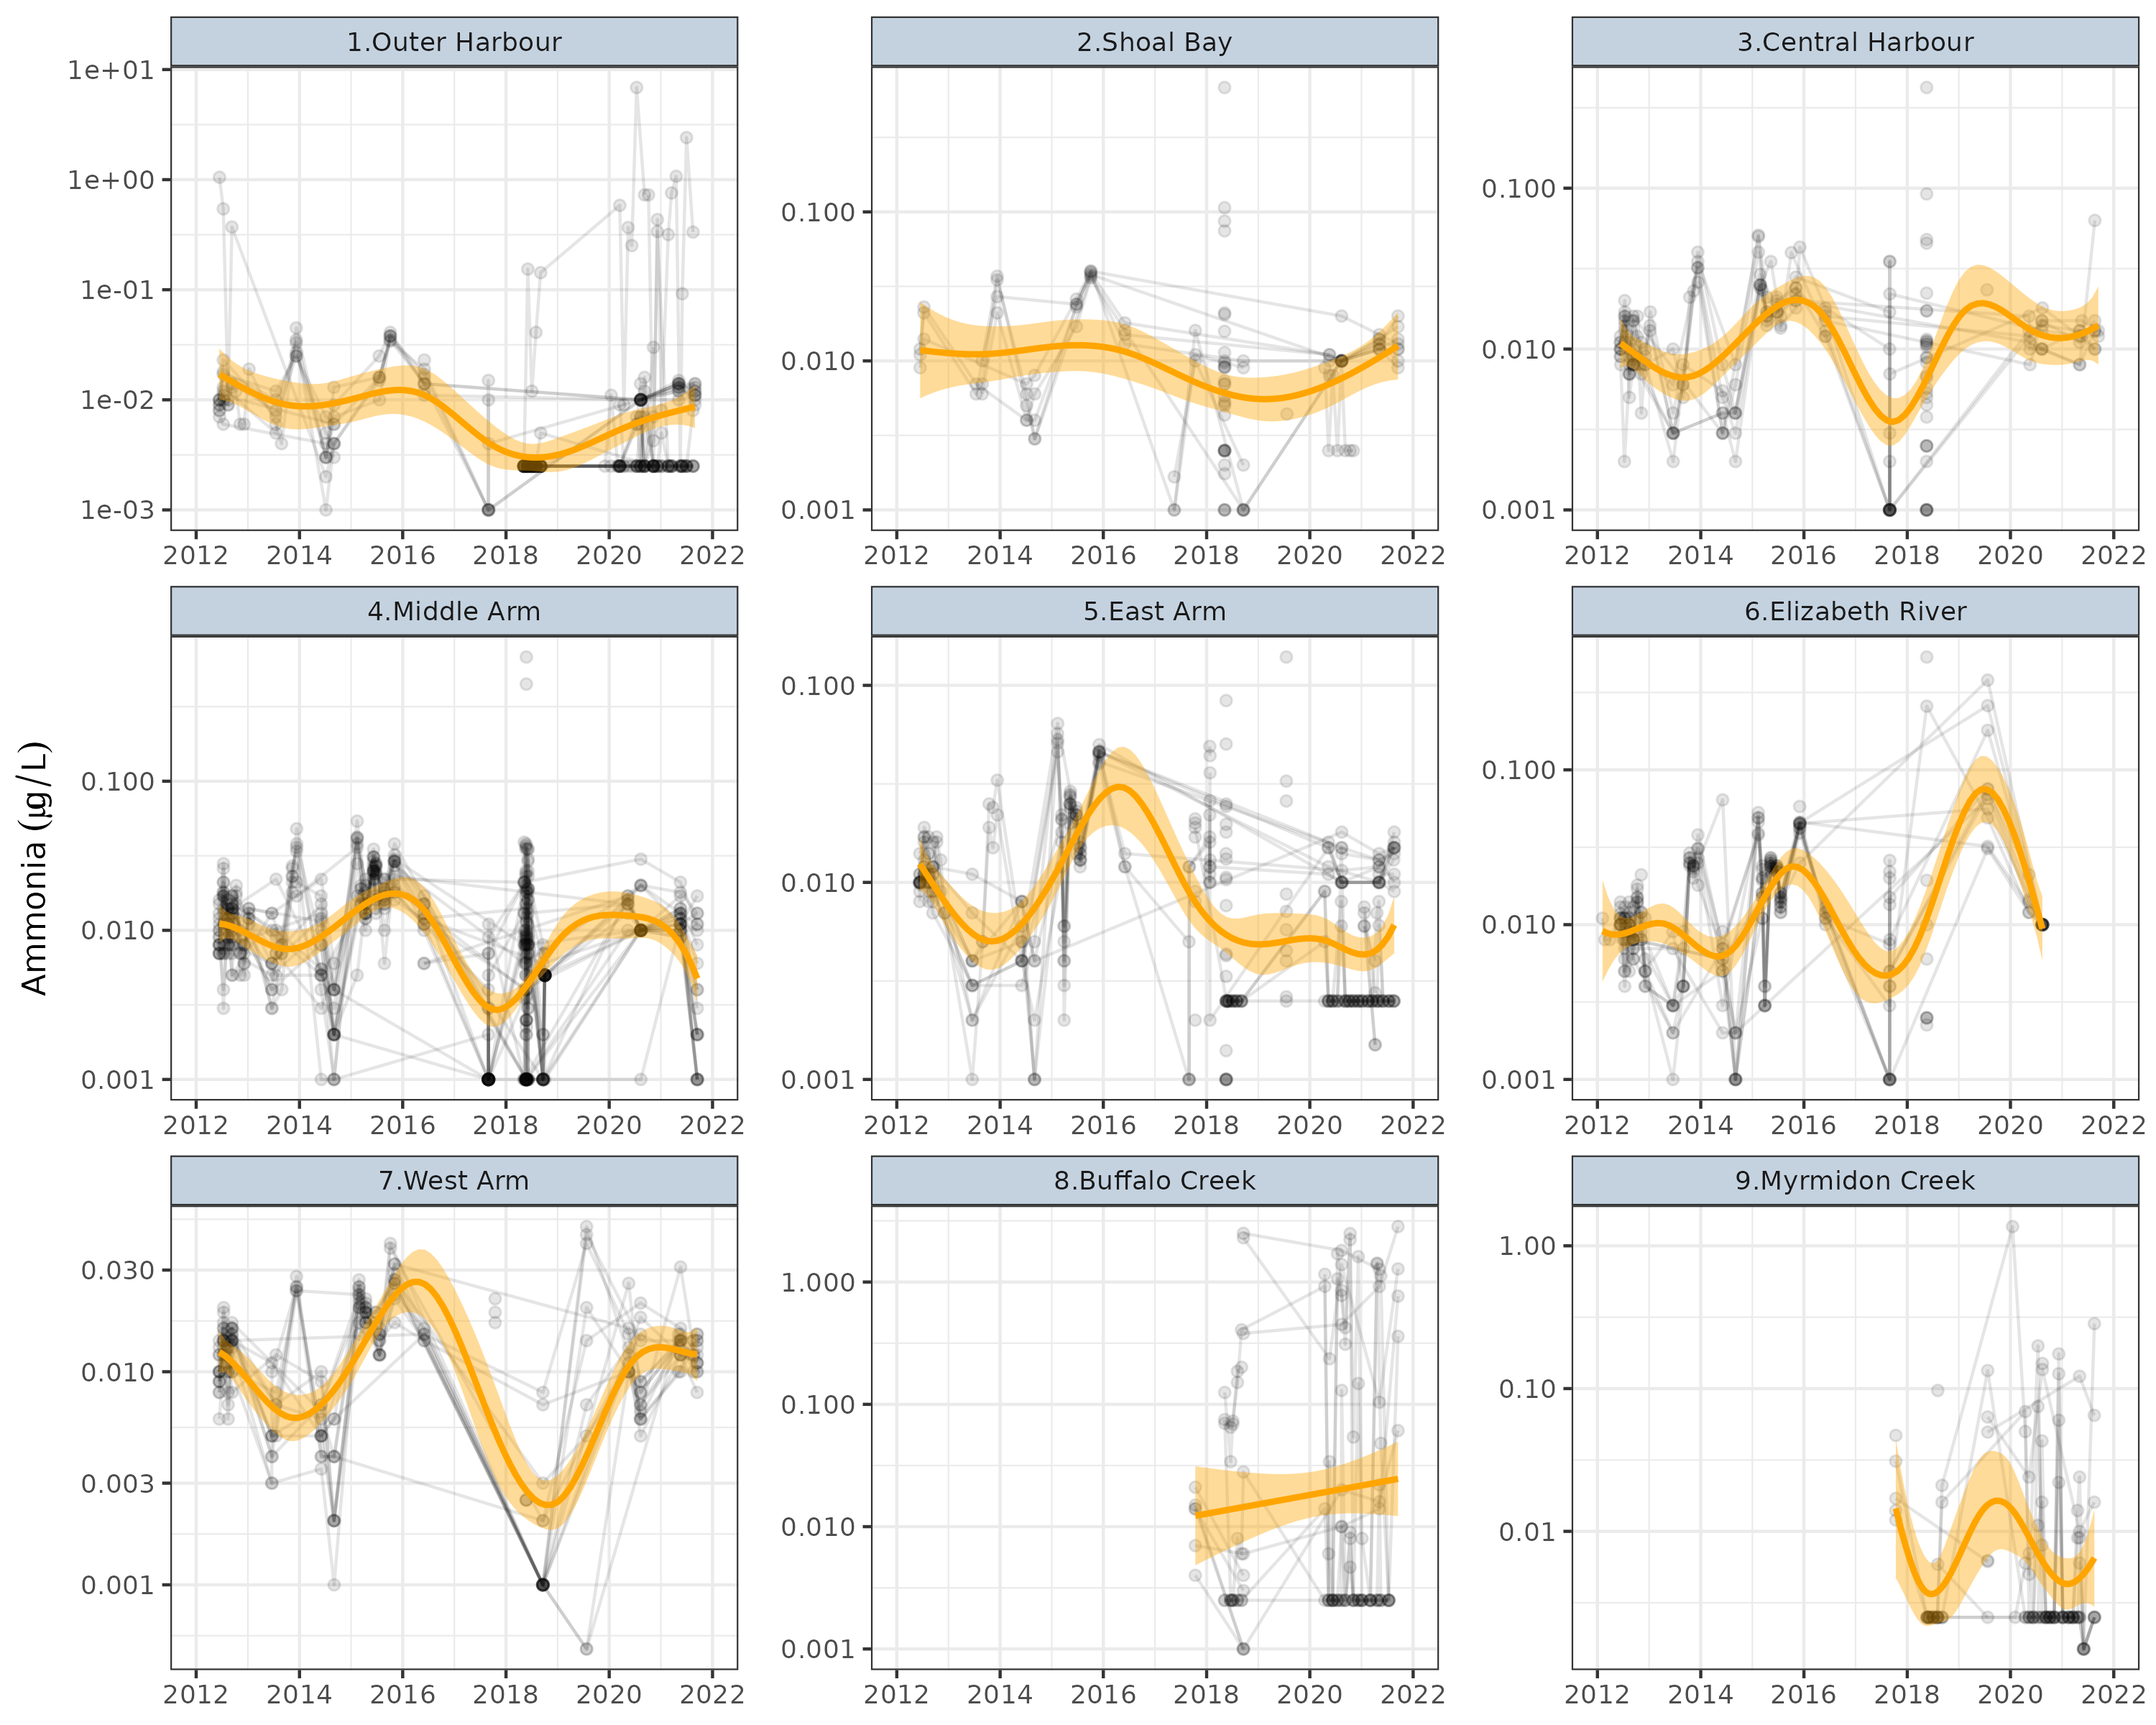

**Figure** **:** Temporal trends in Ammonia (µg/L) for discrete sites within each of the Zones. Points represent collected observations at unique lat/long/Year combinations. Each individual point is 80% transparent, and thus darker points represent a greater quantity of observations with similar values. Faint lines join sets of observations collected at the same lat/long over time. Orange lines represent simple Generalized Additive Modeling splines with 95% confidence envelopes. Note, these are purely simple models that do not take into account any dependency structures (e.g. do not include random effects or autoregressive terms).

### Filterable Reactive Phosphate (µg/L)

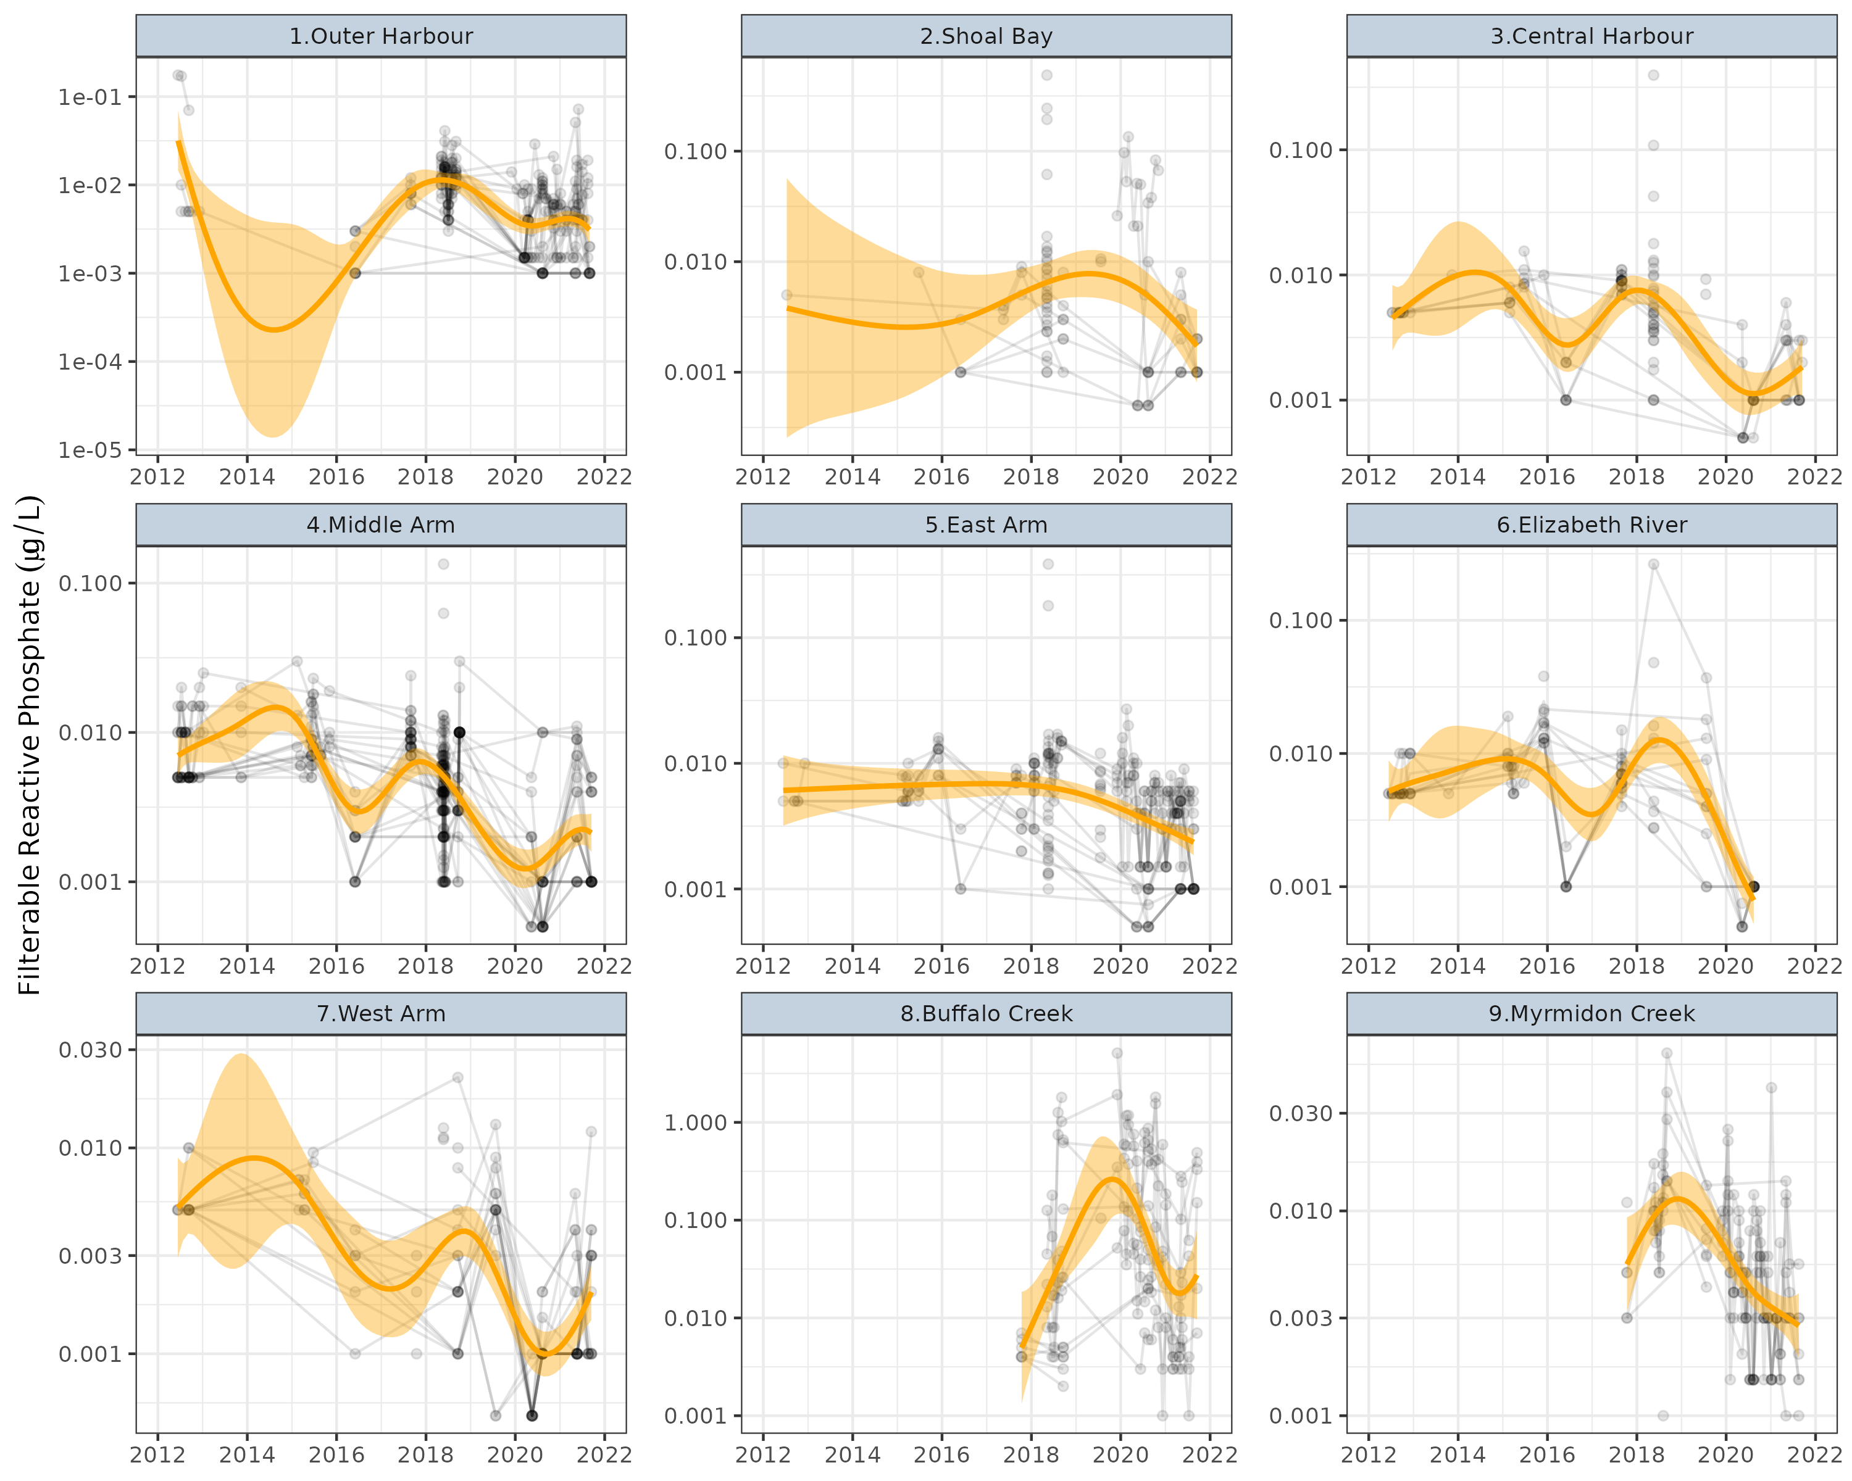

**Figure** **:** Temporal trends in Filterable Reactive Phosphate (µg/L) for discrete sites within each of the Zones. Points represent collected observations at unique lat/long/Year combinations. Each individual point is 80% transparent, and thus darker points represent a greater quantity of observations with similar values. Faint lines join sets of observations collected at the same lat/long over time. Orange lines represent simple Generalized Additive Modeling splines with 95% confidence envelopes. Note, these are purely simple models that do not take into account any dependency structures (e.g. do not include random effects or autoregressive terms).

### NOx as N (µg/L)

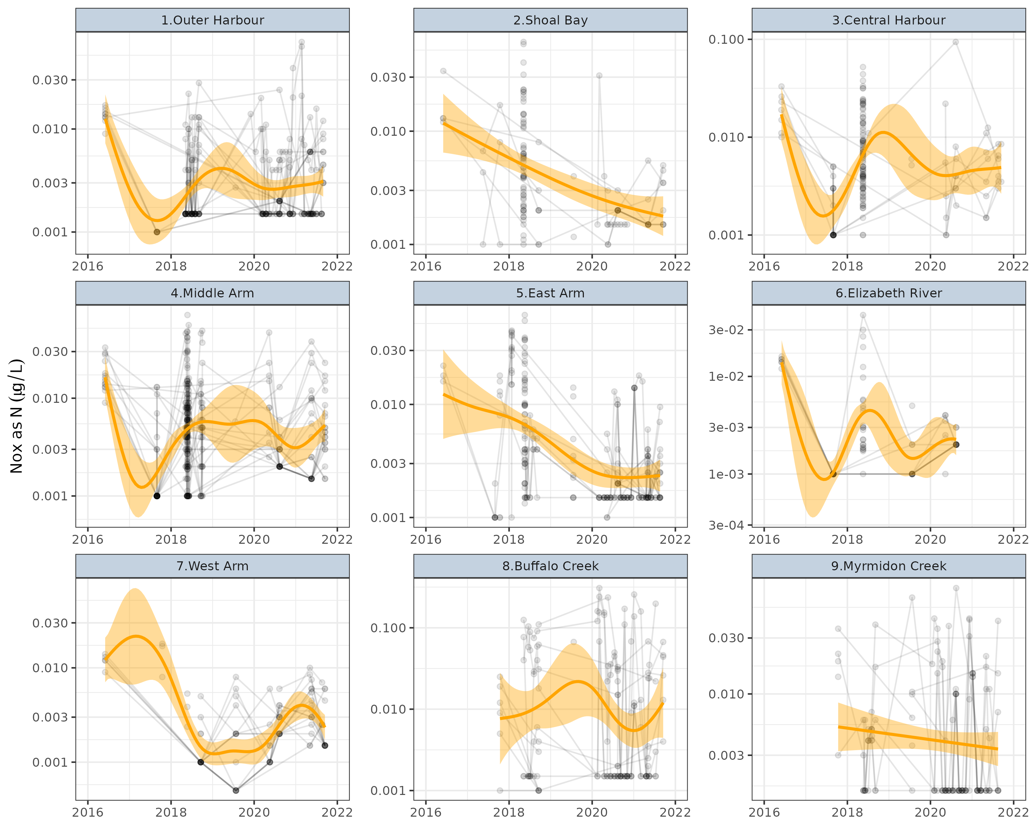

**Figure** **:** Temporal trends in NOx as N (µg/L) for discrete sites within each of the Zones. Points represent collected observations at unique lat/long/Year combinations. Each individual point is 80% transparent, and thus darker points represent a greater quantity of observations with similar values. Faint lines join sets of observations collected at the same lat/long over time. Orange lines represent simple Generalized Additive Modeling splines with 95% confidence envelopes. Note, these are purely simple models that do not take into account any dependency structures (e.g. do not include random effects or autoregressive terms).

# Analyses

## Statistical methodologies

This project aims to explore relationships between a set of water quality stressors that are important targets of a Darwin Harbour water quality monitoring program and a collection of potential drivers (pressures). In general, statistical explorations into potential associations between sets of variables can be a very difficult exercise. The difficulties are often further exacerbated when the set of variables to be correlated originate from multiple different sources and are environmental data.

Firstly, most environmental stressors and pressures data are irregularly and sparsely collected as well as highly noisy. That is, the observation space usually represents a tiny fraction of the full potential sampling domain. Hence, the granularity of the data can limit the sensitivity of any analyses.

Secondly, data assembled from disparate sources are typically collected on differing sparse spatial and temporal scales (as the collections are governed for different purposes). Consequently, there are no guarantees that scales of the data will be relevant to the scales at which any underlying biochemical interactions actually take place. Moreover, since the observations from different sources rarely align in space and time and the underlying conditions can fluctuate rapidly, only very large-scale (in time or space) drivers are going to manifest as observable associations.

Finally, when performing large numbers of statistical analyses to explore a high-dimensional space, it is important to acknowledge that the likelihood of Type I errors (false statistical conclusions) increase dramatically. Implicit in any single classical statistical analysis is notion that we base conclusions about entire populations on the single samples we have available. If the patterns in these samples are highly structured (non-random), we conclude that there is evidence of the association. However, it is possible that just by chance we happened to collect unusual samples that portray a pattern that is just an artefact and does not actually occur more broadly. The more of the analyses we perform, the more likely it is that at least one of these analyses purely reflects an artefact rather than a genuine pattern. Hence, the presence of correlations or associations in samples does not necessarily mean that they definitely exist in the populations.

Even if we accept that a given statistical correlation or association is genuine, it does not necessarily signify that the relationship is causal. Two variables could co-vary as a result of both being driven by another unobserved (latent) influence. Furthermore, in models that contain multiple covariates (predictors), the presence or absence of associations involving one predictor can be the result of confounding or masking due to other observed or unobserved influences.

There are many different approaches that can be employed in order to explore the associations between sets of variables. One approach is to fit univariate generalized linear (mixed) models (GLMM’s) that relate a single *response* (in this case stressor) to a small number of uncorrelated *predictors* (pressures) within a hierarchical (spatial) structure. GLMM’s are well established statistical routines that evaluate the evidence for low-dimensional trends.

Increased complexity can be explored via generalized additive (mixed) models (GAMMs). Rather than fit simple linear (or polynomial) trends through data, GAMM’s fit splines and thus are not constrained to evaluating evidence of very simple trends in the data.

Both GLMMs and GAMMs are designed for relatively low-dimensional explorations of the data space. Neither are well suited to exploring associations between a response and predictors when there are correlations among the predictors. High correlations among pressures is a predictable feature of environmental data. For example, climatic variables such as temperature, precipitation and wind are often highly correlated.

Machine learning technologies are often better suited to higher dimensional problems. Unfortunately, many of these are focused purely on prediction and are of little use in attribution - that is, these models are able to predict very well, however, they are typically unable to understand what predictors are the most important in driving the predicted patterns. Boosted regression model (GBM) trees are an amalgamation of statisical and machine learning routines. They are able to leverage the superior prediction capabilities of machine learning, with the attribution capabilities of statistical models.

Although it is possible to fit a boosted regression tree with correlated predictors, it is important to understand that when doing so, the importance of the predictor most strongly correlated to the response will tend to be elevated at the expense of any other predictors correlated to this predictor. The model is essentially saying that the other correlated predictors do not reveal much additional novel associations with the response that the other predictor has not already offered.

Each of the above techniques (GLMM/GAMM and GBM) allow us to explore the associations from different angles. Consequently, rather than considering them as competing candidate approaches and attempt to intuit which approach is more likely to be best in any given situation, I have elected to use both techniques in a complimentary manner. Each approach will provide a different (yet not entirely independent) line of evidence of the strength and polarity of associations between the stressors and pressures.

It should be noted that the GLMM/GAMM models feature only a single stressor at a time and therefore, stressors that are correlated to one another (and thus have similar relationships to the pressures) will show similar statistical outcomes. Contrastingly, each GBM contains the full set of predictors and highly correlated predictors will tend to complete with one another and the most highly correlated to the response will typically win out. Hence, in GBMs, the statistical outcomes associated with individual pressures that are highly correlated to one another may be profoundly different. It is for this reason, that the two approaches can be seen as complimentary.

### Generalised linear mixed effects models

For each of the five stressors (ammonia, chlorophyll-a, dissolved oxygen, filterable reactive phosphorus and turbidity), a generalised linear mixed model relating the stressor to one of the 33 single focal pressures were fit against a Gamma (log link) distribution.

Regular model fitting protocols usually involve a cycle in which a model is fit, a range of associated model diagnostics are reviewed and if necessary, repeat the cycle with modifications of the model until the practitioner is satisfied that there is no evidence of a lack of model fit. However, for the current project, there are too many modelling combinations to permit us to complete this regular cycle. Consequently, instead, each model was fit using a set of possible model candidates (see below) and then the model that best satisfied the model diagnostics was chosen. Model diagnostic included tests for uniformity, (over) dispersion, outliers and residual quantile patterns all based on simulated residuals (DHARMa).

If more than one model satisfied the diagnostic conditions, then the candidate model was selected on the basis of the lowest AIC (Akake Information Criterion). All models were fit via Restricted/Residual Maximum Likelihood (REML) to minimise bias due to the random effects.

* Model 1: mixed effect model with polynomial effects and first order auto-regressive structure
$$\begin{matrix}y_{ij} & ∼​Γ(μ_{ij},ϕ) \\ log(μ_{ij}) & =β_{0}+β_{1}x_{ij}+β_{2}x_{ij}^{2}+β_{3}x_{ij}^{3}+γ[Site_{j}]+θ(y_{ij−1}−μ_{ij−1})\end{matrix}$$

* where:
  + $y_{ij}$ is the $i^{th}$ observation in the $j^{th}$ Site
  + $μ_{ij}$ represents the expected mean of the observation in the Site
  + represents the dispersion parameter of the gamma distribution, controlling the shape of the distribution
  + $β_{0}$, $β_{1}$, $β_{2}$ and $β_{3}$ are the polynomial regression terms
  + $[Site_j$ is the random intercept for the $j^{t}h$ Site
  + $θ(y_{ij−1}−μ_{ij−1})$ is the stationary first order autoregressive structure, indicating the effect of the lagged dependent variable on the current mean within the $j^{th}$ Site. It has a covariance of $σ^{2}exp(−θ|s−t|)$ where $s$ and $t$ represent $y_{i}$ and $y_{i}−1$ respectively.
* Model 2: mixed effect model with polynomial effects
$$\begin{matrix}y_{ij} & ∼​Γ(μ_{ij},ϕ) \\ log(μ_{ij}) & =β_{0}+β_{1}x_{ij}+β_{2}x_{ij}^{2}+β_{3}x_{ij}^{3}+γ[Site_{j}]\end{matrix}$$

* where:
  + $y_{ij}$ is the $i^{th}$ observation in the $j^{th}$ Site
  + $μ_{ij}$ represents the expected mean of the $i^{th}$ observation in the $j^{th}$ Site
  + $ϕ$ represents the dispersion parameter of the gamma distribution, controlling the shape of the distribution
  + $β_{0}$, $β_{1}$, $β_{2}$ and $β_{3}$ are the polynomial regression terms
  + $[Site_j$ is the random intercept for the $j^{t}h$ Site
* Model 3: mixed effect model with linear effects and first order auto-regressive structure
$$\begin{matrix}y_{ij} & ∼​Γ(μ_{ij},ϕ) \\ log(μ_{ij}) & =β_{0}+β_{1}x_{ij}+γ[Site_{j}]+θ(y_{ij−1}−μ_{ij−1})\end{matrix}$$

* where:
  + $y_{ij}$ is the $i^{th}$ observation in the $j^{th}$ Site
  + $μ_{ij}$ represents the expected mean of the observation in the Site
  + represents the dispersion parameter of the gamma distribution, controlling the shape of the distribution
  + $β_{0}$ and $β_{1}$ are the linear regression terms
  + $[Site_j$ is the random intercept for the $j^{t}h$ Site
  + $θ(y_{ij−1}−μ_{ij−1})$ is the stationary first order autoregressive structure, indicating the effect of the lagged dependent variable on the current mean within the $j^{th}$ Site. It has a covariance of $σ^{2}exp(−θ|s−t|)$ where $s$ and $t$ represent $y_{i}$ and $y_{i}−1$ respectively.
* Model 4: mixed effect model with linear effects
$$\begin{matrix}y_{ij} & ∼​Γ(μ_{ij},ϕ) \\ log(μ_{ij}) & =β_{0}+β_{1}x_{ij}+γ[Site_{j}]\end{matrix}$$

* where:
  + $y_{ij}$ is the $i^{th}$ observation in the $j^{th}$ Site
  + $μ_{ij}$ represents the expected mean of the $i^{th}$ observation in the $j^{th}$ Site
  + $ϕ$ represents the dispersion parameter of the gamma distribution, controlling the shape of the distribution
  + $β_{0}$ and $β_{1}$ are the linear regression terms
  + $[Site_j$ is the random intercept for the $j^{t}h$ Site
* Model 5: additive mixed effect model
$$\begin{matrix}y_{ij} & ∼​Γ(μ_{ij},ϕ) \\ log(μ_{ij}) & =β_{0}+f(x_{ij})+β_{1}Year_{ij}+γ[Site_{j}]\end{matrix}$$

* where:
  + $y_{ij}$ is the $i^{th}$ observation in the $j^{th}$ Site
  + $μ_{ij}$ represents the expected mean of the $i^{th}$ observation in the $j^{th}$ Site
  + $ϕ$ represents the dispersion parameter of the gamma distribution, controlling the shape of the distribution
  + $β_{0}$ is the intercept
  + $f(x_{ij})$ represents a penalised spline smoother function over the $i^{th}$ covariate observation in the $j^{th}$ Site
  + $β_{1}Year_{ij}$ represents the linear effect of the $i^{th}$ Year in the $j^{th}$ Site
  + $[Site_j$ is the random intercept for the $j^{t}h$ Site
* Model 6: additive effect model
$$\begin{matrix}y_{ij} & ∼​Γ(μ_{ij},ϕ) \\ log(μ_{ij}) & =β_{0}+f(x_{ij})\end{matrix}$$

* where:
  + $y_{ij}$ is the $i^{th}$ observation in the $j^{th}$ Site
  + $μ_{ij}$ represents the expected mean of the $i^{th}$ observation in the $j^{th}$ Site
  + $ϕ$ represents the dispersion parameter of the gamma distribution, controlling the shape of the distribution
  + $β_{0}$ is the intercept
  + $f(x_{ij})$ represents a penalised spline smoother function over the $i^{th}$ covariate observation in the $j^{th}$ Site
* Model 8: linear effect model
$$\begin{matrix}y_{ij} & ∼​Γ(μ_{ij},ϕ) \\ log(μ_{ij}) & =β_{0}+beta_{1}x_{ij}\end{matrix}$$

* where:
  + $y_{ij}$ is the $i^{th}$ observation in the $j^{th}$ Site
  + $μ_{ij}$ represents the expected mean of the $i^{th}$ observation in the $j^{th}$ Site
  + $ϕ$ represents the dispersion parameter of the gamma distribution, controlling the shape of the distribution
  + $β_{0}$ is the intercept
  + $β_{1}x_{ij}$ represents the linear effect over the $i^{th}$ covariate observation in the $j^{th}$ Site

The above models were fit for both routine and discrete sampling designs separately. Finally, the models were also run for three different lag versions (lag 0: not lagged, lag 1: lag of one year, lag 2: lag of two years) of each pressure. These lags allow us to explore delayed effects of the drivers of the various pressures.

### Gradient Boosted Models

Gradient boosted models are a type of machine learning model that combine a ensemble of weak learners (typically recursive partitioning regression trees) to create a more accurate and powerful predictive model. A key component of this technique is boosting, which involves sequentially adding new models (trees) to incrementally learn the patterns in the training data.

Briefly, gradient boosted models involve the following steps:

* initialization: Initially, the model starts with a simple regression tree.
* iterative training: the model is then trained iteratively to improve its performance. In each iteration, a new weak learner, is added to the model. This new learner is trained to focus on the data patterns that were poorly predicted by the previous models.
* gradient descent: during each iteration, the new weak learner is trained to minimize the errors or residuals made by the previous models. This is achieved using a technique called gradient descent. The new model is trained to fit the negative gradient of the loss function, with respect to the predictions made by the previous models.
* ensemble prediction: the predictions of all the weak learners are combined to make the final prediction. Each weak learner’s prediction is weighted based on its performance, and the final prediction is the sum of these weighted predictions.
* regularization: to prevent overfitting, regularization techniques such as shrinkage/learning rate and tree depth are applied. Shrinkage reduces the contribution of each new model, making the learning process slower and more conservative, while tree depth limits the complexity of individual trees.

Gradient boosted models have gained popularity due to their ability to handle complex and non-linear relationships in the data, handle a variety of data types, and provide accurate predictions. They are widely used in various domains, including regression, classification, and ranking tasks.

Regular gradient boosted models do not offer any uncertainty estimates. In order to get estimates of uncertainty, it is necessary to bootstrap the model. Boostraping involves repeatedly fitting of a model to randomly resampled (with replacement) data.

For the current project, 100 boostraped gradient boosted models were fit for each of the five stressors (ammonia, chlorophyll-a, dissolved oxygen, filterable reactive phosphorus and turbidity) for each of the routine and discrete sampling designs. Each model contained the full set of pressures. As with the GLMMs/GAMMs lagged versions of the models were also explore. However, unlike the GLMM/GAMM models (which only ever included a single lag, in the gradient boosted models, each of the lagged versions of the pressures were added to the models. Hence, both unlagged and fully lagged versions of each model were fit.

More specifically, each gradient boosted model comprised 10,000 trees, with a tree depth of 9, a bagging fraction of 0.5, a learning rate of 0.001 and 3 cross validation folds. Once fitted, each tree was pruned down via cross validation to prevent over-fitting. The relative influences of each pressure was estimated as the relative number of tree splits involving that pressure. For the purpose of graphical and tabular summaries, only pressures whose relative influence exceeded $100/p$ (where $p$ is the number of pressures) were retained.

Pseudo R² values associated with each individual pressure in a model were determined according to the following equation:

$$R^{2}=1−\frac{var(Pred−Obs)}{var(Obs)}$$

where $Pred$ represents the partial predictions (predictions from the model when all other pressures are held constant) and $Obs$ represent the observed stressor values.

## Summary of results

With such a large number of model combinations (Routine/Discrete, lagged/non-lagged, five stressors, 33 pressures) as well as two approaches (GLMM/GAMM and GBM), it is challenging to distil all the results down into a small number of figures/tables that are able to highlight the main patterns.

The following selections summarise all the findings in a series of cross summation tables broken down into spatial scales (whole harbour then each zone) for both routine and discrete sampling designs. In each table, the five stressors appear in the columns and the top influential pressures across these stressors form the rows. Each cell is further divided into the pseudo R² from the GBM (upper left of cells) and GLMM/GAMM (lower right of cells). Further, cell triangles are shaded according to the magnitude (depth of colour) and polarity (red: negative, green: positive) of the correlation attributed to the focal pressure.

Collectively, the two halves of each cell provide two lines of evidence and perspectives on the predictive influence of a stressor on a pressure. For example, if both halves have relatively high pseudo R² values (and are similarity coloured), we can conclude that there is reasonably strong evidence that changes in the focal stressor are in some way associated with the focal pressure. On the other hand, if only one half of the triangle is coloured, it might indicate that support for this association is less.

If there are numerous pressures for a particular stressor that each have a similar pseudo R² and colour in the lower right side of a cell, yet this is not the case for the upper right side of the cell, this suggests that these pressures were all correlated to one another. In such cases, it is likely that only one of the pressures is genuinely correlated with the stressor. The pseudo R² values for the GBM are expected to be lower than their GLMM/GAMM counterparts since the influences of each stressor is potentially diluted in the former by the presence of the large number of additional (sometimes competing) stressors.

### Routine samples (no lags)

Across the whole harbour for routine samples, there is:

* evidence of weak positive associations between Total P and Chlorophyll-a, Filterable reactive phosphate, NOx and Turbidity
* some evidence of weak positive associations between Total suspended solids and Chlorophyll-a and Filterable reactive phosphate
* some evidence of weak positive associations between Volatile suspended solids and Chlorophyll-a, Filterable reactive phosphate and Turbidity
* some evidence of weak positive associations between Estimated resident population and all of the stressors (except perhaps Ammonia)

These patterns are likely the result of large spatial scale associations. For example, if the sites in one zone are substantially higher in both Chlorophyll-a and Total P than the sites of other zones, then a positive association at the whole harbour scale will result.

The patterns within the zones are more refined and are due to either smaller spatial scale patterns (differences between sites within the zones) or else temporal fluctuations (both variables changing over time):

* there is weak evidence of a positive association between Dissolved oxygen and discharge volume in Buffalo Creek
* in East Arm, there is evidence of a weak positive association between Chlorophyll-a and each of Rainfall anomaly and Estimated resident population
* in East Arm, there is some evidence of a weak negative association between Chlorophyll-a and each of Fire frequency and number of liquid bulk ships
* in East Arm, there is evidence of a positive association between Sea surface temperature anomaly and Filterable reactive phosphorus
* in East Arm, there is evidence of a weak negative association between Gross regional product and Filterable reactive phosphorus
* in East Arm, there is some evidence of a negative associations Filterable reactive phosphorus and each of the number of liquid bulk ships or rig tenders, yet a positive association with Cruise ships
* in Central Harbour, there is evidence that Chlorophyll-a increases in association with estimated residual population and gross regional product and declines with increasing sea surface temperature anomaly
* in Central Harbour, there is evidence that Filterable reactive phosphorus increases in association with declining sea surface temperature anomaly and gross regional product and perhaps increasing Total building activity
* in Central Harbour, there is weak evidence that Turbidity increases in association with increasing Livestock shipping
* in the Elizabeth River, there is weak evidence that Chlorophyll-a decreases in association with increasing Gross regional product and Liquid bulk ships, yet increases with increasing mean air temperature and rainfall anomaly
* in the Outer Harbour, there is weak evidence that Chlorophyll-a decreases in association with increasing Rainfall anomaly and total building activity
* in the Outer Harbour, there is weak evidence that Filterable reactive phosphate increases in association with increasing numbers of Cruise ships
* in Middle Arm, there is weak evidence that Filterable reactive phosphate decreases in association with increasing Gross regional product
* in Middle Arm, there is weak evidence that Turbidity decreases in association with increasing number of dry bulk ships
* in West Arm, there is evidence that Chlorophyll-a increases in association with increasing rainfall anomaly and estimated resident population and declines with increasing number of liquid bulk ships
* in West Arm, there is weak evidence that Turbidity decreases in association with increasing Sea surface temperature anomaly

### Whole harbour

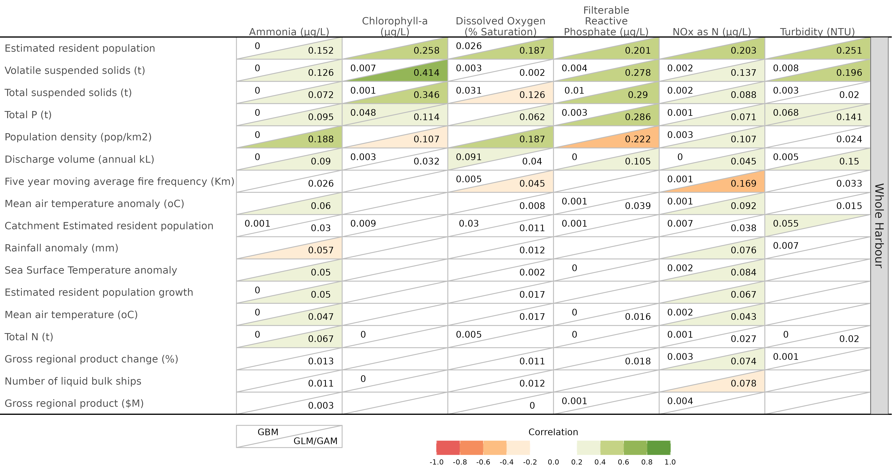

**Figure** **:** Cross summarisation of pseudo-R² values from boosted regression trees (upper left of table cells) and generalized (additive) models (lower right of table cells) associated with each combination of stressors (columns) and pressures (rows) for the whole of the Darwin Harbour **routine samples**. Cells are also coloured according to the degree of correlation (R - derived from R² and polarity of trends). The darker the cell shading, the larger in magnitude the R². Green and orange/red shading signify positive and negative trends respectively.

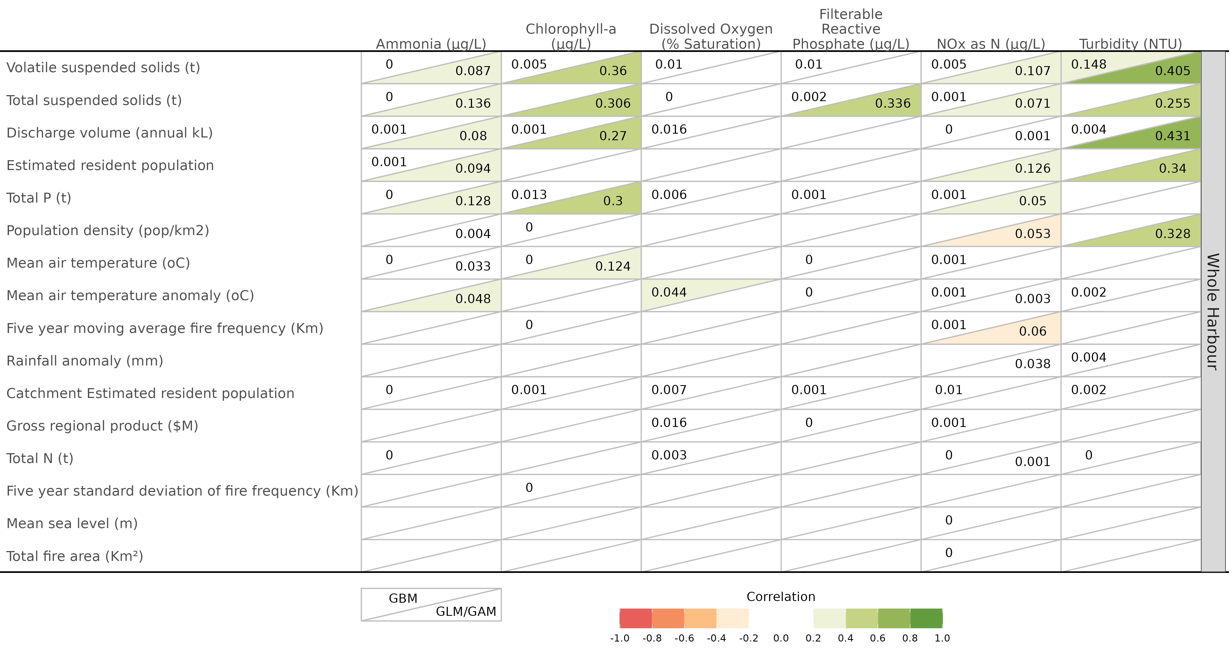

**Figure** **:** Cross summarisation of pseudo-R² values from boosted regression trees (upper left of table cells) and generalized (additive) models (lower right of table cells) associated with each combination of stressors (columns) and pressures (rows) for the whole of the Darwin Harbour **discrete samples**. Cells are also coloured according to the degree of correlation (R - derived from R² and polarity of trends). The darker the cell shading, the larger in magnitude the R². Green and orange/red shading signify positive and negative trends respectively.

### Buffalo Creek

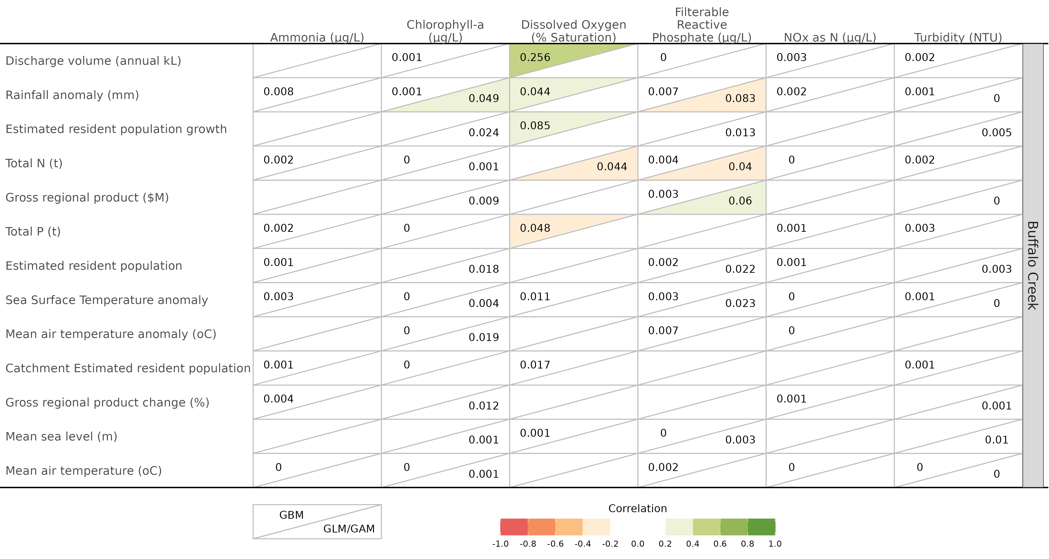

**Figure** **:** Cross summarisation of pseudo-R² values from boosted regression trees (upper left of table cells) and generalized (additive) models (lower right of table cells) associated with each combination of stressors (columns) and pressures (rows) for the Buffalo Creek **routine samples**. Cells are also coloured according to the degree of correlation (R - derived from R² and polarity of trends). The darker the cell shading, the larger in magnitude the R². Green and orange/red shading signify positive and negative trends respectively.

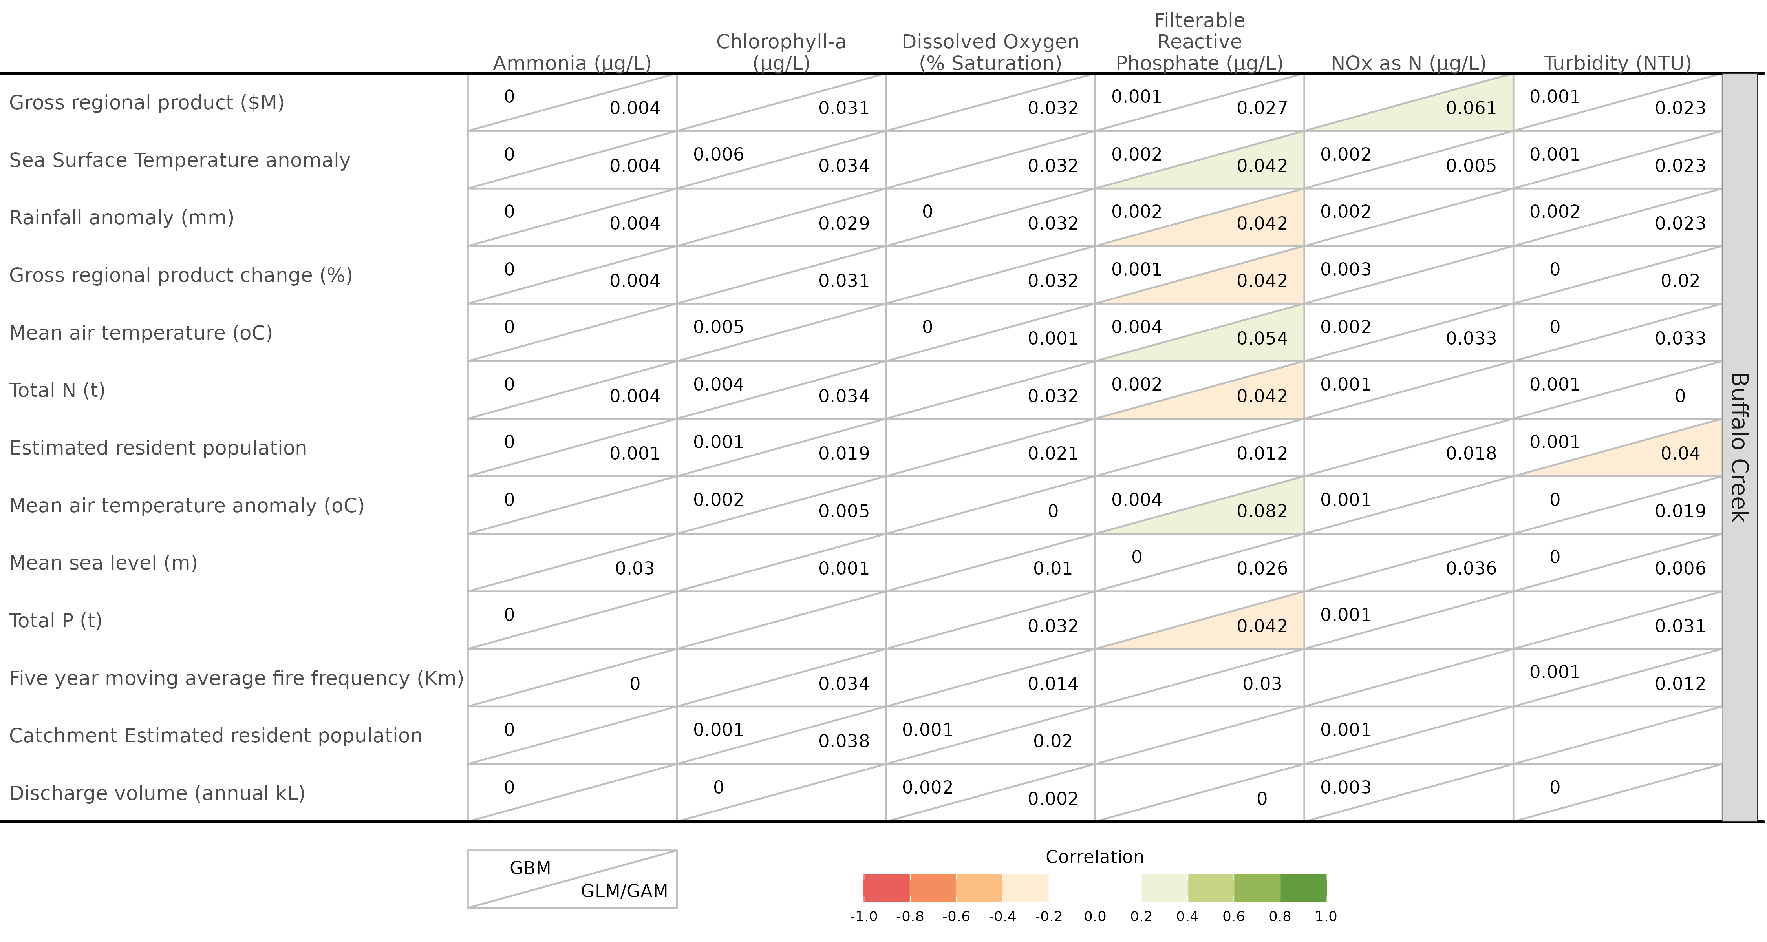

**Figure** **:** Cross summarisation of pseudo-R² values from boosted regression trees (upper left of table cells) and generalized (additive) models (lower right of table cells) associated with each combination of stressors (columns) and pressures (rows) for the Buffalo Creek **discrete samples**. Cells are also coloured according to the degree of correlation (R - derived from R² and polarity of trends). The darker the cell shading, the larger in magnitude the R². Green and orange/red shading signify positive and negative trends respectively.

### East Arm

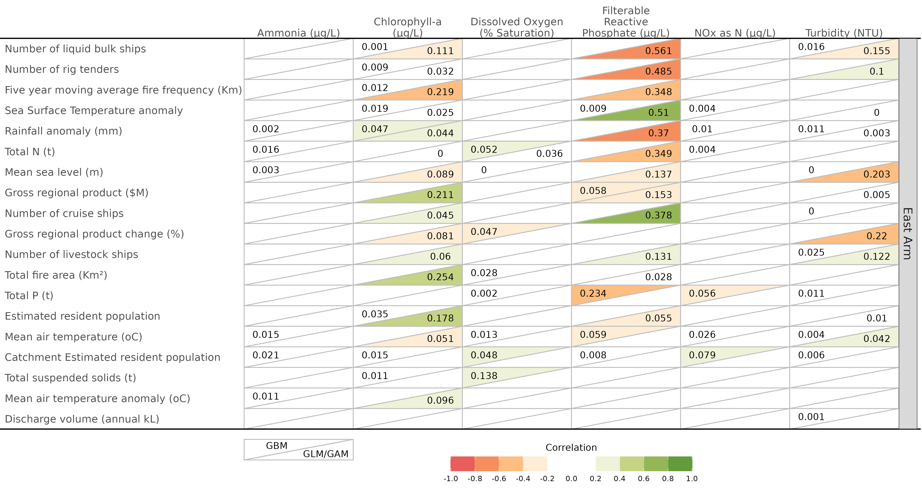

**Figure** **:** Cross summarisation of pseudo-R² values from boosted regression trees (upper left of table cells) and generalized (additive) models (lower right of table cells) associated with each combination of stressors (columns) and pressures (rows) for the East Arm **routine samples**. Cells are also coloured according to the degree of correlation (R - derived from R² and polarity of trends). The darker the cell shading, the larger in magnitude the R². Green and orange/red shading signify positive and negative trends respectively.

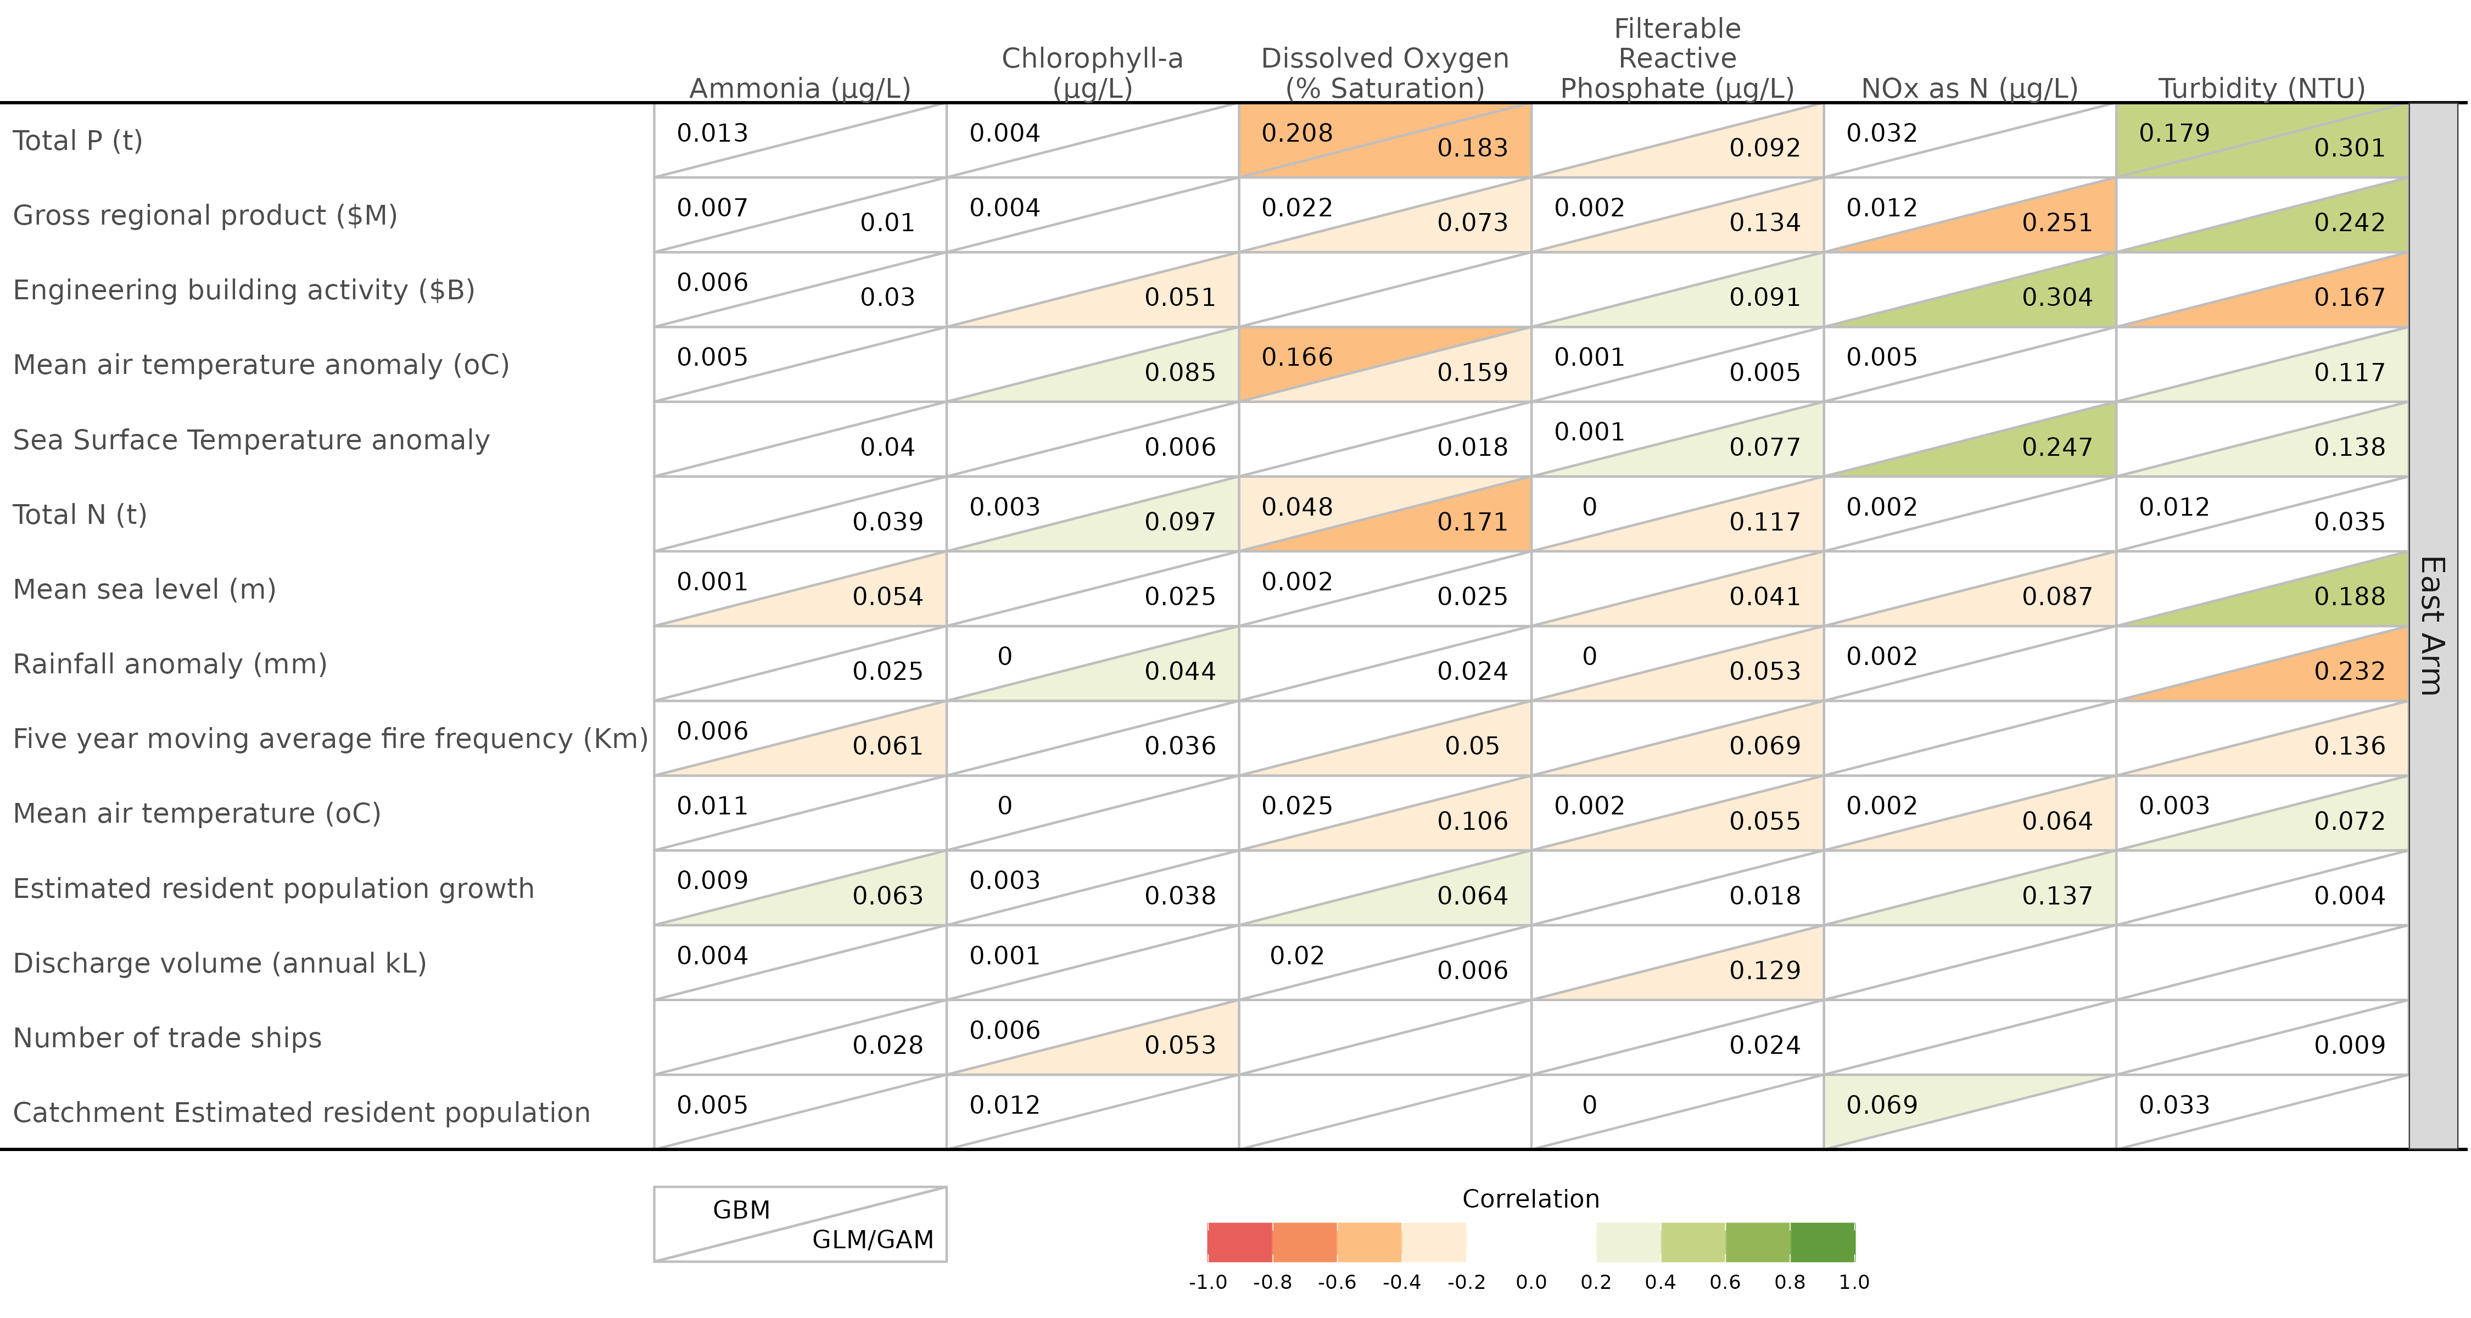

**Figure** **:** Cross summarisation of pseudo-R² values from boosted regression trees (upper left of table cells) and generalized (additive) models (lower right of table cells) associated with each combination of stressors (columns) and pressures (rows) for the East Arm **discrete samples**. Cells are also coloured according to the degree of correlation (R - derived from R² and polarity of trends). The darker the cell shading, the larger in magnitude the R². Green and orange/red shading signify positive and negative trends respectively.

### Central Harbour

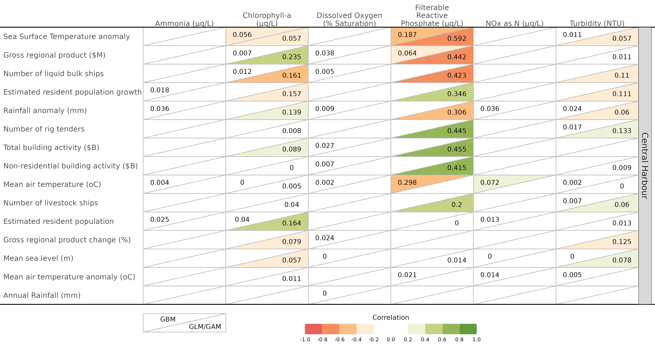

**Figure** **:** Cross summarisation of pseudo-R² values from boosted regression trees (upper left of table cells) and generalized (additive) models (lower right of table cells) associated with each combination of stressors (columns) and pressures (rows) for the Central Harbour routine samples. Cells are also coloured according to the degree of correlation (R - derived from R² and polarity of trends). The darker the cell shading, the larger in magnitude the R². Green and orange/red shading signify positive and negative trends respectively.

### Elizabeth River

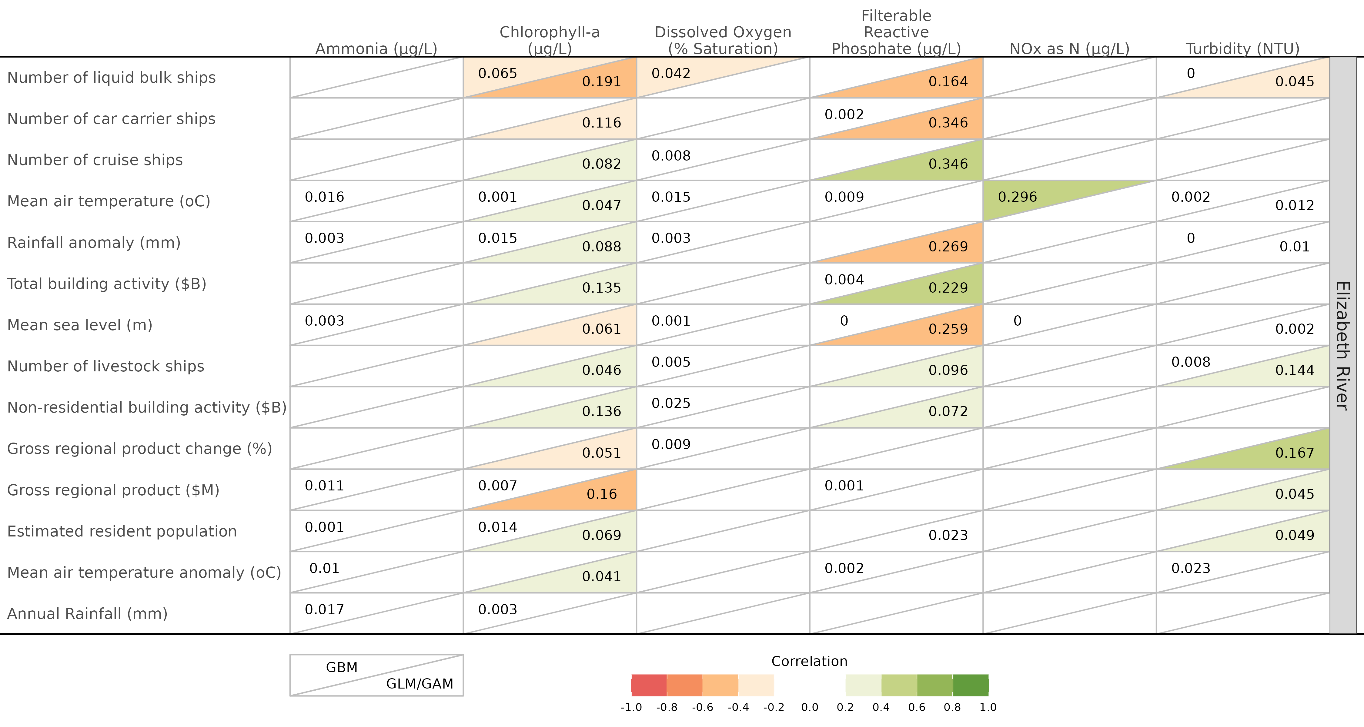

**Figure** **:** Cross summarisation of pseudo-R² values from boosted regression trees (upper left of table cells) and generalized (additive) models (lower right of table cells) associated with each combination of stressors (columns) and pressures (rows) for the Elizabeth River routine samples. Cells are also coloured according to the degree of correlation (R - derived from R² and polarity of trends). The darker the cell shading, the larger in magnitude the R². Green and orange/red shading signify positive and negative trends respectively.

### Outer Harbour

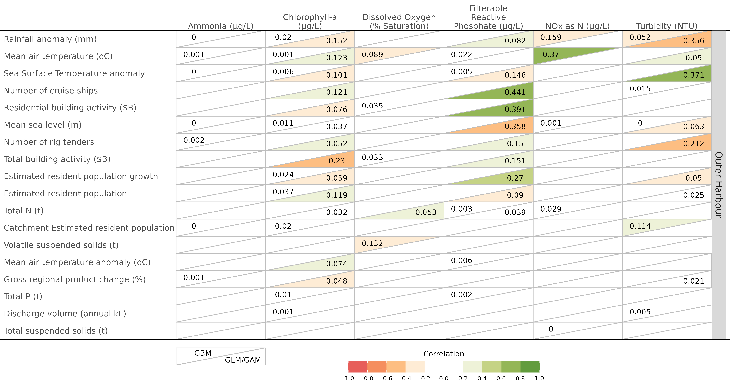

**Figure** **:** Cross summarisation of pseudo-R² values from boosted regression trees (upper left of table cells) and generalized (additive) models (lower right of table cells) associated with each combination of stressors (columns) and pressures (rows) for the Outer Harbour routine samples. Cells are also coloured according to the degree of correlation (R - derived from R² and polarity of trends). The darker the cell shading, the larger in magnitude the R². Green and orange/red shading signify positive and negative trends respectively.

### Middle Arm

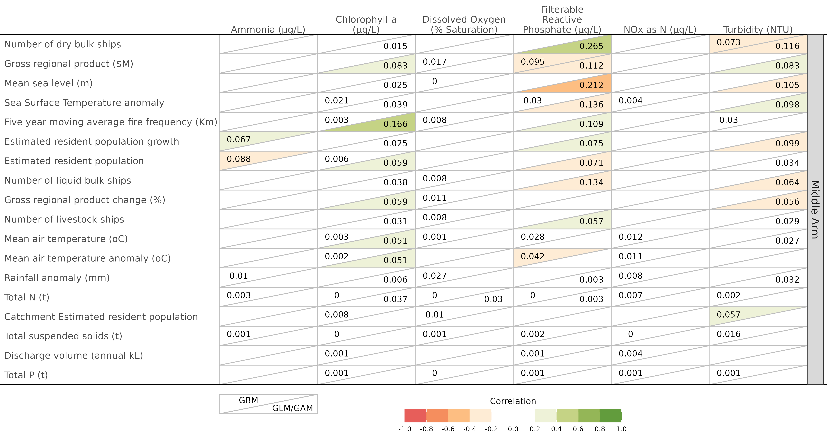

**Figure** **:** Cross summarisation of pseudo-R² values from boosted regression trees (upper left of table cells) and generalized (additive) models (lower right of table cells) associated with each combination of stressors (columns) and pressures (rows) for the Middle Arm routine samples. Cells are also coloured according to the degree of correlation (R - derived from R² and polarity of trends). The darker the cell shading, the larger in magnitude the R². Green and orange/red shading signify positive and negative trends respectively.

### West Arm

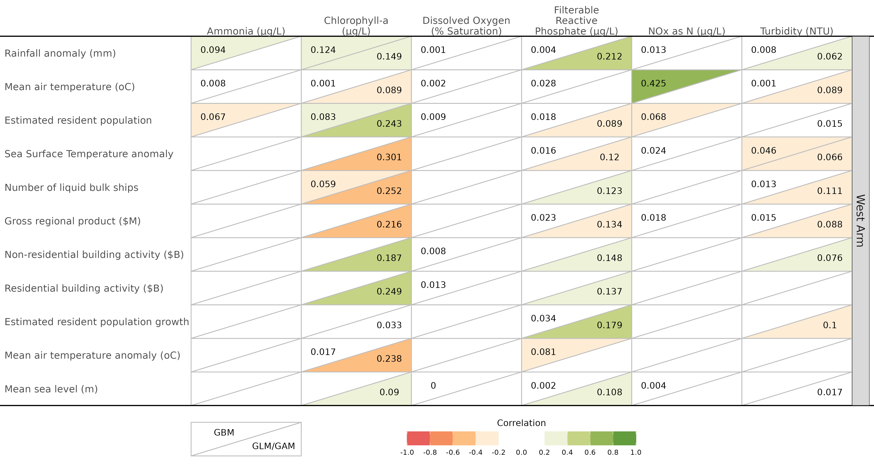

**Figure** **:** Cross summarisation of pseudo-R² values from boosted regression trees (upper left of table cells) and generalized (additive) models (lower right of table cells) associated with each combination of stressors (columns) and pressures (rows) for the West Arm routine samples. Cells are also coloured according to the degree of correlation (R - derived from R² and polarity of trends). The darker the cell shading, the larger in magnitude the R². Green and orange/red shading signify positive and negative trends respectively.

### Shoal Bay

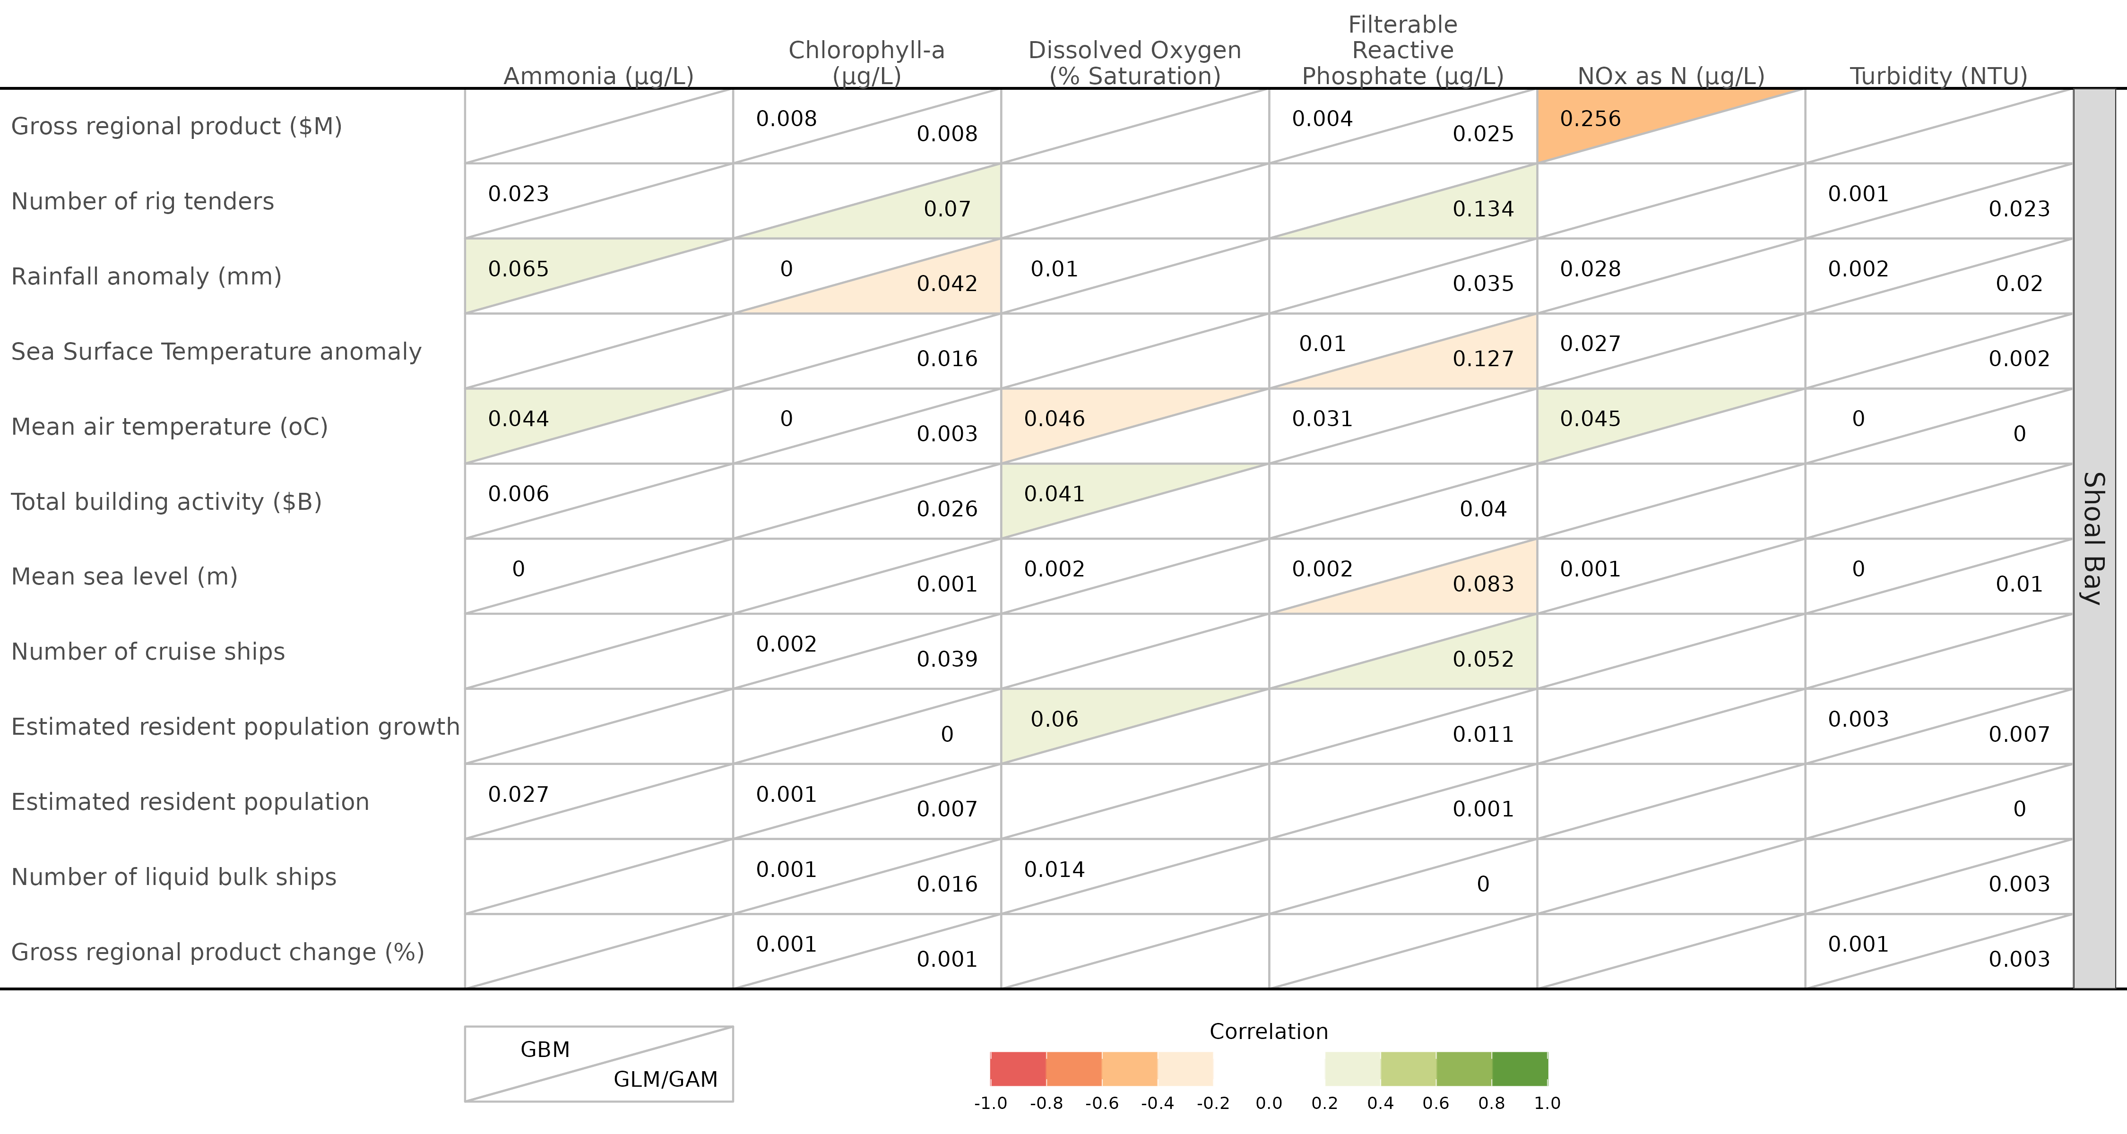

**Figure** **:** Cross summarisation of pseudo-R² values from boosted regression trees (upper left of table cells) and generalized (additive) models (lower right of table cells) associated with each combination of stressors (columns) and pressures (rows) for the Shoal Bay routine samples. Cells are also coloured according to the degree of correlation (R - derived from R² and polarity of trends). The darker the cell shading, the larger in magnitude the R². Green and orange/red shading signify positive and negative trends respectively.

### Discrete samples

### Whole harbour



**Figure** **:** Cross summarisation of pseudo-R² values from boosted regression trees (upper left of table cells) and generalized (additive) models (lower right of table cells) associated with each combination of stressors (columns) and pressures (rows) for the whole of the Darwin Harbour discrete samples. Cells are also coloured according to the degree of correlation (R - derived from R² and polarity of trends). The darker the cell shading, the larger in magnitude the R². Green and orange/red shading signify positive and negative trends respectively.

### Buffalo Creek



**Figure** **:** Cross summarisation of pseudo-R² values from boosted regression trees (upper left of table cells) and generalized (additive) models (lower right of table cells) associated with each combination of stressors (columns) and pressures (rows) for the Buffalo Creek discrete samples. Cells are also coloured according to the degree of correlation (R - derived from R² and polarity of trends). The darker the cell shading, the larger in magnitude the R². Green and orange/red shading signify positive and negative trends respectively.

### East Arm



**Figure** **:** Cross summarisation of pseudo-R² values from boosted regression trees (upper left of table cells) and generalized (additive) models (lower right of table cells) associated with each combination of stressors (columns) and pressures (rows) for the East Arm discrete samples. Cells are also coloured according to the degree of correlation (R - derived from R² and polarity of trends). The darker the cell shading, the larger in magnitude the R². Green and orange/red shading signify positive and negative trends respectively.

### Central Harbour

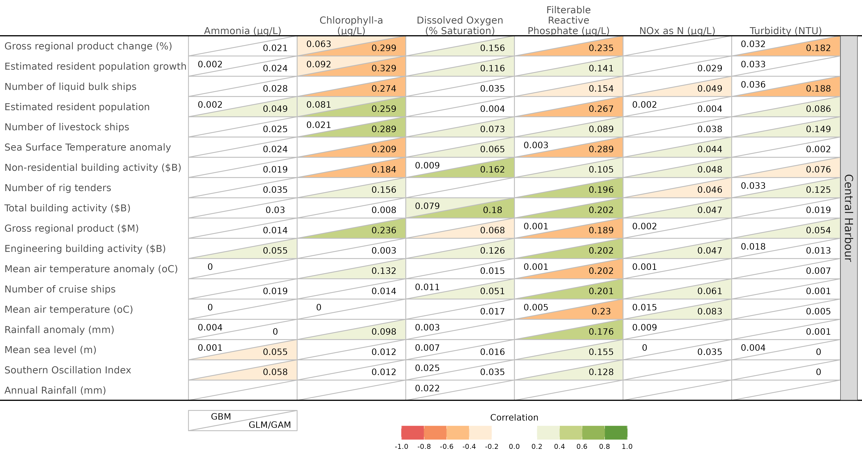

**Figure** **:** Cross summarisation of pseudo-R² values from boosted regression trees (upper left of table cells) and generalized (additive) models (lower right of table cells) associated with each combination of stressors (columns) and pressures (rows) for the Central Harbour discrete samples. Cells are also coloured according to the degree of correlation (R - derived from R² and polarity of trends). The darker the cell shading, the larger in magnitude the R². Green and orange/red shading signify positive and negative trends respectively.

### Elizabeth River

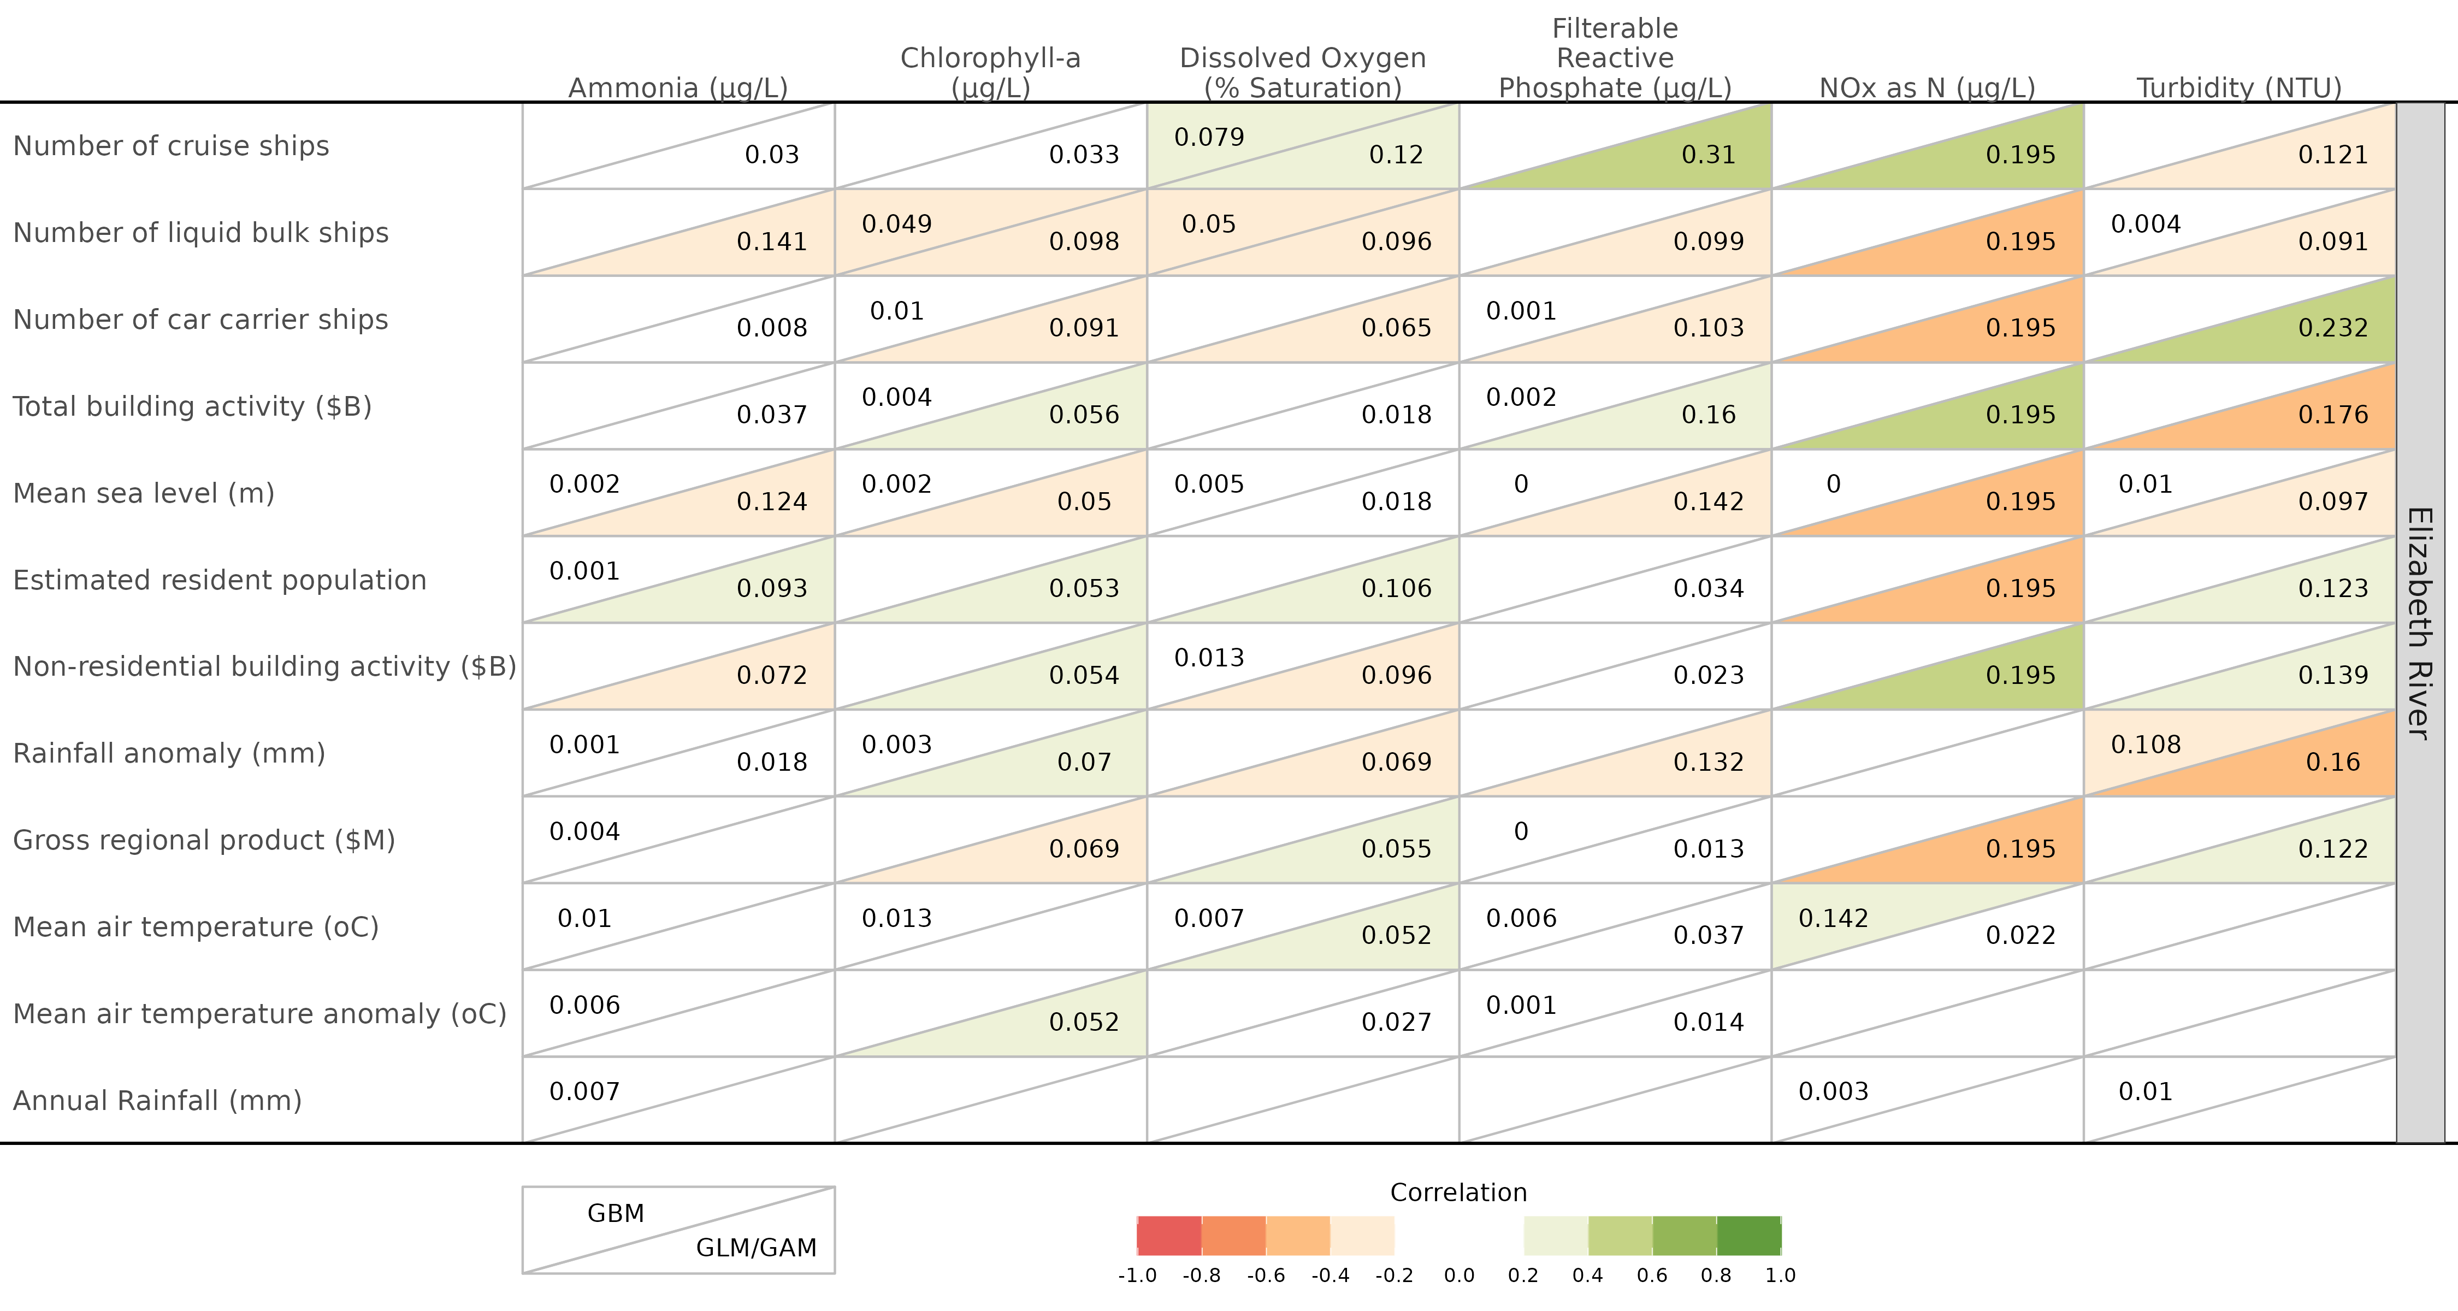

**Figure** **:** Cross summarisation of pseudo-R² values from boosted regression trees (upper left of table cells) and generalized (additive) models (lower right of table cells) associated with each combination of stressors (columns) and pressures (rows) for the Elizabeth River discrete samples. Cells are also coloured according to the degree of correlation (R - derived from R² and polarity of trends). The darker the cell shading, the larger in magnitude the R². Green and orange/red shading signify positive and negative trends respectively.

### Outer Harbour

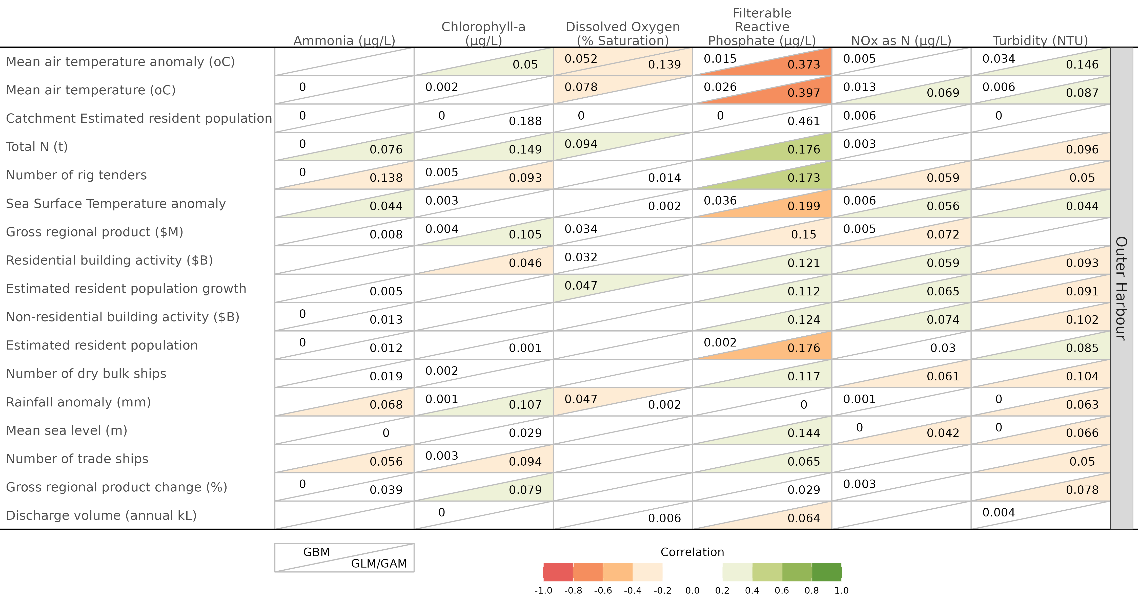

**Figure** **:** Cross summarisation of pseudo-R² values from boosted regression trees (upper left of table cells) and generalized (additive) models (lower right of table cells) associated with each combination of stressors (columns) and pressures (rows) for the Outer Harbour discrete samples. Cells are also coloured according to the degree of correlation (R - derived from R² and polarity of trends). The darker the cell shading, the larger in magnitude the R². Green and orange/red shading signify positive and negative trends respectively.

### Middle Arm

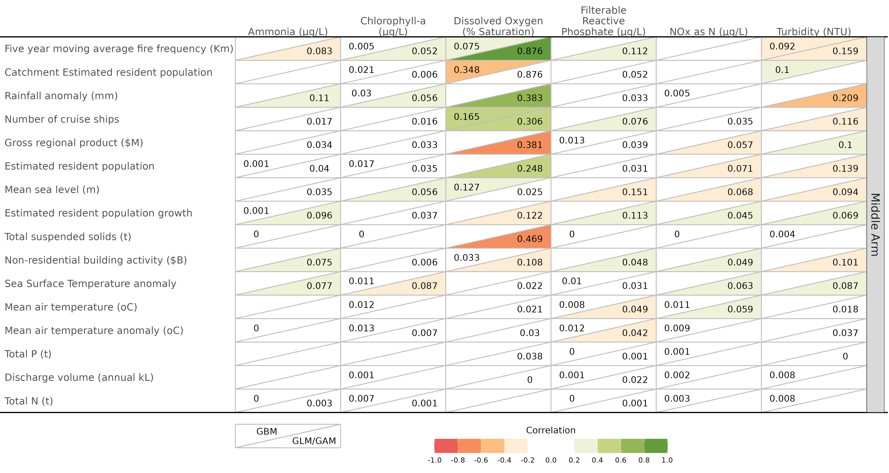

**Figure** **:** Cross summarisation of pseudo-R² values from boosted regression trees (upper left of table cells) and generalized (additive) models (lower right of table cells) associated with each combination of stressors (columns) and pressures (rows) for the Middle Arm discrete samples. Cells are also coloured according to the degree of correlation (R - derived from R² and polarity of trends). The darker the cell shading, the larger in magnitude the R². Green and orange/red shading signify positive and negative trends respectively.

### West Arm

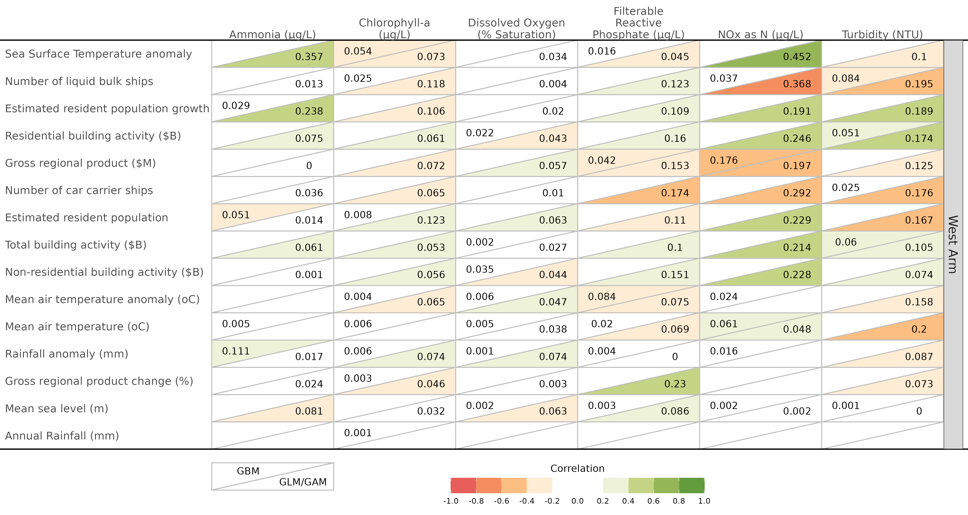

**Figure** **:** Cross summarisation of pseudo-R² values from boosted regression trees (upper left of table cells) and generalized (additive) models (lower right of table cells) associated with each combination of stressors (columns) and pressures (rows) for the West Arm discrete samples. Cells are also coloured according to the degree of correlation (R - derived from R² and polarity of trends). The darker the cell shading, the larger in magnitude the R². Green and orange/red shading signify positive and negative trends respectively.

### Shoal Bay

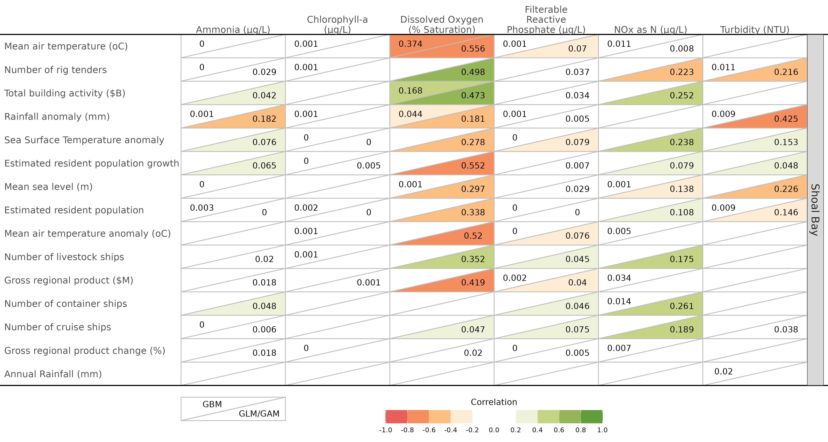

**Figure** **:** Cross summarisation of pseudo-R² values from boosted regression trees (upper left of table cells) and generalized (additive) models (lower right of table cells) associated with each combination of stressors (columns) and pressures (rows) for the Shoal Bay discrete samples. Cells are also coloured according to the degree of correlation (R - derived from R² and polarity of trends). The darker the cell shading, the larger in magnitude the R². Green and orange/red shading signify positive and negative trends respectively.

# About this document

The current standalone (self-contained) HTML document is generated via <https://quarto.org/> and all R codes used in the underlying analyses are embeded herein (albeit behind ‘show the code’ reveal markers).

View a summary of the R environment used at the time of the production of this document.

## R version 4.2.2 (2022-10-31)  
## Platform: x86_64-pc-linux-gnu (64-bit)  
## Running under: Ubuntu 22.04.1 LTS  
##   
## Matrix products: default  
## BLAS: /usr/lib/x86_64-linux-gnu/openblas-pthread/libblas.so.3  
## LAPACK: /usr/lib/x86_64-linux-gnu/openblas-pthread/libopenblasp-r0.3.20.so  
##   
## locale:  
## [1] LC_CTYPE=en_US.utf8 LC_NUMERIC=C   
## [3] LC_TIME=en_US.utf8 LC_COLLATE=en_US.utf8   
## [5] LC_MONETARY=en_US.utf8 LC_MESSAGES=en_US.utf8   
## [7] LC_PAPER=en_US.utf8 LC_NAME=C   
## [9] LC_ADDRESS=C LC_TELEPHONE=C   
## [11] LC_MEASUREMENT=en_US.utf8 LC_IDENTIFICATION=C   
##   
## attached base packages:  
## [1] parallel stats graphics grDevices utils datasets methods   
## [8] base   
##   
## other attached packages:  
## [1] gbm_2.1.8.1 kableExtra_1.3.4 furrr_0.3.1 future_1.28.0   
## [5] doParallel_1.0.17 iterators_1.0.14 foreach_1.5.2 ggsflabel_0.0.1   
## [9] sf_1.0-8 patchwork_1.1.2 emmeans_1.8.1-1 performance_0.10.0  
## [13] glmmTMB_1.1.4 lubridate_1.8.0 readxl_1.4.1 skimr_2.1.5   
## [17] flextable_0.8.2 knitr_1.40 officer_0.4.4 forcats_0.5.2   
## [21] stringr_1.4.1 dplyr_1.0.10 purrr_0.3.4 readr_2.1.3   
## [25] tidyr_1.2.1 tibble_3.1.8 ggplot2_3.3.6 tidyverse_1.3.2   
## [29] officedown_0.2.4 rmarkdown_2.16   
##   
## loaded via a namespace (and not attached):  
## [1] googledrive_2.0.0 minqa_1.2.4 colorspace_2.0-3   
## [4] ellipsis_0.3.2 class_7.3-20 estimability_1.4.1   
## [7] base64enc_0.1-3 fs_1.5.2 rstudioapi_0.14   
## [10] proxy_0.4-27 listenv_0.8.0 bit64_4.0.5   
## [13] fansi_1.0.3 mvtnorm_1.1-3 xml2_1.3.3   
## [16] codetools_0.2-18 splines_4.2.2 R.methodsS3_1.8.2   
## [19] cachem_1.0.6 jsonlite_1.8.2 nloptr_2.0.3   
## [22] broom_1.0.1 dbplyr_2.2.1 png_0.1-7   
## [25] R.oo_1.25.0 compiler_4.2.2 httr_1.4.4   
## [28] backports_1.4.1 assertthat_0.2.1 Matrix_1.5-1   
## [31] fastmap_1.1.0 gargle_1.2.1 cli_3.4.1   
## [34] htmltools_0.5.3 tools_4.2.2 coda_0.19-4   
## [37] gtable_0.3.1 glue_1.6.2 Rcpp_1.0.9   
## [40] cellranger_1.1.0 styler_1.8.0 vctrs_0.4.2   
## [43] svglite_2.1.0 nlme_3.1-160 insight_0.18.4   
## [46] xfun_0.33 globals_0.16.1 lme4_1.1-30   
## [49] rvest_1.0.3 lifecycle_1.0.2 googlesheets4_1.0.1  
## [52] MASS_7.3-58.1 scales_1.2.1 vroom_1.6.0   
## [55] hms_1.1.2 TMB_1.9.1 yaml_2.3.5   
## [58] memoise_2.0.1 gdtools_0.2.4 stringi_1.7.8   
## [61] e1071_1.7-11 boot_1.3-28 zip_2.2.1   
## [64] repr_1.1.6 rlang_1.0.6 pkgconfig_2.0.3   
## [67] systemfonts_1.0.4 evaluate_0.16 lattice_0.20-45   
## [70] rvg_0.2.5 bit_4.0.4 tidyselect_1.1.2   
## [73] parallelly_1.32.1 magrittr_2.0.3 R6_2.5.1   
## [76] generics_0.1.3 DBI_1.1.3 pillar_1.8.1   
## [79] haven_2.5.1 withr_2.5.0 units_0.8-0   
## [82] survival_3.4-0 modelr_0.1.9 crayon_1.5.2   
## [85] uuid_1.1-0 KernSmooth_2.23-20 utf8_1.2.2   
## [88] tzdb_0.3.0 grid_4.2.2 data.table_1.14.2   
## [91] webshot_0.5.4 reprex_2.0.2 digest_0.6.29   
## [94] classInt_0.4-8 xtable_1.8-4 R.cache_0.16.0   
## [97] numDeriv_2016.8-1.1 R.utils_2.12.0 munsell_0.5.0   
## [100] viridisLite_0.4.1